**PNEUMONIA DETECTION FROM CHEST X-RAY: A DEEP LEARNING APPROACH**

***Report submitted to***

***Haldia Institute of Technology, Haldia***

***for the award of the degree***

***of***

**Bachelor of Technology**

**in**

**Computer Science & Engineering**

***by***

**Shubham Prakash (10300120158)**

**Sankhajoti Saha (10300120142)**

**Sayan Digar (10300120147)**

**Ruhi Raj (10300120134)**



DECLARATION

I/We certify that

a. The work contained in this report is original and has been done by me/us under the

guidance of my/our supervisor(s).

b. The work has not been submitted to any other Institute for any degree or diploma.

c. I/We have followed the guidelines provided by the Institute in preparing the report.

d. I/We have conformed to the norms and guidelines given in the Ethical Code of Conduct of the Institute.

e. Whenever we have used materials (data, theoretical analysis, figures, and text) from other sources, we have given due credit to them by citing them in the text of the report and giving their details in the references.

Shubham Prakash Sayan Digar

(Uni Roll:10300120158) (UniRoll:10300120147)

Ruhi Raj Sankhajoti Saha

(Uni Roll:10300120134) (UniRoll:10300120142)

CERTIFICATE

This is to certify that the Dissertation Report entitled, “**Pneumonia Detection from Chest X-rays: A Deep Learning Approach”** submitted by **Shubham Prakash (UniRoll:10300120158), Sayan Digar (Uni Roll:10300120147), Sankhajoti Saha (UniRoll:10300120142), Ruhi Raj (Uni Roll: 10300120134)** to Haldia Institute of Technology, Haldia, India, is a record of bona fide Project work carried out by him/her under my/our supervision and guidance and is worthy of consideration for the award of the degree of Bachelor of Technology in Computer Science and Engineering of the Institute.

-------------------------------------- ------------------------------------

Prof. (Dr.) Subhankar Joardar Prof. Patrali Pradhan

(Head of the Department) Project Mentor

Computer Science & Engineering

**Acknowledgement**

We would like to express my profound gratitude and thanks to my project guide Mrs. Patrali Pradhan, Professor, Department of Information Technology, Haldia Institute of Technology, Haldia for helping with the present topic and intellectual support, inspiring guidance and invaluable encouragement, suggestions and cooperation helped a lot to completion of my project work successfully.

We are also thankful to Dr. Subhankar Joardar, Professor and Head of the Department, Computer Science Engineering. Haldia Institute of Technology, Haldia, for providing the necessary information and guidance regarding the project.

Last but not least, We would like to thank HIT Haldia for providing us with this wonderful opportunity and all my friends for their kind cooperation.

# **Abstract**

Pneumonia is a life-threatening lung infection resulting from several different viral infections. Identifying and treating pneumonia on chest X-ray images can be difficult due to its similarity to other pulmonary diseases. Thus, the existing methods for predicting pneumonia cannot attain substantial levels of accuracy.

This study evaluates the performance of five popular deep learning architectures—CNN, DenseNet, ResNet, Inception, and VGG16—in detecting pneumonia from chest X-ray images. Our findings show that CNN achieved the highest accuracy at 87.02%, followed by CNN, ResNet, Inception, and VGG16. We also considered computational efficiency and model interpretability in our assessment.

This comparative analysis provides insights into the suitability of these architectures for pneumonia detection, aiding in the selection of optimal models for medical image analysis.

**Keywords:** Pneumonia, Convolutional Neural Network (CNN), Rectified Linear Unit (ReLU), Machine Learning

**CONTENTS**

**-------------------------------------------------------------------------------------------**

Title……………………………………………………………………………………i

Declaration………………………………………………………………………….....ii

Certificate……………………………………………………………………………..iii

Acknowledgment……………………………………………………………………..iv

Abstract ……………………………………………………………………………….v

Contents ………………………………………………………………………………vi

1. Introduction...............................................................................................................1

2. Literature Review......................................................................................................6

3.Theoretical Study ......................................................................................................13

3.1 Machine Learning...............................................................................................13

3.2 Neural Network..................................................................................................58

3.3 Activation Function...........................................................................................67

3.4 Gradient Descent..............................................................................................15

4. Experimental Study................................................................................................78

4.1 CNN ……………………………………………………………………………………………………………80

4.2 ResNet ……………………………………………………………………………………………………….94

4.3 DenseNet……………………………………………………………………………………………………109

4.4 Inception ……………………………………………………………………………………………………133

4.5 VGG16 ……………………………………………………………………………………………………….141

4.6 Benefits and Limitations …………………………………………………………………………….151

5. Results and Discussion ………………………………………………………………………………………173

5.1 CNN.................................................................................................................173

5.2 VGG16.............................................................................................................173

5.3 DenseNet……………………………………………………………………………………………………174

5.4 InceptionNet...................................................................................................176

5.5 ResNet………………………………………………………………………………………………………..178

5.6 Discussion…………………………………………………………………………………………………..180

6. Conclusion and Future Work………………………………………………………………………………184

7.References……………………………………………………………………………………188

**1. Introduction**

Pneumonia, a life-threatening lung infection, poses a significant global health challenge, stemming from diverse viral infections. Its elusive nature, often mirroring other pulmonary diseases on chest X-ray images, complicates timely and accurate diagnosis. Conventional methods for predicting pneumonia encounter limitations, failing to achieve substantial accuracy levels. In light of these challenges, this study explores the application of advanced deep learning architectures—Convolutional Neural Networks (CNN), DenseNet, ResNet, Inception, and VGG16—for the precise detection of pneumonia in chest X-ray images.

Epidemics and chronic diseases have claimed the lives of countless individuals throughout historical time, causing huge crises that took many years to resolve. Pandemics and eruptions are two different ways to define infectious diseases within communities over the years. Similarly, a pandemic is the emergence of more occurrences of injury, illness, or other medical problems than anticipated in a specific location between many or a particular group of people over a given period. The majority of the cases are ostensibly connected. The outbreak differs from a pandemic in that it is more confined and less liable to create public concern. One of the pandemics in the past includes pneumonia, which is a dangerous disease causing a large number of health issues.

The complexity of distinguishing pneumonia from other respiratory conditions underscores the need for robust and accurate predictive models. This research delves into a comparative analysis of five prominent deep learning architectures, evaluating their efficacy in medical image analysis. Understanding the strengths and limitations of these models is paramount to enhancing diagnostic accuracy and, consequently, improving patient outcomes.

As we embark on this investigation, the following sections will detail the methodology employed, the dataset utilized, and the specific objectives guiding our research. The outcomes of this study not only contribute to the refinement of pneumonia detection models but also provide valuable insights into the broader application of deep learning in medical image analysis. Addressing the existing gaps in predictive methods, this research aims to pave the way for more reliable and efficient tools in the diagnosis of pneumonia, ultimately advancing the landscape of healthcare in the face of respiratory infections. Here are some techniques which we have used in our project:

Deep learning, a branch of artificial intelligence, is revolutionizing the field of medical imaging analysis, and pneumonia detection is no exception. Deep learning algorithms, particularly Convolutional Neural Networks (CNNs), hold immense potential to automate this process, offering significant advantages:

* **Reduced workload for radiologists:** Automating pneumonia detection can free up valuable time for radiologists, allowing them to focus on more complex cases and improve overall healthcare efficiency.
* **Enhanced accuracy and consistency:** Deep learning models, trained on vast datasets of chest X-rays, can achieve impressive accuracy in pneumonia detection, potentially surpassing traditional methods and reducing misdiagnosis rates.
* **Improved accessibility to diagnosis:** Deep learning models have the potential to be deployed in regions with limited access to radiologists, enabling earlier detection and treatment of pneumonia, particularly in resource-limited settings.

In recent years, deep learning approaches have gained prominence in the field of medical image analysis, offering advanced and automated methods for detecting various diseases, including pneumonia, from medical images. These algorithms leverage the power of artificial intelligence to learn intricate patterns and features within X-ray images, enabling faster and potentially more accurate diagnosis compared to traditional methods.

A chest X-ray is most commonly recommended to patients with uncertain causes of pneumonia. Chest radiographs or chest film (CXR) uses ionizing radiation in the form of X-rays, which is similar to all other methods of radiography. The chest film generates images of the chest. From the chest X-ray the pneumonia can be classified into 4 categories, including lobar pneumonia, bronchopneumonia, lobular pneumonia, and interstitial pneumonia. These 4 different classifications may have quite a lot of variations from between patients, changing with different types of pneumonia. Therefore, the classification of pneumonia is considered a difficult task. In addition, the X-ray findings are not necessarily present in the early stages of the disease, resulting in late diagnosis; chest X-rays are difficult for interpretation. In the current study, chest X-rays are the most suitable method for diagnosing pneumonia; however, detection of pneumonia by chest X-rays is a challenging task due to the shortage of radiologists. After a chest X-ray, blood tests can be used to confirm the diagnosis.

Better tools are needed to interpret chest X-ray data, and neural networks can be used to improve the accuracy of diagnosis. Deep learning and artificial intelligence are widely used in medicine. Geert Litjens et al. reviewed over 300 contributions of convolutions networks and its application in anomaly detection in the field of neuro, retinal, pulmonary, digital pathology, breast, cardiac, abdominal, and musculoskeletal fields. Yang W et al. used convolutional neural networks in the suppression of bony structure in chest X-rays. Despite the development of deep learning, it is not advanced enough to replace physicians in medical diagnosis, instead it should be a tool in aiding the doctors with their diagnosis. Neural networks should be used for time-consuming work, such as looking at the chest X-rays to find signs of pneumonia.

Chest X-rays (CXR) are the most commonly used diagnostic tool for pneumonia due to their wide availability, cost-effectiveness, and non-invasiveness. However, interpreting CXR images can be complex, requiring significant experience to differentiate pneumonia from other respiratory conditions like bronchitis, tuberculosis, or lung cancer. This complexity underscores the need for more reliable and efficient diagnostic tools.

Recent advancements in artificial intelligence (AI) and deep learning have opened new avenues for medical imaging analysis. Deep learning, a subset of machine learning, has shown remarkable performance in various image recognition tasks, making it a promising approach for medical image analysis. Convolutional Neural Networks (CNNs), a type of deep learning architecture, are particularly well-suited for analysing visual data due to their ability to automatically learn hierarchical features from raw images.

The application of deep learning to pneumonia detection from CXR images has the potential to transform the diagnostic process. By leveraging large datasets of labelled CXR images, deep learning models can be trained to recognize patterns and anomalies associated with pneumonia. These models can then assist radiologists by providing a second opinion, improving diagnostic accuracy, and reducing the time needed to interpret images.

Several studies have demonstrated the effectiveness of deep learning in detecting pneumonia from CXR images, showing that these models can achieve diagnostic performance comparable to or even surpassing that of experienced radiologists. These models not only detect pneumonia but can also provide insights into its severity and specific characteristics, further aiding in the clinical decision-making process.

Moreover, the integration of deep learning models into clinical workflows can significantly enhance the efficiency of healthcare delivery, particularly in resource-limited settings where access to expert radiologists may be limited. Automated pneumonia detection systems can provide immediate preliminary assessments, enabling quicker triage and treatment initiation.

Despite the promising results, the deployment of deep learning models in clinical practice faces several challenges. These include the need for large, diverse, and annotated datasets to train robust models, the interpretability of model predictions, and the integration of AI systems into existing healthcare infrastructure. Ensuring the generalizability of these models across different populations and imaging devices is also crucial to their widespread adoption.

Deep learning presents a powerful tool for pneumonia detection from chest X-rays, offering the potential to enhance diagnostic accuracy, efficiency, and accessibility. Ongoing research and development in this field aim to overcome existing challenges, paving the way for AI-driven diagnostic tools to become an integral part of modern healthcare.

The battle against pneumonia, a lung infection that inflames the air sacs, has traditionally relied on the keen eyes of radiologists interpreting chest X-rays. However, this approach has inherent limitations. While chest X-rays offer a readily available and cost-effective diagnostic tool, the analysis is time-consuming and susceptible to human subjectivity, leading to potential delays in diagnosis and inconsistencies in interpretation between radiologists.

Enter deep learning, a transformative branch of artificial intelligence, poised to revolutionize the landscape of pneumonia detection from chest X-rays. Deep learning algorithms, particularly Convolutional Neural Networks (CNNs), are like intelligent students with an insatiable appetite for medical image data. These algorithms are trained on massive datasets of chest X-rays, meticulously categorized as healthy or pneumonia-infected. As they devour this data, CNNs develop an uncanny ability to recognize subtle patterns and features within the X-rays that are often indistinguishable to the human eye. These patterns, like hazy opacities in specific lung regions or characteristic textures, become the tell-tale signs of pneumonia for the trained CNN.

This is just the beginning of a fascinating journey. As we delve deeper, we will dissect the intricate workings of CNNs, unpack the training process that equips them with this remarkable ability, and explore the cutting-edge advancements that are pushing the boundaries of this technology. We will also acknowledge the limitations and considerations surrounding deep learning in healthcare, ensuring its responsible and impactful integration into clinical practice. The potential to transform pneumonia detection from chest X-rays is undeniable, and deep learning stands ready to usher in a new era of precision and efficiency in the fight against this prevalent respiratory illness.

# **2. Literature Review**

New methods for pneumonia detection from chest x-ray with a lot of research methods and several chest x-ray detection techniques with a special interest in the neural networks and deep learning. Many other techniques are used to detect such pneumonia disease. When done the literature survey on various methods of pneumonia detection, we can conclude that to detect pneumonia disease there are many other approaches in Machine Learning itself.

The research on pneumonia detection in chest X-rays utilizes both traditional Machine Learning algorithms and advanced Deep Learning approaches. In this section, we enhance the existing work in two key aspects: (i) methods available for pneumonia detection, and (ii) techniques to address the challenge of imbalanced data. To handle imbalanced data in pneumonia detection, various techniques have been explored, including (a) classification methods, (b) sampling methods, and (c) resembling techniques. Here are some of the Deep Learning algorithms that are used for pneumonia detection are convolutional neural network (CNN), Dense Net, Inception, vgg16 etc;

Wang et al. [ [11](https://www.ncbi.nlm.nih.gov/pmc/articles/PMC9759647/#ref11) ] provided a database named, Chest X-ray14 comprising 112, 120 frontal view X-ray images and 32,717 unique patients, labelled with 8 labels (atelectasis, cardiomegaly, effusion, infiltration, mass, nodule, pneumonia, and pneumothorax). The data set was initially proposed for 8 diseases and later for 14 diseases [ [11](https://www.ncbi.nlm.nih.gov/pmc/articles/PMC9759647/#ref11) ]. The limitation of this dataset in the context of pneumonia is few labelled images with pneumonia (1500 images), leading to highly unbalanced classification. Wang et al. [ [11](https://www.ncbi.nlm.nih.gov/pmc/articles/PMC9759647/#ref11) ] proposed a 2D ConvNet for classifying the abnormalities in the chest X-ray images using a simple binary relevance to predict the labels. Wang et al. [ [11](https://www.ncbi.nlm.nih.gov/pmc/articles/PMC9759647/#ref11) ] used AlexNet, GoogleNet, ResNet, and VGG16 architecture to classify the images. Further, ResNet had achieved the highest accuracy.

Chest X-ray14 data set was used by Rajpurkar et al. [ [12](https://www.ncbi.nlm.nih.gov/pmc/articles/PMC9759647/#ref12) ], who developed CheXNet, with a 121- layer convolutional neural network. The paper compared the performance of the CheXNet to that of a radiologist, using the F1 metric. This network can detect 14 diseases, including pneumonia. While working on an X-ray image, the model gives a result of the probability of a pathology and also shows the localized areas in the image. A total of 98637 (70%) images for training, 6351 (20%) images for validation and 430 (10%) images for testing were utilized, and the model could achieve a f1 score of 0.435 which was higher than the radiologist (0.387).

Yao L et al. [ [13](https://www.ncbi.nlm.nih.gov/pmc/articles/PMC9759647/#ref13) ] also used this dataset to develop a model trained from scratch to ensure that the application specific features were captured. Long Short-term Memory Models (LSTMs) are implemented to leverage interdependencies amount target labels. Yao L et al. [ [13](https://www.ncbi.nlm.nih.gov/pmc/articles/PMC9759647/#ref13) ] employs a 2D convNet as an imagine encoder to process chest X-rays. As there is no standard split for the dataset, the same split is followed to have a better comparison (70% for training, 10% for validation, 20% for testing). Their model has shown an effectiveness and feasibility over other pre-trained models with significantly better results over Wang et al. [ [11](https://www.ncbi.nlm.nih.gov/pmc/articles/PMC9759647/#ref11) ] with an accuracy of 76%.

Benjamin Antin et al. [ [14](https://www.ncbi.nlm.nih.gov/pmc/articles/PMC9759647/#ref14) ] used a supervised learning approach with the same Chest X-ray14 data set, focusing on binary classification to provide a result of pneumonia or non-pneumonia. K-means clustering and logistic regression were used with the Adam [ [15](https://www.ncbi.nlm.nih.gov/pmc/articles/PMC9759647/#ref15) ] algorithm to train the network. However, they explored 5606 random images due to resource constraints. Additionally, they conclude that logistic regression does not accurately predict the result due to the complexities of the data set, and a DenseNet could perform the task better with accuracy (AUC) of 0.60.

Rahib Abiyev et al. [ [16](https://www.ncbi.nlm.nih.gov/pmc/articles/PMC9759647/#ref16) ] trained both traditional and deep networks using Chest X-ray14 dataset and compared their performances with 620 images, and 380 images were used for testing, the back propagation, and counter propagation neural networks. For the BPNN, Rahib Abiyev et al. implemented an architecture with 12 neurons with a sigmoid activation function. The lowest mean square error achieved was 0.0025 for 5000 iterations. The CPNN had 1024 input neurons and 12 output neurons, and the best results were achieved with a learning rate of 0.0036 and 1000 epochs, with a mean square error of 0.0036. The Convolutional Neural Network (CNN) was trained with 70% of the images and tested with 30% of the images. The CNN was implemented with 3 hidden layers, using the ReLu activation function. The CNN was able to achieve a mean square error of 0.0013 with 40,000 iterations. The CNN can achieve the lowest mean square error out of the three. The paper concluded that shallow networks like BPNN and CpNN could not achieve a recognition rate as high as CNN.

Dimpy Varshni et al. [ [17](https://www.ncbi.nlm.nih.gov/pmc/articles/PMC9759647/#ref17) ] detected pneumonia with DenseNet169 for feature extraction and Support Vector Machine (SVM) classifiers. DenseNet169 was selected after comparing the results with XCeption, VGG-19, Resnet50, and DenseNet-121. For the classifier, the best results were achieved with a SVM classifier, as compared to Random Forest, K-nearest Neighbours, and Naive Bayes. Each of the feature model algorithms was tested with each of the classifiers and the AUC was compared for the best results. For optimal binary classification, Dimpy Varshni et al. [ [17](https://www.ncbi.nlm.nih.gov/pmc/articles/PMC9759647/#ref17) ] added 1431 normal images to balance the data set and compared their work to the similar work of Benjamin Antin et al., [ [14](https://www.ncbi.nlm.nih.gov/pmc/articles/PMC9759647/#ref14) ]. Additionally, their DenseNet-169 model has a higher AUC of 0.8002 as compared to Benjamin Antin et al. [ [14](https://www.ncbi.nlm.nih.gov/pmc/articles/PMC9759647/#ref14) ] AUC of 0.609.

Qingji Guan et al. [ [32](https://www.ncbi.nlm.nih.gov/pmc/articles/PMC9759647/#ref32) ] proposed a guided CNN (AG-CNN) for classification of diseases. After a random selection of images in a 70-10-20 split for training, validation, and testing, they got an AUC of 0.776 with ResNet-50 and an AUC of 0.774 with DenseNet-121. Abdullah Irfan et al. [ [33](https://www.ncbi.nlm.nih.gov/pmc/articles/PMC9759647/#ref33) ] trained ResNet-50, Inception V3, and DenseNet121 through 3 different transfer learning models while also doing the same from scratch, finding that the pre-trained models were significantly outperforming the latter. They have found their results for the binary classification of pneumonia with a five-layer model and a training set of 90% of images and validation of 10% of images. The highest AUC values were obtained for DenseNet121 with a value of 0.7100 after running for 20 epochs.

Tatiana Malygina et al. [ [18](https://www.ncbi.nlm.nih.gov/pmc/articles/PMC9759647/#ref18) ] used the Rajpurkar et al. [ [12](https://www.ncbi.nlm.nih.gov/pmc/articles/PMC9759647/#ref12) ] work further by proposing CycleGAN (generative adversarial networks) for solving the imbalance in the dataset and also used 70% (98637 images) for training, 10% (6351) of the images for validation, and 20% (430) of the images for testing. The classifier used in this model was DenseNet-121, similar to Rajpurkar et al. [ [12](https://www.ncbi.nlm.nih.gov/pmc/articles/PMC9759647/#ref12) ] with the implementation of 3 training datasets in binary classification:

* 1) CXR14 without augmentation,
* 2) CXR14 dataset that was used to pretrain the augmented CycleGAN,
* 3) Another dataset to pretrain the augmented CycleGAN.

The results show that their balancing method increased Receiver Operating Characteristics (ROC) AUC from 0.9745 to 0.9929 and Precision Recall (PR) AUC from 0.9580 to 0.9865.

A regional-based convolutional neural network was proposed by Taufik Rahmat et al. [ [19](https://www.ncbi.nlm.nih.gov/pmc/articles/PMC9759647/#ref19) ]. The network had a high confidence in classifying the image into either pathological or normal. The network was also faster than other Region Proposal Networks (RPN). In addition, they used 80% data from training and 20% for testing and compared their model to a medical student and general practitioner with parameters, such as accuracy (62%), sensitivity (72.09%), specificity (54.39%), and precision (54.39%). The models had higher accuracy, sensitivity, and prediction compared to the medical student and general practitioner. Additionally, they also found that their model took an average of 4.8s per image, which was much faster than both the medical student (27s) and the general practitioner (18s).

Chouchan et al. proposed a transfer-learning model to detect pneumonia [ [20](https://www.ncbi.nlm.nih.gov/pmc/articles/PMC9759647/#ref20) ], with 5 models (AlexNet, InceptionV3, ResNet18, DenseNet121, and GoogLeNet). AlexNet was trained for 200 iterations and achieved an AUC value of 0.9783. However, the ResNet18 model achieved the best results with an ROC AUC of 0.9936 with testing accuracy of 94.23% compared to all the other models. The combination of the 5 models had remarkable results of ROC AUC of 0.9934 with testing accuracy of 96.39% and a high sensitivity of 99.62%. When these results are compared to those of Cohen et al. [ [21](https://www.ncbi.nlm.nih.gov/pmc/articles/PMC9759647/#ref21) ], who created a model using DenseNet-121 architecture with training by the Adam optimization [ [15](https://www.ncbi.nlm.nih.gov/pmc/articles/PMC9759647/#ref15) ] and similar learning rates, using the same dataset to achieve an AUC of 0.9840. Cohen et al. [ [21](https://www.ncbi.nlm.nih.gov/pmc/articles/PMC9759647/#ref21) ] also implemented a train-validation-test split of 70-10-20 and notably made code and network freely available.

Vikash Chouchan et al. [ [20](https://www.ncbi.nlm.nih.gov/pmc/articles/PMC9759647/#ref20) ] proposed the model with an AUC of 0.9936 and compared their results to those of Daniel Kermany et al. [ [22](https://www.ncbi.nlm.nih.gov/pmc/articles/PMC9759647/#ref22) ], who achieved accuracy and sensitivity of 92.8% and 93.2%, respectively in comparing chest X-rays of pneumonia vs. normal with an ROC AUC of 0.9680. This result was achieved by testing with 234 normal images and 390 pneumonia images using inception V3 architecture. Li Yao et al. [ [23](https://www.ncbi.nlm.nih.gov/pmc/articles/PMC9759647/#ref23) ] proposed a novel architecture that was learned under weak supervision using a Resnet-v2-50 model with an Adam optimizer [ [15](https://www.ncbi.nlm.nih.gov/pmc/articles/PMC9759647/#ref15) ], with 75% and 25% of the images for training and validation, respectively. The model could achieve an accuracy of 80%, using a learning rate of 0.001.

Acharya et al. proposed a deep Siamese network [ [24](https://www.ncbi.nlm.nih.gov/pmc/articles/PMC9759647/#ref24) ] to classify the images into viral pneumonia, bacterial pneumonia, and no pneumonia and achieved an ROC AUC of 0.9500 using 5328 and 300 images for training and testing in their DSN, respectively. Different deep CNN were evaluated after developing by Yu-Xing Tang et al. [ [25](https://www.ncbi.nlm.nih.gov/pmc/articles/PMC9759647/#ref25) ] to differentiate between normal and abnormal chest X-rays. Yu-Xing Tang et al. also had various deep CNNs architecture, such as visual geometry group (VGG), AlexNet, GoogLeNet, ResNet, and DenseNet. When the model was tested on the Chest X-ray14 dataset with 8500 images, the images that were pretrained on the DenseNet121 attained the highest AUC values of 0.9871. All the 7 models (VGG15, VGG19, AlexNet, ResNet18, ResNet50, Inception V3, and DenseNet121) were tested with pretrained models and models tested from scratch, observing the pretrained networks outperformed the models trained from scratch.

Shuaijing Xu et al. proposed a hierarchical CNN [ [26](https://www.ncbi.nlm.nih.gov/pmc/articles/PMC9759647/#ref26) ] and a new network CXNet-m1 to overcome the limitations of the dataset that this network was trained on 84090 (75%) images. The validation was done on 11212 (10%) images, and the testing was done on 16818 (15%) images. The CXNet-m1 network was compared to networks, such as the VGGNET-16 (AUC=0.5102), VGGNet-16-DCNN (AUC=0.6090), ResNet-50 (AUC=0.5390), ResNet-50-DCNN (AUC=0.6420), Inception-ResNet (AUC=0.5000) and Inception-ResNet-DCNN (AUC=0.6110). It was seen that the CXNet-m1 outperforms these networks with an AUC of 0.6580.

Ivo Baltruschat et al. developed a ResNet-50 [ [27](https://www.ncbi.nlm.nih.gov/pmc/articles/PMC9759647/#ref27) ], ResNet-38, and ResNet-101 models to compare the results with a Multi-layer Perceptron (MLP) classifier to improve the classification results. Ivo Baltruschat et al. used 70% for training, 10% for validation, and 20% for testing from the images in the Chest X-ray14 dataset. The best results were obtained to be 0.8220 AUC with scratch trained ResNet-50.

Togacar et al. proposed a deep-feature CNN [ [28](https://www.ncbi.nlm.nih.gov/pmc/articles/PMC9759647/#ref28) ] by models, such as AlexNet, VGG-16 and VGG-19 with parameters ranging from 100 to a 1000 in number, using a minimum redundancy and maximum relevance algorithm. The features were also given to models, such as K-nearest neighbours, linear discriminant analysis, support vector machine, and linear regression to produce an accuracy of 99.41%.

However, Ken Wong et al. [ [29](https://www.ncbi.nlm.nih.gov/pmc/articles/PMC9759647/#ref29) ] classified the images into normal and disease to provide relief to those with a normal chest X-ray, they considered a not to send sick patients’ home. Their network used Inception-ResNet-v2, which was pre-train on ImageNet and a dilated ResNet block. They set recall at 50% so that half of the patients would be diagnosed as disease-free. For training this network, they also used 3217 images from the Chest X-ray14 dataset, running for 50 epochs to achieve a maximum ROC AUC of 0.9300. To provide a method that can achieve success with limited location annotations, Zhe Li et al. [ [30](https://www.ncbi.nlm.nih.gov/pmc/articles/PMC9759647/#ref30) ] proposed a model that does not predict bounding boxes but regions of the diseases with the goal of providing better visual interpretation. The data contains 880 “annotated” images and 111,240 “unannotated” images. Using a pre-trained ResNet and fully convolutional classification CNN model, they could observe an ROC AUC of 0.6700.

Bo Zhou et al. proposed a weakly supervised adaptive DenseNet [ [31](https://www.ncbi.nlm.nih.gov/pmc/articles/PMC9759647/#ref31) ] with an adaptive DenseNet and customized pooling structure with Chest X-ray14 dataset to classify and identify abnormalities. An adaptive DenseNet was used followed by a weak supervised learning pooling structure to generate feature maps and a probability for each abnormality. The training, validation, and testing were done on 70%, 10%, and 20% of images with a learning rate of 0.002. They compared the ROC AUC with that of Wang et al. [ [11](https://www.ncbi.nlm.nih.gov/pmc/articles/PMC9759647/#ref11) ], Yao L et al. [ [13](https://www.ncbi.nlm.nih.gov/pmc/articles/PMC9759647/#ref13) ], Zhe Li et al. [ [30](https://www.ncbi.nlm.nih.gov/pmc/articles/PMC9759647/#ref30) ] and Rajpurkar et al. [ [12](https://www.ncbi.nlm.nih.gov/pmc/articles/PMC9759647/#ref12) ] to obtain 0.7852 for pneumonia.

Dejun Zhang et al. [ [34](https://www.ncbi.nlm.nih.gov/pmc/articles/PMC9759647/#ref34) ] developed a VGG-based model. The uniqueness of their straightforward VGG model has the minimum number of layers using dynamic histogram enhancement technique in pre-processing, resulting in an AUC of 0.99107. The designed model is a VGG-based CNN model using a sigmoid and ReLU activation functions to detect the pneumonia from the chest X-ray images. The designed model consists of 6 layers, in which 3×3 convolution layers are used with a ReLU activation function and several layers to drop weight into zero randomly to improve performance. This study uses an image enhancement method (Dynamic Histogram Equalization) to increase the image quality before delivering to the model for better results. Enes Ayan et al. [ [35](https://www.ncbi.nlm.nih.gov/pmc/articles/PMC9759647/#ref35) ] used Xception and VGG16 models to solve the task of detecting pneumonia from chest X-rays and achieved an accuracy of 0.87% with VGG16 model, with the fine tuning of parameters. Enes Ayan et al. [ [35](https://www.ncbi.nlm.nih.gov/pmc/articles/PMC9759647/#ref35) ] showed that the Xception net was less accurate than the VGG16. However, the Xception net could detect the presence of pneumonia more frequently when compared to the VGG16. Therefore, a delicate combination of both models is most suitable for best results.

# **3.Theoretical Study**

# **3.1 Machine Learning**

Before we dive into the complexities and applications of machine learning, it is essential to first understand what machine learning truly entails. Machine learning is a significant subfield of artificial intelligence (AI) that emphasizes the development of sophisticated algorithms and statistical models. These models empower computer systems to learn from and make decisions based on data without being explicitly programmed for every individual task. Unlike traditional programming, where a computer is given specific instructions for each task, machine learning algorithms use data to identify patterns, make decisions, and improve their performance over time autonomously.

The primary objective of machine learning is to develop systems that can automatically identify patterns within large sets of data, make accurate predictions, and adapt their behaviour based on new and evolving data. This process involves training models on large datasets, which can consist of various forms of data such as numbers, text, images, or even sounds. The trained models can then generalize from the examples provided in the training data to make predictions or decisions when presented with new, unseen data.

Machine learning can be broadly categorized into three types: supervised learning, unsupervised learning, and reinforcement learning. In supervised learning, the algorithm is trained on a labelled dataset, meaning that each training example is paired with an output label. The model learns to predict the output from the input data. In unsupervised learning, the model is given data without explicit instructions on what to do with it; it tries to find hidden patterns or intrinsic structures within the data. Reinforcement learning involves training models to make sequences of decisions by rewarding desirable behaviours and penalizing undesirable ones, mimicking a trial-and-error approach.

The applications of machine learning are vast and varied, ranging from everyday conveniences like personalized recommendations on streaming services and online shopping to more complex uses such as fraud detection in banking, medical diagnosis, autonomous driving, and predictive maintenance in industrial settings. As data continues to grow exponentially and computational power increases, machine learning models become more sophisticated, enhancing their ability to learn from vast amounts of data and make increasingly accurate predictions.

Machine learning represents a transformative approach within artificial intelligence, leveraging data-driven algorithms to create systems that not only perform tasks efficiently but also improve over time through experience. This capability to learn and adapt makes machine learning a powerful tool in a wide array of fields, driving innovation and providing solutions to complex problems.

Key concepts in machine learning include:

**1. Training Data:**

Machine learning algorithms are fundamentally dependent on historical data, commonly referred to as training data, to learn and make informed decisions. This training data consists of numerous examples that the algorithm uses to understand and internalize various patterns, correlations, and relationships within the data. Each example in the training dataset is typically composed of input data along with the corresponding output or label, especially in supervised learning scenarios. For instance, in a training dataset for image recognition, each image (input) is labelled with the object it depicts (output), such as 'cat', 'dog', or 'car'.

The purpose of the training data is to provide the machine learning algorithm with a rich and diverse set of examples that encapsulate the different scenarios it might encounter in real-world applications. By processing and analysing this data, the algorithm adjusts its internal parameters to minimize errors and improve its accuracy. This learning process involves iterative optimization techniques where the algorithm continuously refines its predictions by comparing them against the actual outcomes in the training data, thereby reducing the discrepancy between predicted and actual results.

In addition to labelled data, training datasets for pneumonia detection using chest X-rays can also include features—individual measurable properties or characteristics of the phenomena being observed. For example, in a training dataset used for pneumonia detection, features might include the patient's age, sex, medical history, and specific image characteristics such as the presence of lung opacities, patterns of lung inflammation, and other radiological findings indicative of pneumonia. The quality and quantity of training data play a crucial role in determining the performance of the machine learning model. A well-curated, comprehensive dataset helps the model generalize better, enabling it to perform accurately on new, unseen data.

Moreover, the training data must be representative of the real-world scenarios the model will face. This includes having sufficient variety to cover all possible cases and avoiding biases that could lead the model to make incorrect or unfair decisions. Data preprocessing steps such as normalization, handling missing values, and data augmentation are often necessary to enhance the quality of the training data. For example, image preprocessing might include resizing, normalization of pixel values, and augmentation techniques such as rotation, flipping, and contrast adjustment to improve the robustness of the model.

In summary, training data serves as the foundational bedrock upon which machine learning algorithms build their predictive models. By learning from this historical data, algorithms can identify intricate patterns and relationships, allowing them to apply these insights to new data and make accurate, reliable predictions in various applications.

2. **Features and Labels:**

Features and labels are the fundamental building blocks of machine learning, forming the foundation for a model's ability to learn and make predictions. Here's a breakdown to clarify their roles in the context of pneumonia detection using chest X-rays:

**Features: The Ingredients**

Imagine features as the ingredients in a recipe. Just as the quality and choice of ingredients determine the outcome of a dish, the features in a dataset are the measurable characteristics or properties that a machine learning model uses to make predictions or classifications. These features are critical because they provide the necessary information for the model to learn and understand the underlying patterns within the data.

Features can be broadly categorized into two types:

* **Numerical Features:** These are quantitative attributes that can be measured and expressed as numbers. Examples include:
  + **Patient Age:** The number of years since birth.
  + **Image Intensity:** The pixel values in the X-ray images that indicate different levels of density within the chest cavity.
  + **Area of Opacity:** The size of the regions within the lungs that appear opaque on the X-ray, which can indicate fluid buildup or infection.
* **Categorical Features:** These are qualitative attributes that describe categories or groups. They often take on a limited number of distinct values. Examples include:
  + **Patient Sex:** Categories might include 'male' or 'female'.
  + **Clinical History:** The presence or absence of prior medical conditions, such as 'asthma', 'COPD', etc.
  + **Hospital Department:** Names of departments where the X-ray was taken, such as 'emergency', 'radiology', etc.

The choice and quality of features are pivotal to a model's performance. Selecting relevant and informative features is essential because they enable the model to accurately identify patterns and relationships within the data. Irrelevant or redundant features can lead to noise, making it harder for the model to learn effectively, while missing or poor-quality features can result in incomplete or biased learning.

**Importance of Feature Selection**

Feature selection involves choosing the most relevant features from the dataset that contribute significantly to the prediction or classification task. This process helps in:

* **Improving Model Accuracy:** By focusing on the most informative features, such as specific patterns in the X-ray images that indicate pneumonia, the model can learn more effectively and make more accurate predictions.
* **Reducing Overfitting:** Simplifying the model by eliminating irrelevant features helps prevent overfitting, where the model performs well on training data but poorly on new, unseen data.
* **Enhancing Computational Efficiency:** Fewer features mean less computational resources are needed, speeding up the training process and reducing the overall complexity.

**Examples of Feature Selection in Pneumonia Detection:**

1. **Image Preprocessing:** Enhancing the quality of the chest X-ray images by adjusting contrast, normalizing pixel values, and removing noise to highlight critical features.
2. **Region of Interest (ROI) Analysis:** Focusing on specific areas of the lungs where pneumonia is likely to be present, thus reducing the influence of irrelevant parts of the image.
3. **Clinical Metadata:** Incorporating relevant patient information such as age, sex, and medical history to provide additional context that can improve model predictions.

**Feature Engineering**:

Feature engineering is the process of transforming raw data into meaningful features that better represent the underlying problem to the predictive models. This might include creating new features from existing ones, normalizing numerical values to a standard range, or encoding categorical features into numerical values that the model can process.

**Types of Features:**

* **Independent Variables:** Features are often referred to as independent variables because they represent factors that are independent of each other and are used to predict the dependent variable, also known as the target variable or label. Independent variables are the inputs that the model analyzes to understand their relationships with the target variable. In statistical and machine learning terminology, the target variable is dependent on these independent variables. For instance, in a model predicting pneumonia presence from chest X-rays, the independent variables could include image pixel intensities, patient age, and clinical history. Each of these variables independently contributes to the prediction of pneumonia.
* **Predictive Attributes:** Another perspective on features is to consider them as predictive attributes. These attributes provide the necessary information that the model leverages to make predictions about the target variable. Predictive attributes are crucial because they directly influence the model's ability to understand and forecast outcomes. For example, in a model predicting pneumonia from chest X-rays, predictive attributes might include image characteristics such as opacity patterns, patient demographics, and previous health conditions. Each of these attributes helps the model predict whether pneumonia is present.

**Detailed Examples:**

**Independent Variables in a Pneumonia Detection Model:**

* **Age:** An independent variable indicating the patient's age, which can be a risk factor for pneumonia.
* **Image Pixel Intensities:** Numerical features representing the pixel values of the chest X-ray, indicating different tissue densities.
* **Lung Opacity Area:** Numerical feature measuring the area of lung opacity observed in the X-ray.
* **Previous Medical Conditions:** A categorical feature indicating whether the patient has prior medical conditions like asthma or COPD.

**Predictive Attributes in a Pneumonia Detection Model:**

* **Radiographic Features:** Specific patterns in the X-ray image, such as the presence of consolidations or infiltrates.
* **Clinical Symptoms:** Categorical features such as 'fever', 'cough', and 'shortness of breath' recorded during patient diagnosis.
* **Medical History:** Categorical feature summarizing the patient's past medical records related to respiratory illnesses.
* **Hospital Department:** Categorical feature indicating where the X-ray was taken, such as 'emergency' or 'inpatient'.

**Examples of Feature Engineering in Pneumonia Detection:**

* **Creating New Features:** Combining radiographic features to generate new indicators of pneumonia, such as the ratio of lung opacity area to total lung area.
* **Normalization:** Scaling pixel intensities of the X-ray images to a standard range to ensure uniformity and improve model performance.
* **Encoding Categorical Features:** Converting patient sex, clinical symptoms, and medical history into numerical values that can be processed by the model.

**Labels: The Target Variable in Pneumonia Detection**

Think of labels as the desired outcome you want the machine learning model to predict. Labels represent the target variable that the model is ultimately trying to learn or classify. They provide the ground truth against which the model's predictions are compared during training.

**Types of Labels:**

1. **Numerical Labels:** Numerical labels represent continuous values that can be measured on a numerical scale. These are often used in regression problems, where the objective is to predict a numerical value based on input features.
   * Example: Predicting the severity of pneumonia on a scale from 1 to 10 based on the extent of lung opacity and other clinical indicators.
2. **Categorical Labels:** Categorical labels represent discrete categories or classes. These are used in classification problems, where the goal is to assign an input to one of several predefined categories.
   * Example: Classifying chest X-rays as 'pneumonia' (1) or 'no pneumonia' (0). Another example is classifying the type of pneumonia, such as 'bacterial', 'viral', or 'atypical'.

**Types of Variable:**

1. **Dependent Variable:** Labels are often referred to as dependent variables because their values depend on the values of the features (independent variables). The model learns the relationship between the features and the labels, aiming to predict the label based on the input features.
   * Example: In a model predicting the presence of pneumonia based on chest X-ray image features, the presence of pneumonia (label) is dependent on the image pixel intensities, patient age, and other clinical features.
2. **Target Variable:** Another common term for labels is the target variable, which emphasizes that this is the variable the model is aiming to predict or classify.
   * Example: In predicting whether a patient has pneumonia or not, the target variable (label) is a binary indicator of pneumonia presence (1) or absence (0).

**Examples of Labels in Pneumonia Detection:**

1. **Pneumonia Presence:**
   * Label: A binary value indicating whether pneumonia is present (1) or not present (0) in the chest X-ray.
2. **Type of Pneumonia:**
   * Label: A categorical value indicating the type of pneumonia, such as 'bacterial', 'viral', or 'atypical'.

**Importance of Labels:**

Labels are crucial because they provide the reference points that a model needs to learn from during the training process. By comparing the model’s predictions to the actual labels, the model can adjust its parameters to minimize errors and improve accuracy. This process involves techniques such as gradient descent in neural networks, where the model iteratively refines its predictions to better match the labels.

**Ensuring Quality Labels:**

* **Accuracy:** Labels must be accurate and correctly represent the desired outcomes. Incorrect labels can mislead the model, resulting in poor performance.
* **Consistency:** Labels should be consistent throughout the dataset. Inconsistent labeling can introduce noise and make it harder for the model to learn effectively.
* **Sufficiency:** There should be a sufficient number of labeled examples to cover the variability in the data. A large and diverse labeled dataset helps the model generalize better to new, unseen data.

**3.Types of Machine Learning:**

**i) Supervised Learning:**

Supervised learning is a fundamental type of machine learning where algorithms are trained on labelled data. This labelled data consists of examples (inputs) paired with their corresponding desired outputs. By analysing these pairs, the algorithm learns the relationship between the input features and the expected output, enabling it to make predictions for new, unseen data.

Here's a deeper dive into supervised learning for pneumonia detection using chest X-rays:

**Training Process:**

1. **Data Collection:** A large dataset of labelled examples is required. In the case of pneumonia detection, this data would include chest X-rays labelled as "pneumonia" or "healthy." The quality and diversity of the data are crucial, as they ensure the model learns from a comprehensive range of scenarios. Diverse data sources can include different patient demographics, varying stages of pneumonia, and different radiographic techniques.
2. **Data Preprocessing:** The data may need cleaning, normalization, and formatting to ensure consistency for the model. This step involves handling missing values, correcting errors, and transforming data into a suitable format. For image data, preprocessing might include:
   * Resizing Images: Standardizing image dimensions to ensure uniformity.
   * Normalizing Pixel Values: Scaling pixel values to a standard range, often between 0 and 1, to facilitate model training.
   * Data Augmentation: Applying techniques such as rotation, flipping, and contrast adjustment to increase the variability of the training dataset and improve the model’s robustness.
3. **Model Selection:** Choosing the right learning algorithm for the task is crucial. For image recognition tasks like pneumonia detection, Convolutional Neural Networks (CNNs) are often a popular choice due to their ability to automatically and adaptively learn spatial hierarchies of features from images. CNN architectures such as ResNet, VGG, and Inception are commonly used for their effectiveness in medical image analysis.
4. **Model Training:** The algorithm iteratively analyses the labelled data, adjusting its internal parameters to minimize the difference between its predictions and the desired outputs. This process is akin to the algorithm learning from the training data. During training, techniques like backpropagation and gradient descent are used to optimize the model's performance. The training process includes:
   * Forward Propagation: Calculating the output of the network given the input X-ray image.
   * Loss Calculation: Measuring the error between the predicted label and the actual label.
   * Backpropagation: Updating the model's weights to reduce the error.
   * Gradient Descent: Optimizing the model's parameters to minimize the loss function.
5. **Model Evaluation:** The trained model's performance is evaluated on a separate dataset (not used for training) to assess its accuracy and generalizability to unseen data. Common evaluation metrics include:
   * Accuracy: The proportion of correctly classified images out of the total images.
   * Precision: The ratio of true positive predictions to the total predicted positives.
   * Recall: The ratio of true positive predictions to the total actual positives.
   * F1 Score: The harmonic mean of precision and recall, providing a balanced measure.
   * ROC-AUC: The area under the receiver operating characteristic curve, assessing the model’s ability to distinguish between classes.
   * Confusion Matrix: A table that summarizes the performance of the model by displaying the true positives, false positives, true negatives, and false negatives.

**Types of Supervised Learning Problems**:

- **Classification**:

This is the most common type of supervised learning, where the goal is to predict the category an unseen data point belongs to. In pneumonia detection, the model classifies a chest X-ray as either showing pneumonia or not. Other examples include email spam detection and sentiment analysis.

- **Regression**:

Here, the model learns to predict a continuous output value, such as the blood sugar level of a patient based on various input features. Other examples include predicting stock prices and estimating house values.

Benefits of Supervised Learning:

- **Effective for Specific Tasks**:

Supervised learning excels at tasks where labelled data is available and the goal is to make well-defined predictions. It is widely used in applications like medical diagnosis, fraud detection, and quality control.

- **High Accuracy**:

When trained on large, high-quality datasets, supervised learning models can achieve impressive accuracy in tasks like image recognition or spam filtering. Advanced models such as deep neural networks can capture complex patterns in data.

- **Interpretability (in some cases):**

Depending on the chosen algorithm, it might be possible to understand the reasoning behind the model's predictions to some extent. This can be valuable in certain applications, such as decision trees and linear models where feature importance can be interpreted.

Limitations of Supervised Learning:

- **Reliance on Labelled Data:**

The success of supervised learning hinges on the quality and quantity of labelled data. Acquiring sufficient labelled data can be time-consuming and expensive. In domains where labelled data is scarce, this becomes a significant bottleneck.

- **Overfitting**:

If the model is trained on a limited dataset, it might overfit to the specific details of that data and perform poorly on unseen data. Addressing overfitting requires techniques like regularization, cross-validation, and pruning.

- **Black Box Problem**:

While interpretability is possible in some supervised learning models, complex models like deep neural networks can be opaque, making it challenging to understand their decision-making process. This lack of transparency can be problematic in critical applications where understanding the rationale behind predictions is necessary.

Supervised learning remains a cornerstone of machine learning, particularly in domains where labelled data is abundant. As explored in the context of pneumonia detection, supervised learning offers a powerful tool for various tasks when implemented thoughtfully and with an awareness of its limitations.

**ii). Unsupervised Learning:**

Unsupervised learning, in contrast to supervised learning, deals with unlabelled data. Unlike supervised learning where the data comes with pre-defined categories or outcomes, unsupervised learning algorithms are tasked with discovering hidden patterns or structures within the data itself, without any explicit guidance or instruction. Imagine being presented with a box of jumbled toys and asked to organize them – that's the essence of unsupervised learning.

Here's a deeper look into unsupervised learning:

**Unveiling Hidden Patterns:**

Unsupervised learning algorithms excel at finding patterns and relationships within unlabelled data. These patterns can be groupings (clusters) of similar data points, underlying structures, or hidden dimensions. The ability to identify these patterns allows for a deeper understanding of the data, revealing insights that might not be immediately obvious.

Common Techniques:

1. **Clustering**:

This technique groups similar data points together based on their features. Imagine sorting the toy box by type (cars, dolls, blocks). Popular clustering algorithms include:

- **K**-**Means**: Assigns data points to k clusters based on feature similarity.

- **Hierarchical Clustering**: Builds a tree of clusters by progressively merging or splitting existing clusters.

- **DBSCAN**: Groups points that are closely packed together while marking points in low-density regions as outliers.

2. **Dimensionality Reduction:**

Unsupervised learning can be used to reduce the complexity of high-dimensional data by identifying the most significant features or dimensions that explain most of the data's variability. Techniques include:

- **Principal Component Analysis (**PCA): Identifies the directions (principal components) that maximize variance.

- **t-Distributed Stochastic Neighbour Embedding (t-SNE)**: A non-linear technique that is particularly useful for visualizing high-dimensional data.

- **Autoencoders**: Neural networks that learn efficient representations of the data (encodings) by training the network to ignore noise.

3. **Anomaly Detection**:

This technique involves identifying data points that deviate significantly from the majority, potentially flagging fraudulent transactions or unexpected equipment failure. Methods include:

- **Isolation Forest**: Isolates anomalies by randomly selecting a feature and then randomly selecting a split value.

- **Gaussian Mixture Models**: Models the data distribution and identifies points with low probability as anomalies.

- **Local Outlier Factor (LOF):** Measures the local density deviation of a given data point with respect to its neighbours.

Applications of Unsupervised Learning:

1. **Market Segmentation**:

Unsupervised learning can help group customers into segments based on their purchase behaviour, allowing for targeted marketing campaigns. By identifying distinct customer segments, businesses can tailor their strategies to meet the specific needs of different groups.

2. **Recommendation Systems**:

Recommending products or content based on a user's past behaviour or preferences relies heavily on unsupervised learning techniques. Collaborative filtering, for instance, groups users with similar preferences and makes recommendations based on the preferences of users in the same group.

3. **Image Segmentation**:

In medical imaging analysis, unsupervised learning can be used to segment an image into different regions, such as separating a tumour from healthy tissue in an MRI scan. This helps in the detailed analysis and diagnosis of medical conditions.

4. **Fraud Detection**:

Identifying unusual financial transactions that deviate from established patterns often involves unsupervised anomaly detection algorithms. These algorithms can flag potentially fraudulent activities for further investigation.

Advantages of Unsupervised Learning:

1. **Unlabelled Data Advantage**:

A significant benefit is the ability to leverage vast amounts of unlabelled data, which is often more readily available than labelled data. This makes it easier to work with large datasets without the need for extensive labelling efforts.

2. **Exploratory Data Analysis**:

Unsupervised learning is a powerful tool for uncovering hidden patterns and relationships within data, providing valuable insights for further exploration and analysis. This initial exploration can guide subsequent data collection and analysis efforts.

3. **Data Preprocessing**:

Unsupervised techniques can be used for data preprocessing tasks like dimensionality reduction, which can improve the efficiency of supervised learning algorithms by reducing the complexity of the input data.

Challenges of Unsupervised Learning:

1. **Evaluation**:

Unlike supervised learning with clear metrics like accuracy, evaluating the effectiveness of unsupervised learning models can be challenging. Defining success often depends on the specific application and the intended use of the discovered patterns. Metrics such as silhouette score for clustering can help, but qualitative assessment is often necessary.

2. **Interpretation**:

The meaning and significance of the patterns unearthed by unsupervised learning models can be subjective and require careful interpretation by domain experts. Understanding the context and implications of the patterns is crucial for making informed decisions based on the results.

3. **Choosing the Right Technique**:

Selecting the most appropriate unsupervised learning technique for a specific task can be complex and depends on the nature of the data and the desired outcome. Different algorithms have different strengths and weaknesses, and the choice often involves experimentation and domain knowledge.

iii)**.** **Reinforcement Learning:**

Reinforcement learning (RL) takes a different approach to learning compared to supervised and unsupervised learning. Instead of relying on labelled data (supervised) or finding patterns in unlabelled data (unsupervised), RL involves an agent interacting with an environment and learning through trial and error. Imagine a child learning to walk – they experiment with movements, receive positive reinforcement (balance) for successful actions, and negative reinforcement (falls) for unsuccessful ones. Reinforcement learning works similarly.

Here's a deeper dive into this fascinating field:

**Core Concepts:**

* **Agent:**

The learning entity that interacts with the environment and takes actions. The agent's goal is to maximize cumulative rewards over time by learning a policy for selecting actions.

- **Environment**:

The system or world the agent operates in, providing feedback through rewards or penalties based on the actions taken by the agent.

- **Action**:

The choices the agent can make within the environment. Actions influence the state of the environment and subsequent rewards received by the agent.

- **Reward**:

A signal (positive or negative) the environment provides to the agent based on its actions. Positive rewards encourage the agent to repeat the action, while negative rewards discourage it. Rewards serve as feedback for the agent to learn from.

- **Policy**:

The agent's strategy for selecting actions based on the current state of the environment. The policy maps states to actions and is learned through experience.

The Learning Process:

1. **Exploration vs. Exploitation**:

The agent explores different actions to learn the environment and exploits the actions that have led to positive rewards in the past. This creates a balance between trying new things and sticking with what works.

2. **Trial and Error**:

Through repeated interactions and receiving rewards or penalties, the agent's policy (strategy) for selecting actions is continuously updated. By learning from its experiences, the agent improves its decision-making abilities over time.

3. **The Goal**:

The ultimate goal is for the agent to learn a policy that maximizes the long-term rewards it receives in the environment. This involves discovering optimal strategies for achieving its objectives.

Applications of Reinforcement Learning:

- **Game Playing**:

RL agents have achieved superhuman performance in complex games like Go and chess, by continually learning and adapting their strategies based on game outcomes.

- **Robotics Control**:

RL algorithms are used to train robots to perform tasks like walking, navigating obstacles, and manipulating objects in an environment. Robots learn from trial and error to improve their control policies.

- **Resource Management:**

RL can be applied to optimize resource allocation in complex systems like traffic light control or network routing. By learning efficient policies, RL agents can improve system performance and resource utilization.

- **Recommendation Systems:**

Recommender systems can be enhanced using RL to personalize recommendations based on user interactions and feedback. RL algorithms learn user preferences and adapt recommendations accordingly.

**Advantages of Reinforcement Learning:**

- **Learning from Interaction**:

RL allows agents to learn directly through interaction with the environment, without the need for explicit programming or labelled data. This makes it suitable for tasks where explicit guidance is not available.

- **Adaptability**:

RL agents can continuously learn and improve their policies as they encounter new situations in the environment. This adaptability allows agents to handle dynamic environments and changing objectives effectively.

- **Handling Complex Environments**:

RL can be applied to problems involving complex environments where the full set of possible states and actions is not known beforehand. RL agents can explore and learn in high-dimensional state spaces with potentially infinite possibilities.

Challenges of Reinforcement Learning:

- **Trial and Error Can Be Slow:**

Learning through trial and error can be slow, especially in complex environments with delayed rewards. Techniques like reward shaping are used to guide the learning process and accelerate convergence.

- **Exploration vs. Exploitation Dilemma:**

Balancing exploration (trying new actions) and exploitation (sticking with successful actions) is crucial for efficient learning. Finding the right balance is a challenging problem in RL.

- **Reward Engineering:**

Defining clear and well-defined reward signals is essential for successful RL. Unclear or misleading rewards can lead to unintended behaviours from the agent, affecting the quality of learned policies.

**4**. **Types of Algorithms:**

Machine learning includes various types of algorithms, such as decision trees, support vector machines, neural networks, clustering algorithms, and regression models, each suited for different tasks and data types.

**i. Decision Trees:**

Imagine a flowchart: A decision tree is a tree-like structure where each node represents a question about the data. The answer to the question determines which branch of the tree you follow, ultimately leading to a leaf node that represents a prediction or classification.

Strengths:

- **Easy to Interpret:**

Decision trees are intuitively understandable, resembling a flowchart with decisions at each node. This transparency makes them accessible to users without specialized technical knowledge, facilitating insights into the decision-making process.

- **Works Well with Various Data Types:**

Decision trees can handle both categorical and numerical data, making them versatile across different types of datasets. This flexibility allows them to be applied to a wide range of problems without requiring extensive data preprocessing.

- Robust to Irrelevant Features:

Decision trees are capable of automatically selecting relevant features during the tree-building process. Irrelevant features are effectively pruned out, leading to simpler and more efficient models that focus on the most discriminative attributes.

Weaknesses:

- **Prone to Overfitting**:

Decision trees can become overly complex and capture noise in the training data, leading to overfitting. This occurs when the tree memorizes the training data instead of learning underlying patterns, resulting in poor generalization performance on unseen data.

- **Sensitive to Feature Order:**

The order in which features are considered during tree construction can impact the resulting tree structure and, consequently, the model's performance. Certain feature orders may lead to suboptimal trees, highlighting the importance of careful feature selection or preprocessing.

Applications:

- **Loan Approval Prediction:**

Decision trees are used in financial institutions to predict whether a loan applicant is likely to default or repay the loan based on various factors such as credit score, income, and debt-to-income ratio.

- **Customer Segmentation**:

Decision trees can segment customers into different groups based on demographics, purchasing behaviour, or other relevant features. This segmentation aids businesses in tailoring marketing strategies and product offerings to different customer segments.

- **Medical Diagnosis**:

Decision trees are employed in healthcare for diagnosing medical conditions based on symptoms, test results, and patient characteristics. They assist healthcare professionals in making informed decisions about treatment plans and patient care.

Decision trees offer a straightforward and interpretable approach to decision-making in classification and regression tasks. While they have notable strengths such as interpretability and versatility, it's essential to mitigate weaknesses like overfitting through techniques like pruning and ensemble methods. In various applications ranging from finance to healthcare, decision trees continue to be a valuable tool for data-driven decision-making.

**ii. Support Vector Machines (SVMs):**

Think of a hyperplane: SVMs are like boundary lines drawn in a high-dimensional space, separating data points of different classes. The goal is to find the hyperplane with the maximum margin between the classes.

Strengths:

- **Effective for High-Dimensional Data:**

SVMs are well-suited for datasets with a large number of features, making them effective for high-dimensional data such as images or text. They can handle complex decision boundaries in feature spaces of arbitrary dimensionality.

- **Good for Classification Problems**:

SVMs excel in binary classification tasks, where the goal is to separate data points into two distinct classes. They can learn complex decision boundaries that maximize the margin between classes, leading to robust classification performance.

- **Works Well with Smaller Datasets**:

SVMs perform well when the number of samples is smaller than the number of features. They are less prone to overfitting in such scenarios and can generalize effectively with limited training data.

Weaknesses:

- **Computationally Expensive for Large Datasets**:

Training SVMs on large datasets can be computationally expensive, especially when using non-linear kernels or optimizing complex objective functions. This computational burden limits their scalability to massive datasets.

- **Difficulty in Interpreting the Decision-Making Process**:

SVMs often act as black boxes, making it challenging to interpret the decision-making process. The hyperplane separating the classes may not be intuitive to understand, hindering the interpretability of the model.

**Applications**:

- **Image Classification (e.g., Spam vs. Non-Spam Emails):**

SVMs are widely used for image classification tasks, such as distinguishing between spam and non-spam emails based on their content and features. They can efficiently handle high-dimensional image data and learn discriminative features for classification.

- **Text Classification (e.g., Sentiment Analysis)**:

SVMs are employed in text classification applications, including sentiment analysis, document categorization, and spam filtering. By representing text data as high-dimensional feature vectors, SVMs can learn to classify text documents into predefined categories or labels.

Support Vector Machines offer a powerful approach to binary classification tasks by finding optimal hyperplanes that separate different classes in feature space. While they are effective for high-dimensional data and smaller datasets, their computational complexity and lack of interpretability may pose challenges in certain scenarios. Nonetheless, SVMs continue to find widespread applications in various domains, including image and text classification, where robust classification performance is paramount.

**iii. Neural Networks:**

Inspired by the brain: Neural networks are loosely inspired by the structure and function of the human brain. They consist of interconnected layers of artificial neurons, where data is processed and transformed layer by layer.

Subtypes:

There are various types of neural networks, with Convolutional Neural Networks (CNNs) being particularly successful for image recognition and Recurrent Neural Networks (RNNs) excelling in sequential data like text or time series analysis.

Strengths:

- **Powerful Learning Capabilities**:

Neural networks possess powerful learning capabilities, capable of capturing and representing complex relationships within data. Through the process of training, neural networks can adapt and optimize their parameters to minimize errors and improve performance.

- **Can Handle Complex Data like Images and Text:**

Neural networks are well-suited for handling complex data types such as images, text, and sequential data. Their ability to automatically learn hierarchical representations of data makes them effective for tasks involving intricate patterns and structures.

- **Ability to Learn Intricate Patterns**:

Neural networks can learn intricate patterns and features from raw data, enabling them to extract meaningful representations that are difficult to capture with traditional machine learning algorithms. This makes them versatile across a wide range of applications.

Weaknesses:

- **Computationally Expensive to Train:**

Training neural networks can be computationally expensive, especially for large-scale models and datasets. Complex architectures and large parameter spaces require significant computational resources and time for training.

- **Prone to Overfitting if Not Regularized:**

Neural networks are susceptible to overfitting, where they memorize noise or irrelevant patterns in the training data, leading to poor generalization performance on unseen data. Regularization techniques such as dropout and weight decay are commonly used to mitigate overfitting.

- **Black Box Problem (Difficulty Interpreting Decisions)**:

Neural networks often act as black boxes, making it challenging to interpret their decisions and understand how they arrive at a particular prediction. The complex interactions between layers and neurons obscure the underlying reasoning behind the model's outputs.

**Applications**:

- **Image Recognition (e.g., Facial Recognition, Medical Image Analysis):**

Neural networks are widely used for image recognition tasks, including facial recognition, object detection, and medical image analysis. Convolutional Neural Networks (CNNs) are particularly effective for extracting features from images and making accurate predictions.

- **Natural Language Processing (e.g., Machine Translation, Sentiment Analysis):**

In natural language processing (NLP), neural networks are employed for various tasks such as machine translation, sentiment analysis, and text generation. Recurrent Neural Networks (RNNs) and Transformer models have demonstrated state-of-the-art performance in language understanding and generation.

- **Speech Recognition:**

Neural networks are utilized in speech recognition systems to transcribe spoken language into text. Recurrent Neural Networks (RNNs) and Convolutional Neural Networks (CNNs) are commonly used architectures for processing audio signals and extracting meaningful features for speech recognition.

Neural networks represent a powerful paradigm for machine learning, capable of learning intricate patterns and representations from complex data. While they offer significant advantages in terms of learning capabilities and versatility, they also pose challenges such as computational complexity, overfitting, and interpretability. Nonetheless, neural networks continue to drive advancements across various domains, including computer vision, natural language processing, and speech recognition.

**iv. Clustering Algorithms:**

Grouping similar data points: Unlike classification where data is assigned to predefined categories, clustering algorithms group data points together based on their inherent similarities.

Common Techniques:

K-Means clustering is a popular technique where data points are assigned to a predefined number of clusters (k) based on their proximity to the cluster's centre.

Strengths:

- **Useful for Exploratory Data Analysis**:

Clustering algorithms are valuable for exploratory data analysis, allowing analysts to gain insights into the structure of the data by identifying natural groupings or clusters. This facilitates understanding and hypothesis generation about the underlying patterns in the data.

- **Uncovering Hidden Patterns in Unlabelled Data**:

Clustering algorithms can reveal hidden structures and relationships within unlabelled data, providing valuable insights into the inherent similarities or dissimilarities between data points. This aids in data-driven decision-making and knowledge discovery.

- **Customer Segmentation:**

Clustering algorithms are widely used for customer segmentation in marketing and business analytics. By grouping customers based on similar characteristics or behaviour patterns, businesses can tailor their marketing strategies and offerings to specific customer segments, enhancing customer satisfaction and retention.

Weaknesses:

- **Choosing the Optimal Number of Clusters Can Be Challenging**:

Determining the appropriate number of clusters (k) for a dataset can be challenging and subjective. Different methods such as the elbow method or silhouette analysis may be used, but there is no definitive answer, and the choice often depends on the specific context and goals of the analysis.

- **Sensitive to the Presence of Outliers in the Data:**

Clustering algorithms can be sensitive to outliers, which are data points that deviate significantly from the majority of the data. Outliers can distort the cluster centroids and affect the clustering results, leading to suboptimal groupings if not properly addressed.

**Applications**:

- **Market Segmentation**:

Clustering algorithms are widely used in market segmentation to divide customers into distinct groups based on demographics, purchasing behaviour, or preferences. This enables businesses to customize their marketing strategies and product offerings to better meet the needs of different customer segments.

- **Anomaly Detection:**

Clustering algorithms can be applied to identify anomalies or outliers in datasets, which may indicate unusual or suspicious behaviour. This is useful in fraud detection, network security, and quality control, where detecting anomalies is crucial for maintaining the integrity and security of systems.

- **Image Segmentation**:

In image processing and computer vision, clustering algorithms are utilized for image segmentation, dividing an image into regions or segments with similar characteristics. This is useful for tasks such as object recognition, image compression, and medical image analysis.

Clustering algorithms offer a valuable approach for exploratory data analysis and pattern recognition, enabling the identification of natural groupings within datasets. While they have strengths in uncovering hidden patterns and segmenting data, challenges such as determining the optimal number of clusters and handling outliers should be carefully addressed to ensure meaningful and reliable results.

**v. Regression Models:**

Predicting continuous values: Regression models learn the relationship between input features and a continuous output variable. For example, predicting house prices based on square footage and location.

-Common Techniques:

Linear regression is a fundamental building block, where a straight line is fitted to the data to model the relationship. More complex models like decision trees or neural networks can also be used for regression tasks.

Strengths:

- **Useful for Predicting Continuous Outputs:**

Regression models are well-suited for predicting continuous output variables, making them valuable in tasks where the target variable is numerical and varies along a continuous scale. Examples include predicting house prices, sales volumes, or temperature.

- **Interpretability of Simpler Models (Linear Regression)**:

Simple regression models such as linear regression offer interpretability, as the relationship between input features and the output variable can be expressed in terms of coefficients. This allows for a clear understanding of how changes in input features affect the predicted output.

- **Good for Understanding Relationships Between Features**:

Regression models provide insights into the relationships between input features and the target variable. By examining the coefficients or feature importance values, analysts can identify which features have the most significant impact on the predicted outcome.

Weaknesses:

- **Performance Depends on the Chosen Model and the Underlying Relationship Between Features**:

The performance of regression models depends on the choice of model and its suitability for capturing the underlying relationship between features and the target variable. If the chosen model is not appropriate for the data or if the relationship is complex, the model may perform poorly.

- **May Not Capture Complex Non-linear Relationships**:

Simple regression models like linear regression assume a linear relationship between input features and the target variable. In cases where the relationship is non-linear or more complex, these models may not adequately capture the underlying patterns in the data, leading to inaccurate predictions.

**Applications**:

- **Sales Forecasting**:

Regression models are used in sales forecasting to predict future sales volumes based on historical sales data, market trends, and other relevant factors. This information helps businesses optimize inventory management, production planning, and resource allocation.

- **Stock Price Prediction:**

Regression models can be applied to predict stock prices based on various financial indicators, market trends, and external factors. While stock price prediction is challenging due to its stochastic nature, regression models provide valuable insights for investors and financial analysts.

- **Weather Forecasting**:

Regression models are utilized in weather forecasting to predict meteorological variables such as temperature, precipitation, and wind speed. By analysing historical weather data and atmospheric conditions, regression models help meteorologists generate forecasts for short-term and long-term weather patterns.

Regression models offer a versatile approach to predicting continuous outcomes and understanding the relationships between input features and the target variable. While they have strengths in interpretability and simplicity, it's essential to consider the appropriateness of the chosen model for the data and the complexity of the underlying relationships. In various domains such as finance, sales, and meteorology, regression models continue to be valuable tools for decision-making and forecasting.

By understanding the strengths and weaknesses of different machine learning algorithms, data scientists and machine learning engineers can make informed decisions to tackle various challenges and unlock the potential of data for better decision-making across diverse fields.

**5**. **Training and Testing:**

Machine learning is a branch of artificial intelligence that involves the development of algorithms that can learn from and make predictions or decisions based on data. One of the crucial aspects of developing effective machine learning models is the proper handling and partitioning of datasets to ensure that the model generalizes well to new, unseen data. This process involves the use of training, validation, and testing sets, along with techniques like cross-validation. Below, we delve into each of these components in detail.

**Training Set**

The training set is the cornerstone of the machine learning process. It consists of labelled examples, where each example comprises an input (features) and the corresponding output (label). The primary purpose of the training set is to allow the model to learn the underlying patterns and relationships in the data. During the training phase, the model uses these labelled examples to iteratively adjust its internal parameters, minimizing the error between its predictions and the actual outputs. This process typically involves an optimization algorithm, such as gradient descent, which iteratively updates the model's parameters to minimize a predefined loss function.

For example, in a supervised learning scenario where the task is to classify emails as spam or not spam, the training set would include a large number of emails (inputs) and their corresponding labels (spam or not spam). The model would learn to associate certain features of the emails (e.g., specific words, the presence of attachments) with the labels, adjusting its parameters accordingly.

**Testing Set**

The testing set plays a critical role in evaluating the performance of a trained machine learning model. It consists of labelled examples that the model has never seen during the training process. After the model has been trained, it is applied to the testing set to generate predictions. These predictions are then compared to the true labels to assess the model's accuracy, precision, recall, F1 score, or other relevant metrics, depending on the specific task.

The testing set provides an unbiased estimate of the model's generalization performance, which is its ability to perform well on new, unseen data. This is crucial because a model that performs exceptionally well on the training data but poorly on the testing data is likely overfitting. Overfitting occurs when a model captures noise or random fluctuations in the training data rather than the underlying patterns, leading to poor performance on new data.

**Validation Set**

In addition to the training and testing sets, a validation set is often used during the model development process. The validation set serves as an independent dataset for tuning hyperparameters and evaluating different model architectures. Hyperparameters are parameters that govern the overall structure and behaviour of the model, such as the learning rate, the number of hidden layers in a neural network, or the maximum depth of a decision tree.

The validation set helps in selecting the best model configuration and preventing overfitting. During training, the model's performance on the validation set is monitored, and adjustments are made to the hyperparameters to improve this performance. Once the hyperparameters have been tuned, the final model is trained on the combined training and validation sets and then evaluated on the testing set.

**Cross-Validation**

Cross-validation is a robust technique used to assess the performance of a machine learning model, especially when the available data is limited. It involves partitioning the dataset into multiple subsets or folds and then performing multiple training and evaluation cycles. The most common form of cross-validation is k-fold cross-validation.

In k-fold cross-validation, the dataset is divided into k equal-sized folds. The model is trained on k-1 of these folds and evaluated on the remaining fold. This process is repeated k times, with each fold serving as the testing set once. The results from each iteration are averaged to obtain a more reliable estimate of the model's performance.

For instance, in 5-fold cross-validation, the dataset is split into five parts. The model is trained on four parts and tested on the fifth part. This process is repeated five times, with each part used as the testing set once. The final performance metric is the average of the five individual results, providing a comprehensive assessment of the model's generalization capability.

**Best Practices in Model Evaluation**

**Data Splitting**

Properly splitting the data into training, validation, and testing sets is crucial. A common practice is to allocate 60-70% of the data to the training set, 10-20% to the validation set, and the remaining 20-30% to the testing set. However, the exact proportions can vary based on the specific use case and the size of the dataset.

**Avoiding Data Leakage**

Data leakage occurs when information from outside the training dataset is used to create the model, leading to overly optimistic performance estimates. To avoid data leakage, ensure that the testing set remains completely unseen during the training and validation phases. Additionally, any preprocessing steps (e.g., normalization, feature scaling) should be performed independently on the training, validation, and testing sets.

**Stratified Sampling**

In classification tasks, it is often beneficial to use stratified sampling to ensure that the training, validation, and testing sets have similar class distributions. This is particularly important when dealing with imbalanced datasets, where some classes are underrepresented. Stratified sampling helps maintain the proportional representation of each class, leading to more reliable evaluation results.

**Use of Metrics**

Selecting appropriate evaluation metrics is critical for assessing model performance. Accuracy may suffice for balanced datasets, but for imbalanced datasets, metrics such as precision, recall, F1 score, and area under the ROC curve (AUC-ROC) provide a more comprehensive evaluation. For regression tasks, metrics like mean absolute error (MAE), mean squared error (MSE), and R-squared are commonly used.

The process of training, validating, and testing machine learning models is fundamental to developing robust, generalizable models. Properly partitioning the data and using techniques like cross-validation help ensure that the model performs well not just on the training data but also on new, unseen data. By adhering to best practices in data splitting, avoiding data leakage, using stratified sampling, and selecting appropriate metrics, data scientists can build models that are both accurate and reliable, ultimately leading to better decision-making and more effective applications of machine learning.

**6**. **Overfitting and Underfitting in Machine Learning**

In machine learning, the balance between a model's ability to learn from training data and its capacity to generalize to new, unseen data is crucial. Two common problems that arise from this balance are overfitting and underfitting. Both of these issues can significantly impact the performance of a model, albeit in different ways.

**Overfitting**

Overfitting occurs when a machine learning model learns not only the underlying patterns in the training data but also the noise and specific details that are irrelevant to the task. This can lead to a model that performs exceptionally well on the training data but fails to generalize to new data. Overfitting is more likely when the model is overly complex, having too many parameters relative to the number of observations in the training set.

**Signs of Overfitting**

1. **High Training Accuracy, Low Testing Accuracy**: The most evident sign of overfitting is when a model shows excellent performance on the training data but performs poorly on the testing data. This discrepancy indicates that the model has learned the training data too well, including its noise and anomalies, which do not generalize to new data.

2. **Model Complexity**: Overly complex models, such as deep neural networks with many layers or decision trees with a large number of nodes, are more prone to overfitting. These models have the capacity to memorize the training data rather than learning the general patterns.

3**. Sensitivity to Data Changes**: An overfitted model is highly sensitive to minor changes in the training data. Even small modifications, like the addition or removal of a few data points, can significantly affect the model's performance. This sensitivity indicates that the model is capturing noise rather than robust patterns.

**Mitigating Overfitting**

1. **Cross-Validation**: Using techniques like k-fold cross-validation can provide a better estimate of the model's performance on unseen data by averaging the results of multiple training-testing splits.

2**. Regularization**: Adding regularization terms to the loss function, such as L1 (Lasso) or L2 (Ridge) regularization, can penalize large coefficients, thus discouraging the model from becoming too complex.

3**. Pruning**: In decision trees, pruning can be used to remove branches that have little importance, thereby simplifying the model.

4. **Early Stopping**: In iterative algorithms like gradient descent, early stopping involves monitoring the model's performance on a validation set and halting training when performance on the validation set starts to deteriorate.

5. **Dropout**: For neural networks, dropout is a regularization technique where, during training, randomly selected neurons are ignored. This prevents neurons from co-adapting too much.

**Underfitting**

Underfitting, on the other hand, occurs when a model is too simplistic to capture the underlying structure of the data. This results in a model that performs poorly on both the training data and new data. Underfitting is often due to the model being insufficiently complex, having too few parameters, or not being trained long enough.

**Signs of Underfitting**

1. **Low Accuracy on Both Training and Testing Data**: An underfitted model will have poor performance on both the training data and the testing data. This indicates that the model has failed to learn the relevant patterns in the training data.

2. **High Bias**: Bias refers to the error introduced by approximating a real-world problem, which may be complex, by a simplified model. An underfitted model has high bias, meaning it makes strong assumptions about the form of the function mapping inputs to outputs.

3. **Model Simplicity**: Simple models, such as linear regression with few features or shallow decision trees, are more likely to underfit the data because they cannot capture the complex relationships in the data.

**Mitigating Underfitting**

1. **Increase Model Complexity**: Using a more complex model can help capture more intricate patterns in the data. This could involve adding more layers to a neural network, increasing the depth of a decision tree, or including more features in a linear model.

2. **Feature Engineering**: Creating new features based on the existing data can help improve the model's ability to capture underlying patterns. Techniques like polynomial feature generation, interactions, and domain-specific transformations can be effective.

3. **Reducing Regularization**: If the regularization parameters are too strong, they can excessively constrain the model, leading to underfitting. Reducing these parameters can allow the model to fit the data better.

4. **Training Longer**: Ensuring that the model is trained for an adequate number of iterations can help it learn more from the data. However, it's essential to monitor performance on a validation set to avoid overfitting.

5.**Using Ensemble Methods**: Techniques like bagging and boosting combine multiple weak models to form a stronger model, which can help reduce underfitting.

**Balancing Between Overfitting and Underfitting**

Achieving a balance between overfitting and underfitting is crucial for developing robust machine learning models. This balance often involves iterative experimentation and fine-tuning of the model's parameters and architecture. Some strategies to achieve this balance include:

1.**Model Validation**: Regularly validate the model's performance on a separate validation set during training to ensure it generalizes well to unseen data.

2. **Hyperparameter Tuning**: Use techniques such as grid search or randomized search to find the optimal hyperparameters that balance bias and variance.

3. **Learning Curves**: Plotting learning curves, which show training and validation performance over time, can help diagnose whether a model is overfitting or underfitting. If both training and validation errors are high, the model is underfitting. If the training error is low and the validation error is high, the model is overfitting.

4. **Regular Updates**: Regularly update the model with new data and retrain it to ensure it remains relevant and continues to generalize well.

In conclusion, understanding and addressing overfitting and underfitting is essential for developing effective machine learning models. By carefully tuning the model's complexity, using appropriate regularization techniques, and employing robust validation strategies, data scientists can create models that not only perform well on training data but also generalize effectively to new, unseen data.

**7**. **Feature Engineering:**

Feature engineering stands as a pivotal and intricate stage within the machine learning workflow. It's a blend of art and science, involving the transformation of raw data into meaningful features that a machine learning model can adeptly interpret to make accurate predictions or classifications. Picture yourself confronted with a disordered toolbox brimming with an assortment of tools—screwdrivers, wrenches, saws, hammers—mingled together in a chaotic jumble. Feature engineering mirrors the process of meticulously sifting through this toolbox, discerning and selecting the most pertinent tools (features) tailored for the specific task at hand, and potentially even devising new tools (derived features) as requisite to ensure efficiency and effectiveness in accomplishing the objective.

Delving deeper into feature engineering unfurls an array of facets that underscore its paramount significance:

Importance of Feature Engineering:

- **Enhanced Model Performance:**

Well-crafted features wield the potential to significantly augment the accuracy and generalizability of machine learning models. By furnishing the model with a plethora of relevant and informative features, it can adeptly discern intricate patterns and relationships within the data, thus enhancing its predictive prowess.

- **Streamlined Model Complexity:**

Feature engineering plays a pivotal role in curtailing the complexity of the model requisite to attain commendable performance. By furnishing the model with succinct, clean, and insightful features, it can hone in on the crux of the data, potentially culminating in simpler models that are more wieldy to train and interpret.

- **Precision in Signal Detection:**

Feature engineering empowers practitioners to winnow out extraneous noise or superfluous information from the data, thereby ensuring that the model is attuned to the salient patterns. It's tantamount to sieving out distractions from the toolbox and zeroing in on the quintessential tools indispensable for the task at hand.

The Feature Engineering Process:

1. **Data Understanding:**

The initial stride encompasses a meticulous comprehension of the data, its intricacies, and the target variable earmarked for prediction. Analogous to acquainting oneself with the assortment of tools available in the toolbox, this phase sets the stage for subsequent feature engineering endeavours.

2. **Data Cleaning and Preprocessing**:

Cleansing the data involves rectifying aberrations such as missing values, inconsistencies, and outliers. Picture tidying and organizing the toolbox before embarking on the quest to select the most suitable tools.

3. **Feature Selection:**

This phase entails identifying and cherry-picking the most salient features from the available data reservoir. Techniques such as correlation analysis and feature importance scores facilitate the discernment of features that exert the most pronounced influence on the target variable—akin to selecting the most pertinent tools from the toolbox.

4. **Feature Transformation**:

Existing features may necessitate transformation or standardization to bolster their usability for the model. This might encompass scaling numerical features to a uniform range, encoding categorical features, or engendering novel features based on existing ones—reminiscent of fine-tuning or amalgamating tools from the toolbox to render them more congruous for the task at hand.

5. **Feature Creation**:

In certain scenarios, novel features can be concocted from existing ones to encapsulate specific patterns or relationships germane to the task at hand. This mirrors the act of fashioning new tools from the available materials in the toolbox, should none perfectly align with the exigencies of the specific requirement.

Benefits of Feature Engineering:

- **Augmented Model Performance:**

Well-engineered features translate to a palpable augmentation in model performance, generalizability, and potentially even expedited training time.

- **Simplified Model Complexity**:

By furnishing cogent and illuminating features, feature engineering facilitates commendable outcomes with simpler models, which are more amenable to interpretation and maintenance.

- **Leveraging Domain Knowledge:**

Feature engineering empowers practitioners to infuse domain expertise into the model by cherry-picking features known to be germane. Analogous to leveraging one's comprehension of the task at hand to select the most felicitous tools from the toolbox, this phase ensures the incorporation of pertinent insights into the modelling process.

Challenges of Feature Engineering:

- **Requisite Domain Expertise:**

Effective feature engineering oftentimes necessitates a profound understanding of the data and the problem domain to pinpoint the most salient features and transformations.

- **Time-intensive Endeavor:**

Feature engineering unfolds as an iterative and time-consuming journey, particularly when grappling with intricate datasets.

- **Trial and Error:**

The efficacy of feature engineering techniques frequently hinges on experimentation and trial-and-error to ascertain the optimal amalgamation of features for a specific model and task—a process reminiscent of iteratively probing and refining the selection of tools until the optimal ensemble is attained..

8. **Hyperparameters:**

Hyperparameters represent pivotal settings in the machinery of machine learning models, governing their behaviour and shaping their performance. While the models diligently ingest data to unravel patterns and relationships, these parameters stand aloof from the learning process, akin to dials and switches dictating the algorithm's operation. Envision a culinary endeavour—a recipe embodies the quintessential ingredients (data), yet the cooking temperature and duration (hyperparameters) wield unparalleled influence over the ultimate culinary creation (model's performance). It's the fine-tuning of these hyperparameters that spells the difference between a mediocre model and one that dazzles with its precision and efficacy.

**Delving Deeper into Hyperparameters:**

In the intricate tapestry of machine learning, hyperparameters assume a pivotal role, exerting a profound impact on the model's performance and generalizability. Here's a deeper exploration into the nuances of hyperparameters:

**Understanding Hyperparameters:**

- Definition: Hyperparameters constitute the settings and configurations that remain external to the learning process, guiding the algorithm's trajectory and modulating its behaviour. They're analogous to the steering wheel of a vehicle, steering the model towards optimal performance.

- Examples: Common hyperparameters encompass learning rates, regularization parameters, kernel functions, and tree depths, among others, contingent on the specific algorithm employed. Each hyperparameter delineates a facet of the model's behavior, thereby warranting judicious calibration for optimal outcomes.

Importance of Hyperparameter Tuning:

- **Optimal Model Performance**: Just as a master chef meticulously adjusts the cooking parameters to achieve culinary perfection, tuning hyperparameters is imperative for coaxing peak performance from machine learning models. A well-tuned model exhibits superior accuracy, robustness, and generalizability, culminating in actionable insights and informed decision-making.

- **Enhanced Model Robustness**: By calibrating hyperparameters with finesse, practitioners fortify their models against overfitting and underfitting—the bane of machine learning endeavours. A judiciously tuned model eschews the perils of suboptimal performance, navigating the complex landscape of data with aplomb.

**Navigating the Hyperparameter Landscape**:

- **Hyperparameter Search Strategies:** Embarking on the quest for optimal hyperparameters entails a judicious balance between exploration and exploitation. Grid search, random search, Bayesian optimization, and evolutionary algorithms stand as stalwart allies in this endeavour, facilitating the discovery of hyperparameters that resonate harmoniously with the underlying data.

- **Cross-Validation Techniques**: Rigorous evaluation of model performance necessitates the employment of robust cross-validation techniques. K-fold cross-validation, leave-one-out cross-validation, and stratified cross-validation furnish practitioners with a comprehensive understanding of the model's efficacy across diverse slices of data.

**Embracing the Iterative Journey**:

- **Iterative Refinement**: Hyperparameter tuning unfolds as an iterative odyssey, replete with experimentation and recalibration. Iteratively probing the hyperparameter space, tweaking configurations, and scrutinizing performance metrics heralds the pathway to enlightenment, paving the way for models that transcend mediocrity and ascend to the echelons of excellence.

Hyperparameters stand as the linchpin of machine learning endeavours, wielding unparalleled influence over model performance and efficacy. Through judicious calibration and iterative refinement, practitioners unlock the latent potential of their models, heralding a new era of predictive prowess and data-driven insights.

9. **Applications:**

Machine learning, with its transformative capabilities, permeates diverse sectors, revolutionizing the landscape of technological innovation and problem-solving. Across various domains and industries, machine learning finds multifaceted applications, propelling advancements and catalysing paradigm shifts. Let's embark on a journey through the myriad applications of machine learning, illuminating its pervasive influence and profound impact:

- **Image and Speech Recognition**:

- Image Recognition: Harnessing convolutional neural networks (CNNs), machine learning algorithms discern objects, faces, and intricate patterns within images. Applications span from autonomous vehicles identifying pedestrians to medical imaging diagnosing diseases.

- Speech Recognition: Powered by recurrent neural networks (RNNs) and deep learning architectures, machine learning facilitates accurate transcription of spoken language, enabling virtual assistants like Siri and Alexa to comprehend and respond to verbal commands.

- **Natural Language Processing (NLP)**:

- Conversational Agents: Machine learning algorithms imbue chatbots with the ability to engage in meaningful conversations, catering to customer inquiries, and facilitating seamless interactions across digital platforms.

- Machine Translation: Leveraging neural machine translation models, machine learning enables real-time translation of text across languages, fostering global connectivity and bridging linguistic divides.

- **Recommendation Systems**:

- Personalized Recommendations: Through collaborative filtering and content-based approaches, machine learning algorithms curate tailored recommendations for products, services, or content, enhancing user engagement and satisfaction on platforms like Netflix and Spotify.

- **Fraud Detection**:

- Anomaly Detection: Machine learning algorithms scrutinize vast volumes of financial transactions, discerning anomalous patterns indicative of fraudulent activity. From credit card fraud to identity theft, machine learning bolsters cybersecurity measures, safeguarding against financial losses and breaches.

- **Predictive Maintenance:**

- Prognostic Analytics: Employing predictive models and sensor data, machine learning forecasts equipment failures and maintenance needs in advance, pre-empting costly downtimes and optimizing operational efficiency across industries such as manufacturing, aviation, and energy.

- **Autonomous Vehicles**:

- Autonomous Navigation: Drawing on reinforcement learning and computer vision techniques, machine learning empowers autonomous vehicles to perceive and navigate dynamic environments, ensuring safe and efficient transportation while mitigating the risk of accidents.

- **Healthcare**:

- Medical Diagnosis: Machine learning algorithms analyse medical imaging scans, genetic data, and patient records to assist in disease diagnosis, treatment planning, and prognosis prediction, revolutionizing healthcare delivery and personalized medicine.

As machine learning continues its inexorable march forward, propelled by advancements in deep learning, reinforcement learning, and other cutting-edge subfields, its transformative potential knows no bounds. From optimizing business operations to enhancing user experiences and advancing scientific discovery, machine learning stands as a cornerstone of innovation, heralding a future defined by intelligence, efficiency, and boundless possibilities.

**10.The benefits of machine learning:**  in the context of pneumonia detection extend far beyond mere automation, encompassing a spectrum of advantages that revolutionize healthcare delivery and patient outcomes. Let's delve into the manifold benefits of leveraging machine learning for pneumonia diagnosis:

- Automation: By automating the initial screening process for pneumonia, machine learning liberates healthcare professionals from mundane tasks, allowing them to allocate their expertise and time more judiciously.

- Enhanced Accuracy: Machine learning models surpass traditional diagnostic methods, exhibiting superior accuracy in identifying pneumonia from X-ray images. This heightened accuracy translates into more reliable diagnoses and informed treatment decisions.

- Data-Driven Decision Making: Harnessing machine learning, healthcare practitioners can extract actionable insights from extensive datasets, facilitating informed, data-driven decision-making processes and optimizing patient care pathways.

- Reduced Workload for Radiologists: The integration of machine learning in pneumonia detection alleviates the burden on radiologists, particularly in resource-constrained settings or during periods of heightened patient influx. By streamlining the screening process, radiologists can channel their expertise towards interpreting complex cases, thus enhancing diagnostic accuracy and efficiency.

- Improved Turnaround Time: Machine learning algorithms expedite the analysis of X-ray images, significantly reducing turnaround time for diagnosis and treatment initiation. This swift response is pivotal in pneumonia cases, where prompt intervention is paramount for favourable patient outcomes.

- Expanded Access to Diagnosis: Deploying machine learning models extends the reach of pneumonia diagnosis to underserved communities and remote regions with limited access to radiologists. This democratization of healthcare services augments early detection efforts, fostering equitable healthcare delivery.

- Consistency and Reduced Subjectivity: Machine learning algorithms offer standardized diagnostic criteria, mitigating the variability and subjectivity inherent in human interpretation. This consistency ensures uniformity in diagnoses across different healthcare facilities and radiologists.

- Adaptive Learning: Deep learning models exhibit remarkable adaptability, continuously refining their diagnostic capabilities as they assimilate new data. This adaptive learning paradigm fosters ongoing improvement in diagnostic accuracy, catering to the evolving landscape of pneumonia patterns and manifestations.

- Identification of Subtle Patterns: Machine learning algorithms discern subtle patterns and nuances within X-ray images, elucidating features that may elude human perception. This heightened sensitivity enables early detection of pneumonia, particularly in its incipient stages, when interventions are most effective.

- Multi-Disease Analysis: With further refinement, machine learning models hold promise in not only detecting pneumonia but also differentiating it from other pulmonary conditions with overlapping radiographic presentations. This multifaceted diagnostic capability augments clinical decision-making, facilitating tailored treatment strategies and optimizing patient outcomes.

In essence, the integration of machine learning in pneumonia detection represents a watershed moment in healthcare, transcending traditional diagnostic paradigms and ushering in an era of precision medicine and enhanced patient care. By harnessing the transformative power of machine learning, we embark on a journey towards a future where healthcare is personalized, equitable, and empowered by data-driven insights.

**11**. The challenges encountered in applying machine learning to pneumonia detection underscore the complexities inherent in translating cutting-edge technology into real-world clinical practice. Let's explore these challenges in depth:

i. Data-related Challenges:

- Data Quality and Quantity: The efficacy of machine learning models hinges on the availability of high-quality, sufficiently large datasets. However, acquiring labeled chest X-ray data of requisite quality remains a formidable challenge, hindered by biases, inconsistencies, and limited access to diverse datasets.

- Data Generalizability: Models trained on data from specific demographics or healthcare systems may exhibit poor performance when confronted with data from distinct populations or variations in X-ray acquisition protocols. Ensuring robust generalizability across diverse cohorts is imperative for the models' applicability in real-world settings.

ii. Model Explainability and Interpretability:

- Black Box Problem: Deep learning models, particularly Convolutional Neural Networks (CNNs), are often characterized by their opacity, rendering the decision-making process inscrutable. This lack of interpretability poses significant challenges in garnering trust among healthcare professionals, who necessitate transparency in understanding the models' diagnostic rationale.

iii. Clinical Integration and Regulatory Issues:

- Integration into Workflow: Seamlessly integrating machine learning models into existing clinical workflows necessitates meticulous attention to user interface design and data interoperability within healthcare systems. Ensuring user-friendly interfaces and efficient data flow is pivotal for facilitating radiologists' adoption of these technologies.

- Regulatory Approval: The regulatory landscape surrounding the validation and deployment of machine learning models for medical diagnosis demands clear pathways and stringent standards. Regulatory bodies must establish robust frameworks to evaluate the safety, efficacy, and reliability of these models prior to widespread clinical implementation.

iv. Ethical Considerations:

- Bias and Fairness: Biases inherent in training data can propagate through machine learning models, exacerbating disparities in healthcare outcomes. Safeguarding against biases and ensuring algorithmic fairness are paramount to mitigate potential inequities and uphold ethical standards in medical decision-making.

- Over-reliance on Automation: While machine learning serves as a valuable decision support tool, it must complement rather than supplant human expertise. Radiologists' clinical acumen remains indispensable in corroborating model predictions and formulating comprehensive diagnostic assessments.

v. Additional Challenges:

- Cost and Infrastructure: The development, training, and maintenance of sophisticated machine learning models entail substantial financial investments and computational resources. Establishing robust computational infrastructure and cultivating expertise in machine learning methodologies are indispensable for successful model deployment.

- Data Privacy and Security: Safeguarding patient privacy and preserving data security pose formidable challenges in the realm of medical imaging. Implementing rigorous data security protocols, anonymization techniques, and compliance with regulatory frameworks are imperative to uphold patient confidentiality and data integrity.

Addressing these multifaceted challenges demands concerted efforts from interdisciplinary stakeholders, encompassing clinicians, data scientists, policymakers, and regulatory bodies. By surmounting these obstacles, we can harness the transformative potential of machine learning to revolutionize pneumonia diagnosis and augment patient care outcomes.

**3.2 Neural Network**

Neural networks (NN), also known as artificial neural networks (ANN) in artificial intelligence, are a core element of deep learning. A neural network is composed of a series of layers made up of neurons.

**Building Blocks of a Neural Network:**

**1. Artificial Neurons:**

Artificial neurons serve as the fundamental processing units of a neural network, drawing inspiration from the complex functionality of biological neurons. These computational entities operate by receiving input signals from other neurons, undergoing transformative computations through the application of mathematical functions (commonly referred to as activation functions), and subsequently transmitting processed output signals to downstream neurons. The activation function serves as a crucial element in this process, enabling the artificial neuron to modulate the strength and nature of the signal it emits based on the input it receives. By virtue of their interconnectedness and hierarchical organization within neural network architectures, artificial neurons facilitate the propagation and processing of information throughout the network.

**2. Layers:**

The organization of artificial neurons into layers constitutes a fundamental architectural principle of neural networks, enabling the systematic processing and transformation of input data. Neural network layers are typically categorized into distinct types, including input, hidden, and output layers. The input layer serves as the initial point of entry for raw data inputs, with each neuron in this layer receiving specific data features or attributes. Subsequent hidden layers, which may vary in number and configuration, undertake complex computations and feature extraction tasks, iteratively refining the representation of input data as it traverses through the network. Finally, the output layer synthesizes the processed information to generate predictions or classifications corresponding to the given task or objective. The hierarchical arrangement of layers within a neural network framework encapsulates a sophisticated mechanism for information processing, wherein the transformational capabilities of artificial neurons are harnessed to extract meaningful insights and drive predictive outcomes.

Here are the key components of a neural network:

**i. Neurons (Nodes): The Processing Units**

Neurons, also referred to as nodes, represent the fundamental processing units within a neural network architecture. In essence, they function akin to simplified counterparts of biological neurons, orchestrating the intricate computations integral to information processing within the network. Conceptually, neurons operate as miniature computational entities, undertaking essential tasks of receiving input signals, conducting computational operations, and subsequently transmitting processed output signals to subsequent layers of neurons.

**Thinking of Neurons as Tiny Computers:**

Analogous to tiny computing units, neurons within a neural network encapsulate the essence of computational functionality. Each neuron serves as a distinct entity responsible for processing incoming signals and generating output signals, thus contributing to the collective intelligence of the network. This conceptualization underscores the foundational role played by neurons in enabling the network to execute complex tasks and infer meaningful patterns from input data.

The Mathematics Underlying Neuronal Operations:

While biological neurons rely on intricate electrochemical processes to facilitate signal transmission, artificial neurons within neural networks operate based on mathematical principles. These mathematical functions govern the transformative processes through which neurons modulate the incoming signals they receive. Notably, the application of mathematical functions, such as the sigmoid function, enables neurons to perform nonlinear transformations, thereby enhancing the network's capacity to capture complex relationships within data. The sigmoid function, for instance, facilitates the mapping of input signals to output values within the range of 0 to 1, with the output intensity contingent upon the strength of the input signal. This mathematical framework forms the bedrock upon which neural networks execute sophisticated computations, laying the groundwork for the extraction of actionable insights from raw data.

ii.**Layers: The Network Architecture**

In the intricate architecture of neural networks, layers play a pivotal role in orchestrating the flow of information and facilitating the computational processes essential for learning and inference. Through the organization of individual neurons into coherent structures, layers imbue neural networks with the capability to discern complex patterns and extract meaningful insights from input data.

Organizing the Neurons:

While individual neurons possess limited computational prowess in isolation, their collective potential unfolds when organized into layers within the network. These layers serve as interconnected frameworks, enabling the seamless propagation and processing of information across the network's architecture. By virtue of this interconnectedness, neural networks harness the synergistic power of neurons to perform intricate computations and infer nuanced relationships within data.

Types of Layers:

Neural network architecture typically comprises three primary types of layers, each serving a distinct functional role in the network's operation:

- Input Layer:

Acting as the network's gateway, the input layer serves as the initial point of interaction with external data sources. Neurons within the input layer receive raw data inputs, which could manifest as numerical representations of image pixels, textual characters, or other relevant features pertinent to the task at hand. Through the reception and processing of these inputs, the input layer lays the foundation for subsequent stages of computation within the network.

- Hidden Layers:

Nestled within the network's architecture, hidden layers constitute the engine room where the crux of learning and processing unfolds. These layers, characterized by their intermediary position between the input and output layers, serve as the bastions of computational complexity. Neurons within hidden layers receive inputs from preceding layers, apply activation functions to modulate these inputs, and subsequently transmit processed outputs to subsequent layers. The number and configuration of hidden layers, along with the density of neurons within each layer, exert profound influence over the network's capacity for abstraction, enabling it to discern intricate patterns and relationships within data.

- Output Layer:

Serving as the ultimate arbiter of the network's predictive capabilities, the output layer culminates the computational journey by generating predictions or classifications based on the processed inputs received from preceding layers. Neurons within the output layer tailor their outputs to align with the specific requirements of the problem at hand, with the number of neurons often corresponding to the distinct classes or categories under consideration. In tasks such as image recognition, each neuron within the output layer may correspond to a unique object category, thereby facilitating the network's ability to discern and classify visual stimuli with precision.

iii.**Weights and Biases: The Dynamic Duo of Neural Networks**

In the intricate dance of neural networks, weights and biases emerge as indispensable elements, intricately woven into the fabric of network connectivity and functionality. Acting as the conduits of information flow and gatekeepers of activation, weights and biases orchestrate the delicate balance between signal propagation and computational thresholding, thereby sculpting the network's predictive prowess and learning dynamics.

Weights: The Strength of Connections

Visualize neural networks as interconnected nodes in a vast web of computational complexity, where each connection harbours a weight imbued with significance and influence. These weights encode the strength and magnitude of each synaptic connection between neurons, dictating the degree of impact exerted by incoming signals on a neuron's activation state. A weight's magnitude reflects its potency in shaping the network's decision-making process, with higher weights amplifying the influence of corresponding input signals. Throughout the training odyssey, the network fine-tunes these weights, sculpting their values to optimize predictive accuracy and minimize error. Through this iterative process of weight adjustment, neural networks crystallize their predictive prowess, honing their synaptic connections to navigate the complex landscape of data with finesse and precision.

Bias: The Activation Threshold

Complementing the intricate dance of weights, biases emerge as pivotal arbiters of neuronal activation, wielding the power to modulate the threshold at which a neuron fires and propagates its signal. Picture biases as the activation thresholds nestled within the core of each neuron, delicately balancing the scales of neuronal excitability. A positive bias tilts the scales in favour of activation, rendering neurons more predisposed to firing and emitting high-output signals. Conversely, a negative bias nudges neurons towards quiescence, imposing a threshold that must be surpassed for activation to occur. Throughout the crucible of training, biases undergo refinement and calibration, fine-tuning their values to harmonize neuronal activation with the network's overarching objectives. By dynamically adjusting biases, neural networks achieve equilibrium between sensitivity and specificity, crafting finely-tailored activation landscapes that underpin their predictive acumen and adaptive prowess.

iv. **Activation Function: Unleashing the Neural Network's Potential**

At the heart of every neural network lies the activation function, a pivotal mechanism that bestows neurons with the power to transform input signals into meaningful output. These functions, imbued with mathematical elegance, imbue neural networks with the ability to discern intricate patterns and nonlinear relationships within complex datasets, thereby unlocking the full spectrum of their predictive prowess and adaptability.

v.**Common Activation Functions**:

- Sigmoid Function: A stalwart of the neural network landscape, the sigmoid function casts its transformative spell, gracefully mapping input values onto a sigmoidal curve that ranges between 0 and 1. This sigmoidal charm renders it ideal for tasks where output probabilities hold sway, such as image classification or sentiment analysis. Through its gentle yet decisive modulation of neuron activation, the sigmoid function serves as a beacon of probabilistic enlightenment, guiding neural networks towards nuanced decision-making and categorical discernment.

- Hyperbolic Tangent (tanh): Stepping onto the neural stage with a flourish, the hyperbolic tangent function extends its embrace across the entire real number spectrum, unfurling a symphony of activation values that oscillate gracefully between -1 and 1. Nestled within the recesses of hidden layers, tanh emerges as a steadfast ally, its expansive domain enabling neurons to navigate the labyrinthine pathways of information flow with finesse and precision. Endowed with the gift of symmetrical activation dynamics, tanh lends an aura of balance and harmony to neural networks, fostering convergence and stability amidst the swirling currents of computation.

- Rectified Linear Unit (ReLU): A beacon of simplicity and efficiency, the Rectified Linear Unit (ReLU) emerges as a torchbearer of activation function prowess, casting aside the shackles of linearity to usher in an era of computational efficiency and predictive robustness. With a deft stroke, ReLU breathes life into neurons, propelling them towards activation if the input surpasses the threshold of positivity, and relegating them to quiescence otherwise. This binary allure, coupled with its computational expediency, renders ReLU an indomitable force within the neural pantheon, powering networks with resilience and speed on their quest for predictive mastery.

In the ethereal realm of neural networks, activation functions stand as sentinels of transformation, imbuing neurons with the power to transcend the confines of linearity and embrace the boundless expanse of nonlinear data relationships. Through their nuanced modulation of neuron activation, these functions orchestrate a symphony of computational prowess, guiding neural networks towards the zenith of predictive acumen and adaptive resilience.

The introduction of activation functions into the neural network framework marks a monumental leap forward in the realm of artificial intelligence, bestowing upon neural networks the remarkable ability to transcend the confines of linearity and navigate the intricate landscapes of nonlinear data relationships with finesse and precision.

At the heart of every neural network lies the activation function, a fundamental building block that serves as the catalyst for transformative computation. These functions, infused with mathematical elegance, endow neurons with the power to imbibe input signals and orchestrate their metamorphosis into meaningful output, thereby unravelling the latent patterns and nonlinear correlations embedded within complex datasets.

In the ethereal realm of neural networks, activation functions stand as sentinels of transformation, guiding neurons along the winding pathways of computation towards the realization of their predictive potential. Through their nuanced modulation of neuron activation, these functions orchestrate a symphony of computational prowess, imbuing neural networks with the agility and adaptability needed to navigate the ever-changing landscape of data with grace and efficacy.

**vi. The loss function:** stands as the beacon of truth in the labyrinth of deep learning, casting light upon the disparity between a model's predictions and the ground truth. As the custodian of fidelity, the loss function quantifies the magnitude of this dissonance, serving as the compass that guides the iterative journey towards predictive enlightenment.

In the crucible of training, the overarching objective is to minimize this dissonance, to reconcile the chasm between prediction and reality. The loss function, also known as the cost function or objective function, assumes the mantle of arbiter, bestowing upon the neural network the gift of self-awareness. Through its discerning gaze, the loss function evaluates the efficacy of a model's predictions, measuring their fidelity to the ground truth with unwavering precision.

In the context of deep learning, where complexity reigns supreme, the loss function emerges as a cornerstone of optimization. It quantifies the divergence between predicted values and actual data, furnishing the training process with a beacon of guidance. Like a lighthouse in the stormy seas of computation, the loss function provides a signal that illuminates the path towards model refinement and improvement.

At its core, the loss function embodies the essence of learning itself – the relentless pursuit of alignment between perception and reality. Through its judicious application, neural networks embark on a quest for mastery, honing their predictive prowess with each iteration. Thus, in the grand tapestry of deep learning, the loss function stands as a sentinel of progress, a silent witness to the relentless march towards computational enlightenment.

**vii. Optimization algorithms:** serve as the guiding hand that navigates neural networks through the intricate terrain of model refinement, steering them towards the hallowed shores of predictive mastery. Among these algorithms, gradient descent stands as a towering colossus, its principles akin to a beacon illuminating the path to optimization nirvana.

Picture yourself ensnared within the labyrinthine corridors of a maze, your sole desire to unearth the elusive exit – the minimum loss. Here, gradient descent emerges as your faithful companion, orchestrating a symphony of small steps in the direction of descent, akin to a weary traveller descending a mountain peak. Each step, meticulously calculated based on the gradient of the loss function, propels you closer to your goal, gradually diminishing the chasm between expectation and reality.

As the layers of the neural network intertwine like threads in a grand tapestry of computation, the optimization algorithms orchestrate a ballet of weight and bias adjustments, sculpting the network's architecture with surgical precision. Beginning with the input layer, traversing the labyrinthine pathways of hidden layers, and culminating in the triumphant crescendo of the output layer, these algorithms imbue neural networks with the power to distil raw data into predictive wisdom.

In this grand symphony of computation, neural networks emulate the intricate dance of neurons in the human brain, synergizing their collective intelligence to extract salient features and discern subtle relationships from the vast expanse of the training set. Like neurons firing in synchrony, each layer of the network harmonizes with the next, forging a unified front against the spectre of uncertainty.

Indeed, the training methods that underpin the efficacy of neural networks – be it supervised learning, unsupervised learning, semi-supervised learning, or reinforcement learning – find their analog in the pulsating heart of network optimization. Through the crucible of training, neural networks evolve, transcending the boundaries of their artificial confines to embrace the boundless horizons of predictive insight and adaptive resilience.

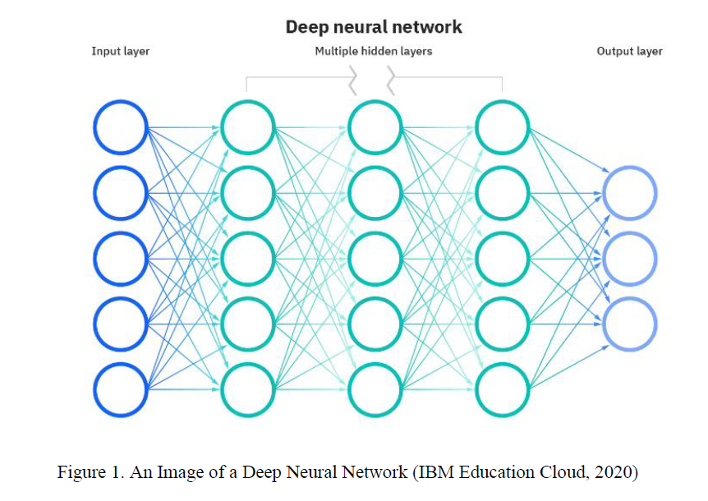

# **3.3 Activation function**

Activation functions serve as the gatekeepers of neural network dynamics, imbuing nodes with the power to unleash their transformative potential upon the input they receive. In the intricate dance of computation, activation functions orchestrate a symphony of activation signals, propelling neural networks towards the lofty heights of predictive prowess and adaptive resilience.

At its core, activation in neural networks entails the application of a function to the weighted sum of inputs, infusing the model with a dose of non-linearity that transcends the confines of linear computation. This injection of non-linearity serves as the catalyst for learning, enabling neural networks to decipher the intricate tapestry of complex patterns and relationships woven within the data.

The choice of activation function holds profound implications for the network's performance and efficacy, with each function bestowing a unique flavour of activation dynamics upon the neurons it governs. From the sigmoid gentle curvature to the ReLU's steadfast linearity, each activation function crafts a distinct landscape of activation thresholds and decision boundaries, shaping the neural network's ability to navigate the labyrinthine pathways of information flow.

Moreover, the selection of an activation function is not a trivial affair, but rather a nuanced decision informed by the specific nuances of the data and the exigencies of the task at hand. Whether grappling with image classification, natural language processing, or time series forecasting, the choice of activation function must align harmoniously with the intricacies of the problem domain, fostering convergence and enhancing the network's capacity for discernment and adaptation.

Thus, in the grand tapestry of neural network architecture, activation functions emerge as the silent architects of computation, sculpting the contours of neural dynamics and guiding the network towards the zenith of predictive acumen and adaptive resilience. Through their subtle modulation of activation signals, these functions illuminate the path towards computational enlightenment, empowering neural networks to transcend the boundaries of linear computation and embrace the boundless expanse of nonlinear data relationships.

Here are some commonly used activation functions:

1. **Sigmoid Activation Function:**

* It is a function which is plotted as **‘S’** shaped graph.
* **Equation:**A = 1 / (1 + e-x)
* **Nature:** Non-linear. Notice that X values lies between -2 to 2, Y values are very steep. This means, small changes in x would also bring about large changes in the value of Y.
* **Value Range:**0 to 1
* **Uses:**Usually used in output layer of a binary classification, where result is either 0 or 1, as value for sigmoid function lies between 0 and 1 only so, result can be predicted easily to be ***1*** if value is greater than **0.5** and ***0***

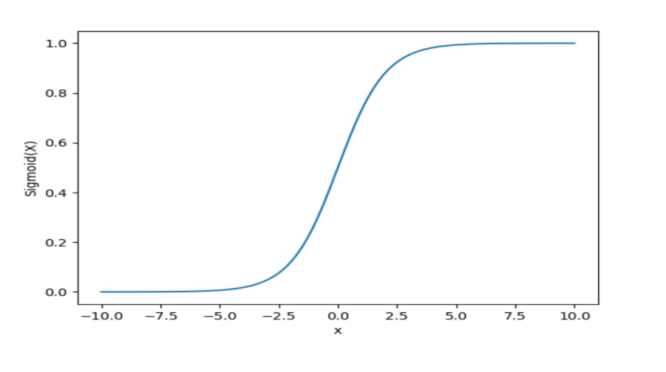

2. **Hyperbolic Tangent (tanh) Activation Function:**

* The activation that works almost always better than sigmoid function is Tanh function also known as **Tangent Hyperbolic function**. It’s actually mathematically shifted version of the sigmoid function. Both are similar and can be derived from each other.
* **Equation :-**

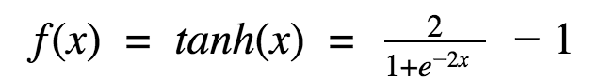

* **Value Range:-**-1 to +1
* **Nature: -**non-linear
* **Uses: -**Usually used in hidden layers of a neural network as it’s values lies between **-1 to 1**hence the mean for the hidden layer comes out be 0 or very close to it, hence helps in *centring the data* by bringing mean close to 0. This makes learning for the next layer much easier.

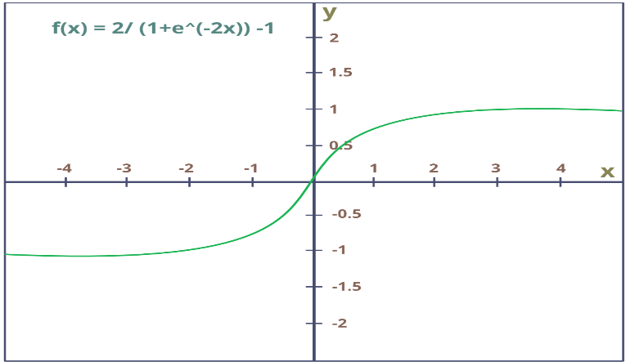

3. **Rectified Linear Unit (ReLU) Activation Function:**

* It Stands for *Rectified linear unit*. It is the most widely used activation function. Chiefly implemented in *hidden layers* of Neural network.
* **Equation: - *A(x) = max(0,x)***. It gives an output x if x is positive and 0 otherwise.
* **Value Range: -**[0, inf)
* **Nature: -**non-linear, which means we can easily backpropagate the errors and have multiple layers of neurons being activated by the ReLU function.
* **Uses: -**ReLu is less computationally expensive than tanh and sigmoid because it involves simpler mathematical operations. At a time only a few neurons are activated making the network sparse making it efficient and easy for computation.

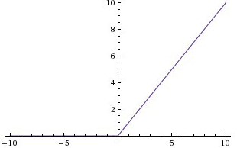

4. **Leaky ReLU Activation Function:**

Leaky Rectified Linear Unit (Leaky ReLU) is an activation function commonly used in neural networks, addressing the "dying ReLU" problem associated with the traditional Rectified Linear Unit (ReLU). The Leaky ReLU allows a small, non-zero gradient for negative inputs, preventing neurons from becoming completely inactive during training.

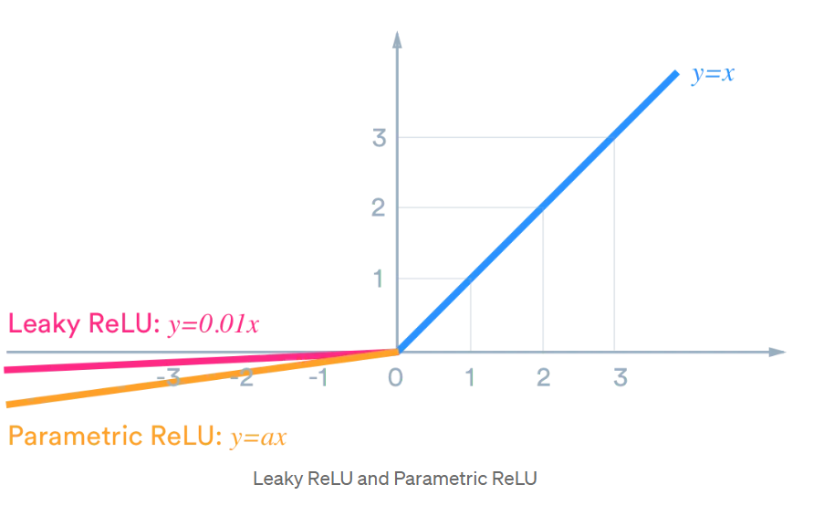

**f(y)=max(0.01*x , x).**

This function returns x if it receives any positive input, but for any negative value of x, it returns a really small value which is 0.01 times x. Thus it gives an output for negative values as well.

5. **Parametric ReLU (PReLU) Activation Function:**

Parametric Rectified Linear Unit (PReLU) is an extension of the Leaky Rectified Linear Unit (Leaky ReLU) activation function, where the slope of the negative part is not a fixed constant but is instead a learnable parameter. This allows the neural network to adapt and determine the optimal value for the slope during the training process.

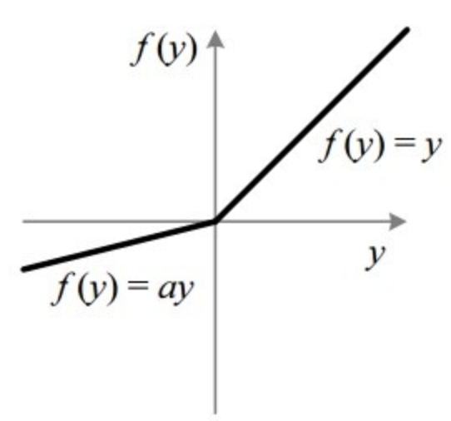

These activation functions introduce non-linearity to the neural network, enabling it to learn complex relationships in the data. The choice of activation function depends on the characteristics of the problem at hand, and researchers often experiment with different functions to find the one that works best for a particular task.

# **3.4 Gradient descent**

Gradient Descent is defined as one of the most commonly used iterative optimization algorithms of machine learning to train the machine learning and deep learning models. It helps in finding the local minimum of a function.

The best way to define the local minimum or local maximum of a function using gradient descent is as follows:

1. If we move towards a negative gradient or away from the gradient of the function at the current point, it will give the **local minimum** of that function.
2. Whenever we move towards a positive gradient or towards the gradient of the function at the current point, we will get the **local maximum** of that function.

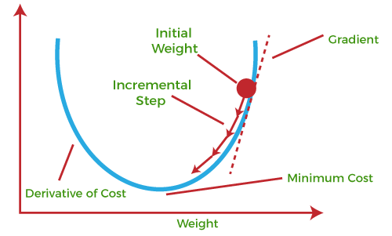

The main objective of using a gradient descent algorithm is to minimize the cost function using iteration***.*** To achieve this goal, it performs two steps iteratively:

* Calculates the first-order derivative of the function to compute the gradient or slope of that function.
* Move away from the direction of the gradient, which means slope increased from the current point by alpha times, where Alpha is defined as Learning Rate. It is a tuning parameter in the optimization process which helps to decide the length of the steps.

In neural networks, although the input can get the output value after the series of weights, bias and activation function calculation. But this is not enough for the training of the model. Accuracy is a very important thing for machine learning. Therefore, a value to evaluate the performance of a neural network needs to be introduced. This is the cost function, a value that measures the error gap between the predicted value of a neural network and the actual value of a data sample. The goal of gradient descent is considered to be minimizing the cost function, and minimizing the cost function then allows the model to be most accurate. Here are some key points about Gradient Descent:

1. **Optimization Algorithm:**

Gradient Descent, revered as a fundamental optimization algorithm in the realm of machine learning, serves as a beacon of efficiency and precision. Its primary objective? To navigate the complex terrain of mathematical functions, meticulously seeking the elusive nadir – the point of minimal value.

This iterative journey towards optimization unfolds through a series of calculated steps, each strategically crafted to inch closer to the ultimate goal: the minimum. With each iteration, Gradient Descent meticulously adjusts the parameters of the function, guided by the mathematical compass of gradients.

At its core, Gradient Descent embodies the essence of mathematical elegance, harnessing the power of calculus to compute the slope of the function at each point. This gradient provides invaluable insight, illuminating the direction of the steepest descent towards the coveted minimum.

Armed with this knowledge, Gradient Descent embarks on its quest, traversing the multidimensional landscape of function space with unwavering determination. With each calculated step, it descends towards the depths of optimization, driven by the singular purpose of minimizing the function's value.

In the ever-evolving tapestry of machine learning, Gradient Descent stands as a steadfast companion, guiding models towards the zenith of performance and efficiency. With its precision and ingenuity, it paves the way for advancements in predictive analytics, unlocking new realms of possibility in the quest for computational excellence.

2. **Minimization Objective:**

At the heart of Gradient Descent lies a noble purpose: the minimization of a function's value, a quest that finds particular resonance in the domain of machine learning. Here, amidst the intricate web of algorithms and models, Gradient Descent emerges as a trusted ally, wielding its optimization prowess to tackle the formidable challenge of minimizing cost or loss functions.

In the landscape of machine learning, where models strive to glean insights from data and make accurate predictions, the quest for optimization is paramount. Enter the cost or loss function, a faithful metric that quantifies the disparity between predicted outcomes and ground truth. It is this function that serves as the lodestar for Gradient Descent, guiding its meticulous descent towards the realm of minimal error.

With unwavering focus, Gradient Descent navigates the labyrinthine pathways of optimization, driven by the imperative to minimize the discrepancy encapsulated within the loss function. Each iteration brings it closer to this elusive objective, as it refines the parameters of the model with precision and diligence.

The significance of Gradient Descent in minimizing cost or loss functions transcends mere utility; it embodies the very essence of progress in machine learning. Through its tireless pursuit of optimization, Gradient Descent empowers models to learn from data, adapt to changing environments, and ultimately, unravel the intricate tapestry of knowledge hidden within vast datasets.

3. **Gradient Calculation:**

IWithin the iterative dance of Gradient Descent, each step is meticulously guided by the calculation of gradients, those vectors that illuminate the path toward optimization. As the algorithm embarks on each iteration, it embarks on a journey of discovery, seeking to unravel the intricate tapestry of the function's landscape.

At the heart of this journey lies the gradient, a mathematical construct that encapsulates the rate of change of the function with respect to its parameters. With each calculation, the algorithm unveils the direction of the steepest ascent, offering a beacon of guidance amidst the complexity of the function's domain.

Armed with this directional insight, Gradient Descent charts its course, navigating the terrain of the function's surface with precision and purpose. With each step, it endeavours to traverse the landscape in search of valleys, those elusive realms where the function's value reaches its nadir.

In the realm of machine learning, where optimization is the cornerstone of progress, the calculation of gradients assumes paramount importance. It is through this process that models glean insights from data, refine their parameters, and inch ever closer to the realm of optimal performance. Thus, within the intricate tapestry of Gradient Descent, the calculation of gradients emerges as a guiding light, illuminating the path toward the summit of optimization.

1. **Direction of Descent:** In the grand symphony of optimization, the direction of descent orchestrates the graceful movement of Gradient Descent towards the valleys of minimal function values. As the algorithm embarks on its iterative quest for optimization, it follows the siren call of the negative gradient, a beacon of guidance in the tumultuous sea of parameter space.

Within this ethereal realm, where gradients serve as celestial cartographers, the negative gradient emerges as a harbinger of progress. Like a compass needle pointing due south, it directs the algorithm towards the path of steepest decrease, beckoning it towards the tranquil embrace of minimal function values.

# In this dance of descent, each step is imbued with purpose and intent, as the algorithm traverses the undulating terrain of the function's landscape. With the negative gradient as its guiding star, Gradient Descent navigates the labyrinthine pathways of parameter space, steadfast in its pursuit of optimization.

# And so, with each iteration, the algorithm descends deeper into the abyss of function values, propelled by the gravitational pull of the negative gradient. Through this celestial choreography, Gradient Descent unravels the mysteries of optimization, forging a path towards the hallowed grounds of minimal function values.**4. Experimental Study**

This section is a crucial part of a research paper, outlining the detailed plan and procedures followed to conduct the study. Below is an elaboration of the methodology for a research study on "**Pneumonia Detection Using Machine Learning Algorithms**”.

I. **Data Collection:**

Dataset Source: The dataset is sourced from [Mooney, P. (2017). Chest X-Ray Images (Pneumonia). Kaggle.](https://www.kaggle.com/datasets/paultimothymooney/chest-xray-pneumonia), ensuring a diverse collection of chest X-ray images with labelled pneumonia and normal cases.

Data Diversity: To enhance diversity, the dataset includes images from different age groups, genders, and ethnicities, contributing to the generalizability of the models.

Quality Assurance: Only high-resolution images with clear indications of pneumonia are included, ensuring data quality for robust model training.

II. **Data Preprocessing:**

Data preprocessing, akin to refining raw ingredients before a culinary masterpiece, is essential for crafting robust and reliable machine learning models. Here's a breakdown of the preprocessing steps often undertaken to whip raw data into shape:

1. Image Resizing: Just as a chef meticulously cuts ingredients to uniform sizes, resizing images to a standard dimension ensures consistency in the dataset. This step not only streamlines computational operations but also mitigates potential distortions caused by varying image dimensions.

2. Pixel Value Normalization: Like balancing flavours in a recipe, normalizing pixel values harmonizes the intensity range across images, enhancing model convergence and performance. By scaling pixel values to a consistent range (e.g., 0 to 1), normalization facilitates smoother gradient descent during model training.

3. Data Augmentation: Much like adding spices to enhance flavour, data augmentation injects variety and richness into the dataset, fortifying the model against overfitting and enhancing its generalization capabilities. Techniques such as rotation, flipping, and subtle adjustments to brightness and contrast breathe new life into the dataset, exposing the model to a diverse array of scenarios and perspectives.

By meticulously preparing and refining the dataset through resizing, normalization, and augmentation, data preprocessing lays the foundation for a robust and resilient machine learning model, poised to tackle real-world challenges with confidence and efficacy.

III. **Dataset:**

Size and Composition:

The dataset consists of 5,863 images, divided into 2 categories, ensuring a balanced representation of pneumonia-positive and pneumonia-negative cases.

Preprocessing Steps:

1. Standardized Resolution: All images undergo resizing to a standardized resolution, ensuring uniformity across the dataset. This step harmonizes the dimensions of images, streamlining computational processes and avoiding distortions caused by varying sizes.

2. Pixel Value Normalization: Normalization techniques are applied to standardize pixel values across images. By scaling pixel intensities to a consistent range, typically between 0 and 1, normalization enhances model convergence and performance, facilitating smoother gradient descent during training.

3. Augmentation: To enrich the dataset and bolster model generalization, augmentation techniques are introduced. These techniques, including rotation, flipping, and adjustments to brightness and contrast, inject variability into the dataset, exposing the model to a diverse range of scenarios and perspectives. This augmentation strategy fortifies the model against overfitting and equips it to handle real-world data with greater robustness.

**4.1 CNN:**

A Convolutional Neural Network (CNN) is a type of deep neural network designed for processing and analysing visual data, such as images and videos. It's a powerful architecture for tasks like image classification, object detection, and segmentation. CNNs are particularly effective in capturing spatial hierarchies and patterns through the application of convolutional operations.

**The convolution process is illustrated below:**

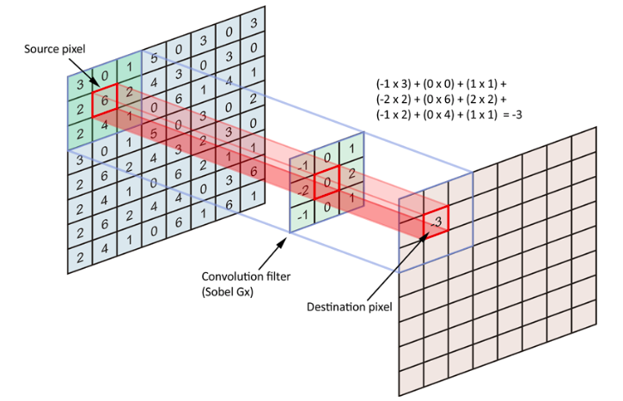

Using convolution filters with different dimensions or values results in different features extracted.

Features are then detected using the reLu activation on each destination pixel.

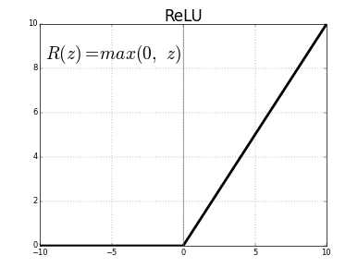

Features are the enhanced with Max Pool layers.

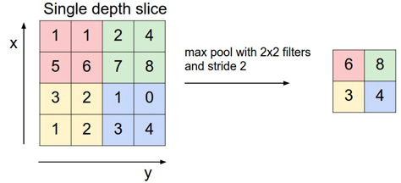

The stride parameters determine the distance between each filter. The padding one determines if we ignore the borderline pixels or not (adding zeros helps the neural network to get information on the border)

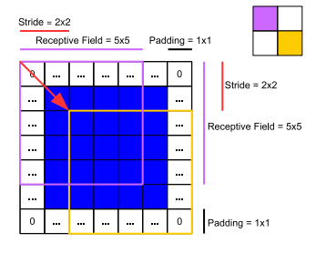

The output is then concatenated in Dense layer.

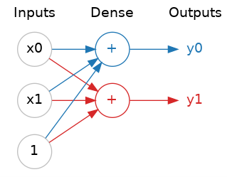

By using a sigmoid activation, the neural network decides which class the image belongs to.

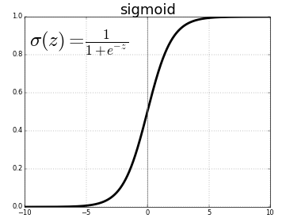

Convolutional Neural Networks (CNNs) are a class of deep neural networks designed for tasks involving images and spatial data. Several key components and concepts are associated with CNNs:

**i). Convolutional Layers:**

- Convolutional layers serve as the bedrock of Convolutional Neural Networks (CNNs), heralding a transformative era in the realm of computer vision and pattern recognition. These layers, akin to the neurons in biological visual systems, operate by convolving input data with a set of learnable filters, also known as kernels. Through this convoluted lens, CNNs dissect raw input images into a mosaic of local regions, each harbouring distinct features and textures waiting to be unravelled. The magic of convolution lies in its ability to distil complex spatial hierarchies and intricate patterns, allowing the network to discern subtle nuances and salient features amidst the pixelated landscape. With each convolutional operation, the network embarks on a journey of discovery, traversing the multidimensional canvas of the input data to uncover hidden treasures of information. Through the interplay of convolutional layers, CNNs orchestrate a symphony of feature extraction, transforming raw pixels into abstract representations imbued with semantic meaning. In essence, convolutional layers serve as the vigilant gatekeepers of visual data, ushering it through a transformative process that empowers machines to perceive, comprehend, and interpret the world with unparalleled acuity and insight.

**ii. Filters and Kernels:**

- Filters, also known as kernels, stand as the vanguards of feature extraction in the realm of convolutional operations within neural networks. These diminutive matrices, often no larger than a few pixels, embark on a journey across the vast expanse of input data, traversing its multidimensional terrain with purpose and precision. With each stride, these filters engage in a delicate dance of element-wise multiplications and aggregations, probing the depths of the input space to discern hidden patterns and salient features. Through the alchemy of convolution, these filters serve as the artisans of abstraction, distilling raw data into a tapestry of meaningful representations. What sets filters apart is their innate capacity to adapt and evolve, for they are not static entities but dynamic entities sculpted by the crucible of learning. As the network navigates the seas of training data, these filters undergo a metamorphosis, honing their edge to capture increasingly nuanced facets of the input landscape. Through the crucible of backpropagation, the network refines its filters, sculpting them into instruments finely tuned to extract the most relevant features from the cacophony of input data. In this symphony of learning, filters emerge as the silent sentinels, silently shaping the network's perception and understanding of the world.

**iii. Pooling Layers:**

- Pooling layers, revered companions to convolutional layers in the pantheon of neural network architectures, stand as the gatekeepers of spatial reduction and dimensionality control. In the grand tapestry of deep learning, these layers wield their power of down samplling with precision and finesse, orchestrating a symphony of transformation that balances information retention with computational efficiency.

Max pooling and average pooling, the stalwarts of this domain, emerge as the architects of dimensionality reduction, their methodologies finely tuned to distil the essence of input data while discarding extraneous minutiae. In the realm of max pooling, the sentinel of simplicity and efficacy, each spatial region undergoes rigorous scrutiny, with only the most salient feature triumphantly elevated to represent the entire domain. Through this process of maximal selection, the pool of information is distilled to its quintessence, preserving the core while shedding the periphery.

On the other hand, average pooling, the paragon of equilibrium and uniformity, adopts a more egalitarian approach, where every element within the spatial domain contributes equally to the collective whole. Through the egalitarian lens of averaging, the pool of information converges towards a harmonious equilibrium, smoothing out fluctuations and tempering extremes to reveal the underlying essence of the data.

In the crucible of training, these pooling layers stand as bulwarks against overfitting and computational extravagance, sculpting the input landscape into a lean, yet potent, representation of essential features. With each stride towards down sampling , these layers forge a path towards computational parsimony, where complexity yields to clarity, and signal triumphs over noise. In this dance of reduction and refinement, pooling layers emerge as the unsung heroes of neural network architectures, their contributions vital yet often overlooked, as they pave the way towards computational efficiency and model robustness.

**iv. Activation Functions:**

- Activation functions, the veritable lifeblood of neural networks, infuse these computational behemoths with the transformative power to transcend the confines of linearity and embrace the boundless expanse of nonlinearity. In the illustrious realm of Convolutional Neural Networks (CNNs), these activation functions stand as the sentinels of complexity, orchestrating a symphony of nonlinear mappings that unravel the intricate relationships between inputs and outputs.

At the vanguard of this revolution stands the Rectified Linear Unit (ReLU), a beacon of simplicity and efficiency that reigns supreme in the pantheon of activation functions. With its elegant simplicity and computational expediency, ReLU bestows upon neural networks the gift of nonlinear activation, propelling them towards convergence with unprecedented speed and efficacy.

Yet, amidst the cacophony of activation functions, the Sigmoid function emerges as a stalwart of probabilistic enlightenment, casting its sigmoidal charm upon neural networks with the grace and finesse of a seasoned sage. With its gentle modulation of neuron activation, Sigmoid engenders a realm of probabilistic discernment, guiding neural networks towards nuanced decision-making and categorical enlightenment.

Meanwhile, the Hyperbolic Tangent (tanh) function stands as a paragon of symmetry and balance, its oscillatory embrace traversing the entire real number spectrum with unwavering poise and equilibrium. Nestled within the recesses of hidden layers, tanh emerges as a steadfast ally, its symmetrical activation dynamics fostering convergence and stability amidst the tumultuous currents of computation.

In the tapestry of CNNs, these activation functions weave a narrative of complexity and adaptability, their nonlinear transformations guiding neural networks towards the zenith of predictive acumen and adaptive resilience. With each invocation, they breathe life into the latent potential of neural networks, empowering them to unravel the mysteries of complex mappings and unlock the secrets hidden within vast troves of data.

**v. Fully Connected Layers:**

- Fully connected layers, the stalwarts of traditional neural networks, stand as bastions of interconnectedness and computational prowess within the intricate architecture of Convolutional Neural Networks (CNNs). In these layers, every neuron forms a symbiotic relationship with every neuron in the preceding and succeeding layers, creating a dense web of connections that traverses the depths of the network.

In the grand tapestry of a CNN, fully connected layers often find their rightful place in the latter stages, where they serve as the harbingers of classification and decision-making. Here, amidst the labyrinthine pathways of computation, these layers harness the collective intelligence of interconnected neurons to distil complex feature representations into actionable insights.

As the final frontier in the quest for understanding, fully connected layers bear the weight of classification tasks with unwavering resolve. With each neuron acting as a sentinel of knowledge, they sift through the intricate nuances of feature maps, discerning patterns and relationships with unparalleled precision.

In the crucible of classification, fully connected layers stand as beacons of computational ingenuity, their dense interconnections forging a pathway to enlightenment amidst the chaos of raw data. With each connection, they weave a tapestry of understanding, unraveling the mysteries of the unseen and charting a course towards predictive mastery.

**vi. Striding:**

-Striding, the silent conductor orchestrating the convolutional symphony, dictates the rhythm with which filters traverse the expanse of input data in a Convolutional Neural Network (CNN). Like a choreographer guiding dancers across a stage, striding determines the pace and spacing of filter movement, shaping the spatial dimensions of the resulting feature maps.

With each stride, the filter takes a step forward, shifting its focus to a new patch of the input data. The size of this step, akin to the beat in a musical composition, governs the degree of overlap between neighbouring regions covered by the filter. A larger stride introduces more space between filter placements, reducing overlap and consequently shrinking the spatial dimensions of the output feature maps.

In the intricate ballet of convolution, striding plays a pivotal role in sculpting the contours of feature representations. By adjusting the tempo of filter movement, striding influences the granularity of spatial information captured by the network. Fine-tuning the stride size allows for delicate balance between detail preservation and computational efficiency, guiding the network towards optimal performance on diverse datasets.

**vii. Padding:**

- Padding, the silent guardian of spatial integrity in Convolutional Neural Networks (CNNs), stands as a bulwark against the erosion of spatial dimensions during convolutional operations. Like a buffer zone encircling a precious artifact, padding envelops the input data with additional pixels, safeguarding its borders and preserving spatial fidelity throughout the convolutional journey.

In the realm of CNNs, convolutional filters traverse the input data, extracting features with each stride. However, at the edges of the input, the filter encounters a dilemma – incomplete exposure to neighbouring pixels, leading to diminished feature extraction potential. Padding comes to the rescue, extending the boundaries of the input by appending extra rows and columns of pixels, thereby ensuring that every pixel receives equal treatment during convolution.

By augmenting the input with padding, CNNs avert the peril of information loss at the fringes, maintaining spatial consistency and enabling robust feature extraction across the entire input space. Whether navigating the intricate contours of an image or deciphering the nuances of spatial relationships, padding fortifies the foundation of CNNs, empowering them to unravel complex patterns with unwavering precision.

**viii. Batch Normalization:**

- Batch Normalization emerges as a beacon of stability and efficiency in the tumultuous seas of deep learning, bestowing neural networks with the gift of normalized inputs and accelerated convergence. This transformative technique operates at the heart of each layer within a mini-batch, harmonizing the disparate input distributions and fostering a climate of uniformity and equilibrium.

At its core, Batch Normalization serves as a bulwark against the perils of internal covariate shift, shielding neural networks from the disruptive forces of fluctuating input distributions. By normalizing the input of each layer, Batch Normalization ensures that the network traverses the landscape of parameter space with steadfast consistency, mitigating the risk of vanishing or exploding gradients that threaten to derail the training process.

In the crucible of deep learning, where even minor perturbations can reverberate through the network, Batch Normalization stands as a stalwart guardian, ushering stability and efficiency into the training regimen. With its transformative influence, Batch Normalization empowers neural networks to navigate the complexities of high-dimensional data with grace and resilience, paving the way for accelerated convergence and heightened predictive performance.

**ix. Dropout**

- Dropout emerges as a silent sentinel in the battle against overfitting, wielding its randomized power to sculpt neural networks into bastions of robustness and generalization. This ingenious regularization technique, akin to a judicious pruning of the network's branches, operates by selectively deactivating a fraction of neurons during each training iteration, instilling resilience and adaptability in the face of data variability.

In the crucible of deep learning, where the siren song of overfitting threatens to lure networks astray, Dropout stands as a steadfast guardian of model integrity. By introducing controlled chaos into the network's architecture, Dropout compels neurons to stand on their own merits, fostering the emergence of diverse and discriminative feature representations.

With each epoch, Dropout fosters a crucible of resilience within the network, fortifying its defense against the specter of overfitting. Through its stochastic intervention, Dropout imbues neural networks with the capacity to discern signal from noise, navigating the treacherous seas of high-dimensional data with grace and precision.

In the tapestry of regularization techniques, Dropout shines as a beacon of innovation, illuminating the path to model robustness and generalization. With its transformative influence, Dropout empowers neural networks to transcend the shackles of overfitting, embarking on a journey towards predictive mastery and resilience.

**x. Transfer Learning**

- Transfer learning emerges as a beacon of hope in the realm of deep learning, offering a lifeline to models adrift in the turbulent seas of limited data. This transformative technique leverages the knowledge encoded in pre-trained CNN models, honed on vast datasets like ImageNet, to kickstart the learning journey on new, more specialized tasks.

At its core, transfer learning embodies the philosophy of standing on the shoulders of giants, harnessing the wealth of insights gleaned from large-scale datasets to illuminate the path forward. Rather than laboriously starting from scratch, transfer learning empowers models to inherit the wisdom distilled from diverse domains, accelerating their trajectory towards mastery.

The process unfolds in two distinct phases: feature extraction and fine-tuning. During feature extraction, the pre-trained model's convolutional base acts as an immutable foundation, extracting high-level features from the input data. These features serve as potent building blocks for the task at hand, enabling the model to discern meaningful patterns even in the absence of abundant data.

In the subsequent fine-tuning phase, the model's parameters undergo a process of refinement, attuning themselves to the nuances of the target task. Through iterative adjustments guided by task-specific data, the model refines its representations, honing its predictive acumen and adaptability to the intricacies of the new domain.

By embarking on this dual-pronged journey of feature extraction and fine-tuning, transfer learning empowers models to transcend the constraints of limited data, unlocking the full spectrum of their predictive potential. With each iteration, these models ascend to new heights of performance, guided by the guiding light of knowledge inherited from their pre-trained predecessors.

**xi. Data Augmentation**

- Data augmentation emerges as a beacon of versatility in the realm of deep learning, infusing the training pipeline with a dynamic array of transformations that breathe life into the input data. By subjecting the dataset to a symphony of random perturbations—rotation, scaling, flipping, and beyond—data augmentation bestows upon the model a robust resilience against the capricious whims of variability.

At its essence, data augmentation embodies the philosophy of embracing diversity, enriching the training corpus with a kaleidoscope of variations that mirror the real-world intricacies of the target domain. Rather than fixating on a static, unyielding dataset, data augmentation invites models to dance amidst a whirlwind of transformations, cultivating a nuanced understanding of the underlying data manifold.

The augmentation process unfolds as a symphony of creativity, with each transformation imbuing the input data with newfound vitality and depth. Rotation introduces a playful twist, shifting perspectives and illuminating novel angles of insight. Scaling extends a helping hand, stretching the boundaries of imagination to encompass a broader spectrum of possibilities. Flipping mirrors the dance of symmetry, reflecting the multifaceted nature of reality in its mirrored embrace.

Through this tapestry of transformations, data augmentation nurtures a model's adaptability, fortifying its resilience against the vagaries of unseen variations. By exposing the model to a rich tapestry of augmented data during training, data augmentation imbues it with a keen intuition for the myriad manifestations of reality, empowering it to generalize with grace and confidence.

In the crucible of training, data augmentation emerges as a steadfast ally, sculpting models that are not merely adept at navigating the familiar terrain of the training set but also poised to conquer the uncharted territories of real-world deployment. With each augmentation, models embark on a voyage of discovery, charting a course towards predictive mastery amidst the boundless expanse of data diversity.

**xii. Object Localization and Detection**

- Extending the horizons of convolutional neural networks (CNNs), object localization and detection tasks beckon as uncharted frontiers, inviting the integration of novel layers and techniques to unravel the mysteries of spatial awareness and perceptual acuity.

At the heart of this evolution lies a symphony of architectural innovations, where CNNs transcend their traditional confines to embrace the complexities of object localization and detection. Anchored in the rich tapestry of convolutional layers, these networks embark on a journey of discovery, harnessing the power of anchor boxes, region proposals, and non-maximum suppression to navigate the labyrinthine pathways of spatial cognition.

Anchor boxes emerge as beacons of geometric intuition, imbuing CNNs with the ability to localize objects across a spectrum of scales and aspect ratios. By anchoring the network's gaze to a predefined grid of bounding boxes, anchor boxes pave the way for robust object localization, enabling the network to cast its net wide and capture the elusive essence of spatial context.

Region proposals unfurl as harbingers of selective attention, guiding the network's gaze towards salient regions of interest amidst the visual tapestry. Through a delicate interplay of convolutional layers and proposal mechanisms, region proposals sculpt a landscape of spatial awareness, empowering the network to hone in on the most pertinent cues amidst the cacophony of visual stimuli.

Non-maximum suppression emerges as a sentinel of discernment, sifting through the deluge of candidate detections to distil a refined ensemble of object hypotheses. With a judicious blend of thresholding and suppression, non-maximum suppression prunes the detection landscape, ensuring that only the most salient and non-overlapping object proposals endure the crucible of scrutiny.

In this symphony of spatial cognition, CNNs transcend their traditional role as mere classifiers, evolving into veritable maestros of object localization and detection. Through the fusion of anchor boxes, region proposals, and non-maximum suppression, these networks emerge as torchbearers of perceptual acuity, navigating the rich tapestry of visual data with grace and precision.

**4.2 ResNet:**

ResNet, an abbreviated form of Residual Network, represents a groundbreaking paradigm shift in the realm of deep convolutional neural network architectures, conceived to surmount the formidable challenges inherent in training exceedingly deep networks. Originating from the visionary minds of Kaiming He, Xiangyu Zhang, Shaoqing Ren, and Jian Sun, ResNet unfurled its transformative potential in their seminal 2016 treatise titled "Deep Residual Learning for Image Recognition."

At the core of ResNet's revolutionary framework lies a pivotal innovation: the integration of residual blocks, heralding a new era in the training of neural networks of unprecedented depth. In stark contrast to conventional deep networks bedevil by the vexing specter of the vanishing gradient problem, ResNet's ingenious architecture circumvents this obstacle with aplomb. Central to this feat are the ingenious skip connections, alternatively dubbed identity shortcuts, interwoven into the fabric of ResNet's residual blocks.

These skip connections forge direct pathways that bypass certain layers within the network, facilitating the unimpeded flow of information from earlier to later layers. This strategic detour empowers ResNet to gracefully navigate the treacherous depths of its architecture, ensuring that the gradients flowing backward during training remain potent and efficacious. By circumventing the perils of gradient degradation, ResNet transcends the limitations of its predecessors, emboldening practitioners to delve into realms of depth previously deemed inaccessible.

In essence, ResNet stands as a beacon of innovation, heralding a paradigm shift in the landscape of deep learning. Through its elegant fusion of residual blocks and skip connections, ResNet beckons forth a new era of neural network architectures, emboldening researchers and practitioners alike to push the boundaries of depth and sophistication in pursuit of ever-greater feats of artificial intelligence.

ResNet's profound impact reverberates across a myriad of domains, catalysing advancements in image recognition, object detection, semantic segmentation, and beyond. Its resilience in traversing the labyrinthine depths of neural architectures instils newfound confidence in the quest for ever-deeper models capable of unraveling the intricacies of real-world data.

Moreover, ResNet's legacy extends far beyond its immediate architectural confines, serving as a lodestar for subsequent innovations in deep learning. Its pioneering spirit imbues the research community with a sense of audacity, inspiring the conception of novel architectures and methodologies that push the envelope of what's achievable in artificial intelligence.

Indeed, ResNet's enduring legacy stands as a testament to the power of ingenuity and perseverance in the face of seemingly insurmountable challenges. As the torchbearer of deep neural network architectures, ResNet beckons forth a future teeming with possibilities, where the frontiers of artificial intelligence are limited only by the bounds of human imagination.

In the annals of machine learning history, ResNet stands tall as a paragon of innovation, a testament to the indomitable spirit of exploration, and a harbinger of a future where the depths of neural architectures know no bounds.

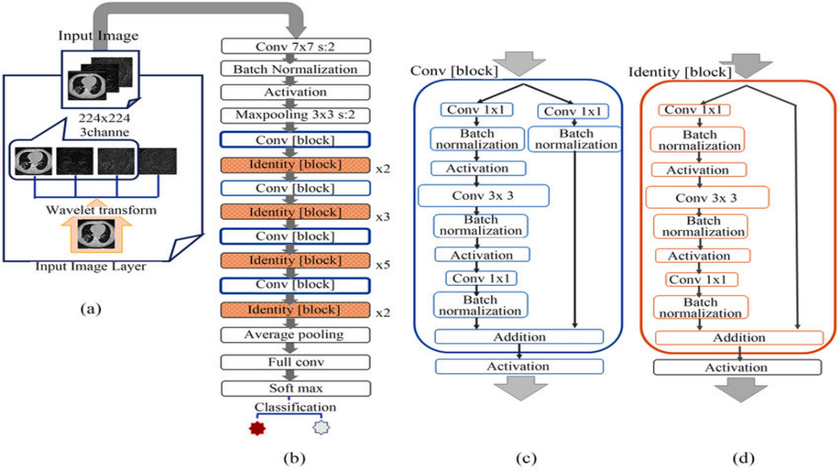

Key Components of ResNet:

1. **Residual Blocks:**

ResNet's revolutionary approach hinges on the ingenious concept of residual learning, which fundamentally alters the paradigm of information flow within neural networks. Unlike traditional architectures that strive to directly learn the mapping from input to output, ResNet embraces a more nuanced strategy by focusing on learning residual mappings.

At the heart of this transformative methodology lies the residual block, a quintessential building block that embodies the essence of ResNet's innovation. Within the confines of a residual block, the network endeavours to learn the residual function, denoted as \( F(x) \), which represents the deviation from the identity mapping. Rather than replacing the original input \( x \) entirely, the output of the residual block is computed as the sum of the input and the learned residual, symbolized as \( y = F(x) + x \).

This seemingly subtle shift in approach yields profound implications for the network's capacity to navigate the complexities of deep architectures. By incorporating skip connections that directly link input and output across residual blocks, ResNet fosters an unimpeded pathway for gradient propagation during backpropagation. This strategic maneuver effectively mitigates the notorious vanishing gradient problem that has long plagued the training of deep neural networks, ensuring the smooth transmission of gradient signals across layers.

In essence, ResNet's pioneering utilization of residual learning and skip connections heralds a new era in deep neural network architecture, characterized by unprecedented depth, efficiency, and efficacy. By embracing the power of residual mappings and fostering seamless gradient flow, ResNet empowers neural networks to scale the dizzying heights of complexity and sophistication, forging pathways to unparalleled realms of performance and understanding.

2. **Identity Shortcuts:**

Indeed, the skip connections employed in ResNet embody a conceptually elegant simplicity, operating as identity mappings that seamlessly shuttle the input directly to the output, unfettered by any intermediary transformations. By preserving the raw input signal through these skip connections, ResNet bestows upon the network a remarkable degree of flexibility and adaptability, enabling it to navigate the intricate landscape of layer interactions with unparalleled dexterity.

The intrinsic virtue of identity mappings lies in their innate capacity to facilitate the learning of residual functions in a manner that is both efficient and robust. By allowing the network to effectively "skip" certain layers during the forward pass if they fail to contribute meaningfully to the learning process, these identity mappings serve as gateways to expedited training and enhanced convergence. Moreover, they afford the network the freedom to dynamically adjust its architecture based on the exigencies of the task at hand, seamlessly bypassing superfluous layers while focusing its computational resources on regions of paramount importance.

This elegant strategy of leveraging identity mappings as skip connections not only imbues ResNet with unparalleled prowess in training very deep networks but also endows it with a graceful resilience in the face of architectural complexity. By embracing the simplicity of direct input-output mappings, ResNet charts a course towards greater efficiency, efficacy, and elegance in the realm of deep learning architecture, paving the way for unprecedented advancements in model depth, sophistication, and performance.

3. **Network Architecture:**

Indeed, the ResNet family encompasses a spectrum of architectures, each distinguished by its depth and complexity, with the numerical suffix denoting the total number of layers within the network. Ranging from the relatively compact ResNet-18 to the imposing ResNet-152, these variants traverse the landscape of architectural intricacy with a singular objective: to unlock the latent potential of very deep neural networks.

As the depth of ResNet architectures increases, so too does their capacity to discern intricate patterns and extract meaningful features from raw input data. Deeper networks possess a heightened sensitivity to nuanced spatial hierarchies and abstract representations, enabling them to tackle increasingly complex computer vision tasks with unprecedented acumen and efficacy.

The empirical evidence attests to the superior performance of deeper ResNet architectures across a panoply of computer vision benchmarks, including image classification, object detection, and semantic segmentation. By harnessing the power of architectural depth, ResNet variants such as ResNet-50, ResNet-101, and ResNet-152 have emerged as stalwarts of the deep learning landscape, achieving state-of-the-art results on diverse datasets and setting new benchmarks for model performance and scalability.

In essence, the evolution of ResNet architectures embodies a relentless quest for greater depth, sophistication, and expressiveness in the realm of computer vision, culminating in a pantheon of models that stand as testament to the transformative potential of very deep neural networks.

4. **Global Average Pooling (GAP):**

Indeed, in the grand tapestry of ResNet architectures, global average pooling (GAP) emerges as a pivotal departure from traditional fully connected layers, revolutionizing the landscape of feature aggregation and model regularization.

At the terminus of the network's convolutional journey, where the rich tapestry of feature maps unfolds in all its complexity, traditional architectures would invariably resort to fully connected layers, stitching together the myriad threads of spatial information into a dense fabric of connectivity. Yet, ResNet, with its unwavering commitment to innovation and efficiency, opts for a more elegant solution: global average pooling.

In essence, global average pooling distil the essence of each feature map into a single scalar value, averaging the spatial dimensions to extract the most salient features while discarding extraneous details. This act of spatial compression not only imbues the network with a form of implicit regularization, mitigating the risk of overfitting, but also dramatically reduces the model's parameter count, fostering a leaner, more streamlined architecture.

By eschewing the conventional paradigm of fully connected layers in favour of global average pooling, ResNet achieves a harmonious synthesis of simplicity and sophistication, harnessing the power of spatial abstraction to distil complex feature representations into their most essential forms. In doing so, ResNet reaffirms its status as a vanguard of architectural innovation, setting new standards for efficiency, scalability, and performance in the ever-evolving landscape of deep learning.

**Benefits of ResNet:**

ResNet, short for Residual Networks, is a type of deep neural network architecture that has gained popularity and achieved remarkable success in various computer vision tasks, particularly image classification. Here are some of the key benefits of ResNet:

**i. Deep Network Training:**

- Absolutely, ResNet's groundbreaking approach to tackling the challenges of deep neural network training has revolutionized the landscape of deep learning, ushering in an era of unprecedented depth and complexity without succumbing to the perils of vanishing gradients or performance degradation.

At the heart of ResNet's transformative power lies its ingenious solution to the age-old problem of training very deep networks. By introducing residual connections, ResNet provides a direct conduit for the flow of gradients during backpropagation, circumventing the obstacles posed by vanishing gradients that plagued earlier architectures. This revolutionary design allows for the efficient propagation of information through hundreds or even thousands of layers, ensuring that each layer can contribute meaningfully to the learning process without being impeded by diminishing gradients.

The residual connections in ResNet serve as architectural scaffolding, providing a sturdy framework upon which deep networks can be constructed and optimized with remarkable ease. By decoupling the learning process from the inherent challenges of depth, ResNet empowers practitioners to explore the boundless depths of neural network architectures, unlocking new frontiers of performance and capability.

In essence, ResNet's legacy lies not only in its ability to train exceptionally deep networks but also in its democratization of deep learning, making the formidable power of deep neural networks accessible to a broader community of researchers, engineers, and enthusiasts. As a testament to its enduring impact, ResNet continues to serve as a guiding light in the quest for ever-deeper insights and ever-more powerful models in the realm of artificial intelligence.

**ii. Residual Blocks:**

- Indeed, the residual block lies at the core of ResNet's architectural brilliance, embodying a paradigm shift in the way deep neural networks are designed and trained. By integrating skip connections within each block, ResNet pioneers a transformative approach to gradient flow, thereby circumventing the pitfalls of the vanishing gradient problem that have long plagued traditional deep networks.

At its essence, the residual block embodies a profound departure from conventional neural network architectures. Rather than striving to learn the direct mapping from input to output, as conventional networks do, ResNet adopts a more nuanced strategy: learning the residual mapping. This fundamental shift in perspective empowers ResNet to focus on capturing the deviations or residuals between the input and output, rather than attempting to encode the entire transformation within each block.

The inclusion of skip connections within the residual block serves as a conduit for the uninhibited flow of gradients during backpropagation, ensuring that the network can effectively propagate error signals across hundreds or even thousands of layers. This alleviates the vanishing gradient problem that typically arises in deep networks, where gradients diminish exponentially as they traverse deeper layers, thereby impeding the learning process.

By providing shortcut connections that bypass certain layers, the residual block empowers the network to dynamically adapt its depth and complexity based on the demands of the task at hand. Layers that contribute minimally to the learning process can be effectively bypassed, allowing the network to allocate computational resources more efficiently and focus on learning higher-level abstractions.

In essence, the residual block embodies a fundamental principle of deep learning: embracing the inherent non-linearity and complexity of real-world data by enabling networks to learn residual representations. This innovative approach not only mitigates the challenges posed by training very deep networks but also unlocks new frontiers of performance and scalability in the realm of artificial intelligence. As a cornerstone of the ResNet architecture, the residual block stands as a testament to the transformative power of innovative thinking and creative problem-solving in the field of deep learning.

**iii. Improved Convergence:**

- Absolutely, the inclusion of residual connections within the ResNet architecture serves as a catalyst for the convergence of the training process, accelerating learning dynamics and enhancing the overall efficiency of the model.

At its core, the residual learning framework embodies a philosophy of efficiency and adaptability, empowering the model to navigate the complex landscape of optimization with newfound agility and resilience. By incorporating skip connections that bypass certain layers, ResNet liberates the network from the constraints of rigid layer-to-layer dependencies, enabling it to dynamically adapt its learning trajectory based on the demands of the task at hand.

One of the key advantages afforded by residual connections is their ability to expedite convergence by focusing on learning residual information. Rather than laboriously attempting to encode the entirety of the transformation within each block, the model can leverage skip connections to bypass unnecessary layers and home in on the residual deviations between input and output. This streamlined approach to learning not only accelerates convergence but also enhances the model's capacity to extract meaningful features and patterns from the data.

Moreover, the presence of residual connections imbues the network with a robustness and resilience that transcends traditional architectures. By providing alternate pathways for the flow of gradients during backpropagation, residual connections mitigate the risk of vanishing gradients and facilitate more efficient error propagation across multiple layers. This fosters a more stable and consistent learning process, reducing the likelihood of stagnation or divergence during training.

In essence, residual connections serve as a beacon of efficiency and adaptability within the ResNet framework, illuminating a path towards faster convergence and more effective optimization. By harnessing the power of skip connections to focus on learning residual information, ResNet empowers neural networks to transcend the limitations of conventional architectures and unlock new frontiers of performance and scalability in the realm of deep learning.

**iv. Parameter Efficiency:**

-Indeed, the efficiency of ResNet architectures in terms of parameter utilization stands as a testament to the transformative power of skip connections in deep neural networks.

Traditional deep architectures, devoid of skip connections, often grapple with the challenge of parameter proliferation, necessitating an ever-expanding network capacity to achieve comparable performance. However, ResNet architecture introduces a paradigm shift in parameter efficiency by leveraging skip connections to streamline the learning process and optimize parameter utilization.

At the heart of this efficiency lies the fundamental principle of residual learning, where skip connections facilitate the direct propagation of gradients through the network, effectively bypassing unnecessary layers and reducing the burden on individual parameters. This streamlined approach to parameter utilization enables ResNet architectures to achieve superior performance with a fraction of the parameters required by traditional architectures, thereby unlocking new frontiers of computational efficiency and scalability.

By judiciously allocating parameters to the most salient features and patterns in the data, ResNet architectures strike a delicate balance between model complexity and performance, harnessing the power of skip connections to achieve optimal parameter efficiency. This not only translates into significant savings in computational resources but also enhances the model's ability to generalize and adapt to diverse datasets and tasks.

In essence, ResNet architectures epitomize the ethos of efficiency in deep learning, revolutionizing the landscape of parameter utilization and paving the way for a new generation of computationally efficient neural networks. By embracing the power of skip connections, ResNet architectures usher in a new era of parameter-efficient deep learning, where performance and scalability converge to redefine the boundaries of what is possible in artificial intelligence.

**v. Higher Accuracy:**

- Indeed, ResNet architectures have emerged as a cornerstone in the realm of computer vision, setting new benchmarks for accuracy and generalization across a myriad of tasks.

In the ever-evolving landscape of deep learning, the quest for higher accuracy and improved generalization remains paramount. Traditional deep learning architectures, while formidable in their own right, often grapple with the challenges of vanishing gradients, parameter inefficiency, and degradation, hindering their ability to achieve optimal performance on complex tasks.

Enter ResNet architectures, with their revolutionary approach to deep learning. By introducing skip connections and residual blocks, ResNet architectures effectively mitigate the vanishing gradient problem, enabling the training of exceptionally deep networks with hundreds or even thousands of layers. This newfound depth empowers ResNet architectures to capture intricate patterns and features in data, facilitating more nuanced and accurate predictions across a wide spectrum of computer vision tasks.

Moreover, the parameter-efficient nature of ResNet architectures allows for superior generalization, ensuring that the model can effectively extrapolate from training data to unseen examples. The skip connections in ResNet architectures facilitate the direct propagation of gradients through the network, enabling smoother optimization and convergence during training. This, in turn, leads to enhanced generalization performance, as the model can effectively distil essential features from the data and adapt to diverse inputs with greater robustness.

From image classification to object detection and beyond, ResNet architectures have demonstrated their prowess across a myriad of computer vision tasks. Their ability to achieve higher accuracy and better generalization has cemented their status as indispensable tools in the deep learning practitioner's toolkit, unlocking new frontiers of performance and paving the way for groundbreaking advancements in artificial intelligence. As the field continues to evolve, ResNet architectures stand as a beacon of innovation, driving the boundaries of what is possible in computer vision and beyond.

**vi. Transfer Learning:**

- Absolutely, the versatility of ResNet models in transfer learning scenarios is indeed one of their most compelling attributes.

In the realm of deep learning, access to large labelled datasets is often a luxury rather than a norm. However, the pre-trained ResNet models on datasets like ImageNet offer a ray of hope in such scenarios. These pre-trained models have already learned to extract rich hierarchical features from vast amounts of diverse data, making them invaluable resources for tasks with limited labelled training data.

Transfer learning with ResNet models involves leveraging the knowledge encoded in these pre-trained models and fine-tuning them for specific tasks with smaller datasets. By adjusting the parameters of the pre-trained model to better align with the nuances of the target task, transfer learning allows for more efficient and effective learning from limited data.

This capability is particularly advantageous in real-world scenarios where collecting large labelled datasets may be impractical or prohibitively expensive. Tasks such as medical image analysis, satellite image classification, and anomaly detection often suffer from data scarcity, making transfer learning with ResNet models an indispensable tool for practitioners in these domains.

Furthermore, transfer learning with ResNet models can significantly accelerate the development and deployment of machine learning solutions. By leveraging the knowledge distilled from large-scale datasets, practitioners can bootstrap their models with pre-existing expertise, jumpstarting the learning process and achieving higher performance with less data.

In essence, the transfer learning capability of ResNet models democratizes access to state-of-the-art deep learning architectures, empowering practitioners across diverse domains to tackle complex tasks with limited labeled data. As the field continues to evolve, transfer learning with ResNet models stands as a testament to the power of leveraging pre-existing knowledge to drive innovation and accelerate progress in artificial intelligence.

**vii. Versatility:**

- The adaptability of ResNet architectures extends far beyond image classification, encompassing a myriad of computer vision tasks with remarkable efficacy.

Object Detection:

In the realm of object detection, where the goal is to identify and localize objects within an image, ResNet architectures shine. By incorporating additional layers and techniques such as region proposal networks, anchor boxes, and non-maximum suppression, ResNet models can be extended to accurately detect and classify objects of interest. Their ability to capture hierarchical features enables precise localization and classification of objects across varying scales and orientations, making them indispensable tools for tasks like autonomous driving, surveillance, and augmented reality.

Semantic Segmentation:

ResNet architectures are equally adept at semantic segmentation, a task that involves assigning semantic labels to each pixel in an image. By leveraging their deep hierarchical representations, ResNet models can effectively capture spatial dependencies and contextual information, enabling pixel-level classification with remarkable accuracy. Techniques such as dilated convolutions and skip connections further enhance the performance of ResNet-based semantic segmentation models, making them invaluable for applications like medical image analysis, urban planning, and environmental monitoring.

Image Generation:

Moreover, ResNet architectures have found widespread utility in image generation tasks, where the goal is to synthesize realistic images from scratch or manipulate existing ones. By leveraging their learned representations of complex visual patterns, ResNet-based generative models can produce high-fidelity images with astonishing realism. Variants such as conditional generative adversarial networks (cGANs) and variational autoencoders (VAEs) built on top of ResNet architectures enable fine-grained control over the generated images, facilitating applications like style transfer, image inpainting, and artistic rendering.

The versatility of ResNet architectures stems from their ability to learn rich hierarchical representations of visual data, which can be harnessed across a diverse range of computer vision tasks. Whether it's detecting objects in cluttered scenes, segmenting medical images with precision, or generating photorealistic images from textual descriptions, ResNet models stand as indispensable tools for advancing the frontiers of computer vision and artificial intelligence.

**viii. State-of-the-Art Performance:**

- Absolutely, ResNet architectures have indeed established themselves as the gold standard in the deep learning community, consistently setting the benchmark for performance across a wide array of image-related tasks.

Image Classification:

In the domain of image classification, where the goal is to categorize images into predefined classes, ResNet models have consistently outperformed their predecessors and competitors on benchmark datasets such as ImageNet. Their ability to capture intricate features and hierarchical representations enables them to achieve unprecedented levels of accuracy, surpassing human-level performance in many cases. As a result, ResNet architectures have become the de facto choice for image classification tasks in research and industry, setting new standards for excellence in computer vision.

Object Detection and Localization:

ResNet architectures have also revolutionized the field of object detection and localization, where the goal is to identify and precisely localize objects within images. By leveraging their deep hierarchical representations and sophisticated architectures, ResNet-based object detection models achieve unparalleled levels of accuracy and efficiency, enabling applications in fields such as autonomous vehicles, surveillance, and robotics. Their robustness to scale, orientation, and occlusion makes them invaluable tools for real-world deployment in challenging environments.

Semantic Segmentation and Image Understanding:

Furthermore, ResNet architectures have made significant contributions to semantic segmentation and image understanding tasks, where the objective is to assign semantic labels to individual pixels in an image. By capturing rich contextual information and spatial dependencies, ResNet-based semantic segmentation models deliver superior performance compared to earlier approaches, enabling applications such as scene understanding, medical image analysis, and urban planning. Their ability to parse complex scenes with precision and accuracy has propelled ResNet architectures to the forefront of research in computer vision.

Overall, the unparalleled performance and versatility of ResNet architectures have solidified their position as the go-to choice for image-related tasks in the deep learning community. Whether it's image classification, object detection, semantic segmentation, or beyond, ResNet models continue to push the boundaries of what's possible in computer vision, driving innovation and progress in artificial intelligence.

**4.3 DenseNet:**

DenseNet, an abbreviation for Densely Connected Convolutional Networks, represents a groundbreaking advancement in the realm of deep neural network architectures. Conceived as a response to the limitations encountered in traditional convolutional neural networks (CNNs), such as the vanishing gradient problem and inefficiencies in feature reuse, DenseNet emerged from the innovative minds of Gao Huang, Zhuang Liu, Laurens van der Maaten, and Kilian Q. Weinberger through their seminal work titled "Densely Connected Convolutional Networks," published in 2017.

At its core, DenseNet draws inspiration from the foundational concepts of residual networks (ResNet) while departing from the conventional connectivity patterns observed in traditional CNN architectures. Instead of employing skip connections that simply add the input to the output, DenseNet introduces a novel connectivity paradigm characterized by densely connected blocks. Within these blocks, the output of each layer is not merely added to the subsequent layer's input; rather, it is concatenated with the input itself. This dense connectivity scheme fosters profound feature reuse and facilitates the seamless flow of information throughout the network.

By embracing this dense connectivity pattern, DenseNet architectures promote a highly efficient exchange of information between layers, thereby alleviating the vanishing gradient problem commonly encountered in deep networks. Moreover, the extensive feature reuse facilitated by dense connections enhances the representational capabilities of the network, allowing it to extract and leverage intricate patterns and relationships within the data more effectively.

In essence, DenseNet stands as a testament to the power of innovation in deep learning architecture design. By reimagining the fundamental connectivity patterns of CNNs and introducing dense connections that encourage robust feature reuse, DenseNet has transcended the limitations of its predecessors, unlocking new frontiers in the realm of deep neural network design and paving the way for advancements in a myriad of application domains.

The ingenious design of DenseNet has garnered widespread acclaim within the deep learning community, propelling it to the forefront of cutting-edge research and applications. Central to its success is the notion of dense connectivity, which revolutionizes the flow of information within the network, leading to unprecedented levels of efficiency, expressiveness, and performance.

In traditional CNN architectures, each layer typically receives inputs only from its preceding layer. However, DenseNet diverges from this convention by establishing dense connections between all layers within a dense block. This interconnectedness ensures that each layer has direct access to the feature maps produced by all preceding layers, enabling it to leverage a rich reservoir of information encapsulating diverse features and representations. As a result, DenseNet exhibits remarkable depth and expressiveness, empowering it to capture intricate patterns and nuances in the data with unparalleled efficacy.

Moreover, the dense connectivity pattern fosters a profound sense of feature reuse throughout the network. By concatenating feature maps from previous layers with those of subsequent layers, DenseNet encourages the propagation of relevant information across the network, effectively mitigating the risk of information loss and promoting robust learning and generalization. This holistic approach to information exchange not only enhances the network's representational power but also imbues it with a heightened capacity for learning complex data distributions and relationships.

In practical applications, DenseNet architectures have demonstrated remarkable versatility and efficacy across a diverse array of tasks, including image classification, object detection, semantic segmentation, and more. Their ability to seamlessly integrate with transfer learning paradigms further enhances their utility, allowing practitioners to leverage pre-trained DenseNet models on large-scale datasets and fine-tune them for specific tasks with limited data, thereby accelerating model development and deployment.

In conclusion, DenseNet stands as a testament to the transformative potential of innovative architectural design in deep learning. By embracing dense connectivity and fostering a culture of information exchange and reuse, DenseNet has transcended the boundaries of traditional CNN architectures, ushering in a new era of efficiency, expressiveness, and performance in deep neural network design. As the field continues to evolve, DenseNet remains a beacon of inspiration, driving advancements and breakthroughs in the pursuit of intelligent systems capable of tackling the most complex and challenging tasks.

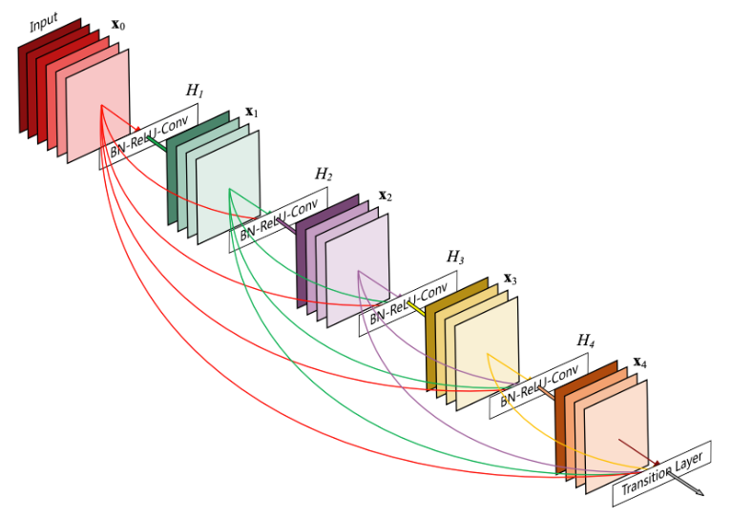

The key components of DenseNet include:

**i. Dense Blocks:**

- The core concept of DenseNet revolves around the dense block, which fundamentally alters the traditional connectivity patterns found in convolutional neural networks (CNNs). In a dense block, each layer establishes direct connections with every other layer in a comprehensive feedforward manner. Unlike conventional architectures where layers are typically connected in a sequential manner, DenseNet's dense connectivity ensures that each layer receives feature maps not only from its immediate predecessor but also from all preceding layers. This means that the input to any given layer is a concatenation of feature maps from all preceding layers, forming a rich, interconnected network structure. Moreover, each layer's own feature maps are then transmitted to all subsequent layers, fostering a highly intertwined network architecture. This dense connectivity pattern promotes extensive feature reuse across the network, enabling information to flow seamlessly from one layer to another. As a result, DenseNet enhances the overall information flow and gradient propagation throughout the network, facilitating more efficient learning and representation of complex data patterns.

**ii. Bottleneck Layers:**

- Within each dense block of a DenseNet architecture, bottleneck layers play a crucial role in managing computational complexity without sacrificing expressive power. These bottleneck layers are strategically inserted to reduce the number of channels before establishing dense connections between layers. The typical configuration involves employing a 1x1 convolutional layer for dimensionality reduction, followed by a 3x3 convolutional layer.

By incorporating these bottleneck layers, DenseNet effectively controls the computational cost associated with processing feature maps within the dense block. The 1x1 convolutional layer serves to compress the channel dimensionality, thereby condensing the information contained within the feature maps. This dimensionality reduction step is essential for minimizing computational overhead while preserving the essential features of the input data.

Following the 1x1 convolution, a subsequent 3x3 convolutional layer is applied to capture spatial patterns and relationships within the feature maps. This convolutional operation enables the network to extract higher-level representations from the compressed feature space, enhancing the model's ability to learn intricate data patterns.

Overall, the integration of bottleneck layers within dense blocks allows DenseNet architectures to strike a balance between computational efficiency and representation capacity. By leveraging these layers, DenseNet achieves a streamlined network structure capable of efficiently learning complex data representations while effectively managing computational resources.

**iii. Transition Layers:**

- Transition layers play a pivotal role in DenseNet architectures by facilitating the seamless integration of dense blocks while effectively managing the spatial dimensions of feature maps. These layers serve as connectors between consecutive dense blocks, orchestrating the transition from one block to the next while ensuring the appropriate adjustment of feature map sizes.

Typically, transition layers are structured to incorporate two key components: a 1x1 convolutional layer for dimensionality reduction followed by average pooling to downsample the spatial resolution of the feature maps.

1. 1x1 Convolutional Layer for Dimensionality Reduction: The transition layer begins by employing a 1x1 convolutional layer, which acts as a computational filter to reduce the number of channels within the feature maps. This dimensionality reduction step serves to compress the representation space, thereby optimizing computational efficiency while retaining essential information.

2. Average Pooling for Spatial Downsampling: Following the dimensionality reduction, the transition layer applies average pooling to downsample the spatial dimensions of the feature maps. This pooling operation aggregates information within local regions, effectively reducing the spatial resolution of the feature maps while preserving essential features. By downsampling the feature maps, the transition layer helps control the growth of computational complexity and facilitates the efficient flow of information through the network.

By incorporating these components, transition layers enable DenseNet architectures to seamlessly transition between dense blocks while regulating the spatial dimensions of feature maps. This orchestrated control over feature map sizes plays a crucial role in maintaining the balance between model expressiveness and computational efficiency, ultimately contributing to the overall effectiveness of DenseNet models in capturing complex data representations.

**iv. Global Average Pooling (GAP):**

-In the final stages of DenseNet architectures, global average pooling (GAP) emerges as a strategic replacement for traditional fully connected layers. This pivotal operation offers several advantages that contribute to the efficiency and effectiveness of the network's design.

1. Dimensionality Reduction and Fixed-Size Representation: Unlike fully connected layers, which require a fixed-size input, global average pooling computes the average value of each feature map across spatial dimensions. This process generates a fixed-size vector regardless of the input size, effectively reducing the dimensionality of the feature representation. By transforming variable-sized feature maps into a uniform representation, GAP facilitates seamless integration with subsequent layers and enhances computational efficiency.

2. Regularization and Reduction of Overfitting: By aggregating feature maps through average pooling, GAP introduces a form of regularization to the network. This regularization mechanism helps prevent overfitting by promoting feature generalization and reducing the network's reliance on specific spatial locations within the feature maps. Consequently, DenseNet models equipped with global average pooling exhibit improved robustness and generalization performance, particularly when trained on diverse datasets with varying input sizes.

3. Parameter Efficiency and Computational Scalability: Global average pooling contributes to the reduction of model parameters by eliminating the need for fully connected layers and their associated weight matrices. By transitioning from spatially distributed feature maps to a compact fixed-size representation, GAP significantly reduces the number of parameters in the final layers of the network. This parameter efficiency not only enhances computational scalability but also streamlines model training and inference, particularly in resource-constrained environments.

4. Interpretability and Feature Localization: Beyond its computational benefits, global average pooling fosters interpretability by providing insights into feature importance and localization. The resulting fixed-size vector encapsulates the aggregated information from the entire feature map, offering a concise representation of salient features within the input data. This interpretability facilitates feature visualization and analysis, empowering practitioners to gain deeper insights into the model's decision-making process and underlying data representations.

In essence, the adoption of global average pooling in DenseNet architectures reflects a strategic design choice aimed at enhancing model efficiency, regularization, and interpretability. By leveraging the collective information embedded within feature maps, GAP enables DenseNet models to achieve superior performance while maintaining computational scalability and robustness across diverse datasets and applications.

**v. Feature Concatenation:**

- The cornerstone of DenseNet's architecture lies in its dense connectivity, which fosters extensive information exchange and gradient propagation across the network. This connectivity paradigm is realized through feature concatenation, a process that seamlessly integrates the output of each layer with the feature maps from all preceding layers within a dense block.

1. Feature Concatenation: At the heart of DenseNet's dense connectivity is the practice of feature concatenation, where the output of each layer is combined with the feature maps from all preceding layers. This concatenation operation forms a composite feature tensor that encapsulates a comprehensive representation of the input data, enriched by the collective insights gleaned from earlier layers. By consolidating information from multiple sources, feature concatenation enables each layer to leverage the rich contextual cues and fine-grained details encoded in the preceding feature maps.

2. Information Flow and Gradient Propagation: By incorporating feature concatenation at each layer within a dense block, DenseNet establishes a direct pathway for information flow and gradient propagation throughout the network. Unlike traditional architectures where information may be diluted or lost as it traverses through intermediate layers, DenseNet's dense connectivity ensures that every layer has access to the complete history of feature transformations from preceding layers. This holistic view of the input data empowers subsequent layers to make more informed decisions and extract nuanced patterns, thereby enhancing the network's representational capacity and discriminative power.

3. Enhanced Feature Reuse: Through feature concatenation, DenseNet promotes enhanced feature reuse, allowing each layer to leverage the diverse representations learned across different stages of the network. By amalgamating features from multiple sources, DenseNet effectively mitigates the risk of information bottlenecks and promotes the efficient utilization of network capacity. This collaborative approach to feature aggregation fosters synergistic interactions between layers and facilitates the emergence of rich hierarchical representations that capture both low-level details and high-level semantics.

4. Gradient Pathways: Dense connectivity also plays a pivotal role in facilitating gradient pathways during backpropagation. By preserving a direct connection between each layer and its predecessors, DenseNet ensures that gradients can flow unimpeded through the network, circumventing the challenges associated with vanishing or exploding gradients. This robust gradient flow enables more stable and efficient training, allowing DenseNet models to converge faster and achieve superior performance on a wide range of tasks.

In essence, DenseNet's dense connectivity via feature concatenation embodies a holistic approach to information integration and gradient propagation within deep neural networks. By fostering comprehensive information exchange and preserving gradient pathways, DenseNet empowers networks to effectively leverage the collective wisdom embedded in the entire network architecture, thereby unlocking new frontiers in representation learning and model performance.

**vi. Dense Connectivity Patterns:**

- DenseNet's versatility extends beyond its core architecture, offering flexibility in connectivity patterns within each dense block to accommodate diverse architectural variations tailored to specific requirements and constraints.

1. Original Dense Connectivity: The foundational DenseNet architecture embraces dense connectivity across all layers within a dense block. This design philosophy fosters maximal information exchange and feature reuse by facilitating direct connections between every pair of layers. Each layer receives input from all preceding layers and passes its feature maps to all subsequent layers, enabling seamless information flow and gradient propagation throughout the block. This dense interconnection scheme promotes synergy among layers and enhances the network's capacity to capture intricate patterns and representations.

2. DenseNet-BC with Bottleneck Layers: Building upon the original DenseNet framework, DenseNet-BC introduces bottleneck layers to enhance computational efficiency without compromising expressiveness. In this variant, each dense block incorporates bottleneck layers, comprising a sequence of 1x1 convolutional layers for dimensionality reduction followed by a 3x3 convolutional layer. By reducing the number of channels before dense connections, bottleneck layers control computational costs while preserving the network's representational power. This optimization strategy strikes a balance between model complexity and efficiency, making DenseNet-BC well-suited for resource-constrained environments.

3. DenseNet with Skip Connections: Another variant of DenseNet explores the integration of skip connections within dense blocks to augment information flow and facilitate gradient propagation. Unlike the original dense connectivity pattern, which concatenates feature maps from all preceding layers, DenseNet with skip connections selectively incorporates skip connections to promote direct paths for information exchange between distant layers. By strategically introducing skip connections, this variant aims to mitigate information degradation and enhance gradient flow, particularly in deeper architectures where vanishing gradients may impede training progress. This hybrid connectivity scheme combines the benefits of dense connections with the resilience of skip connections, offering a robust framework for training highly expressive and efficient models.

In summary, DenseNet's adaptability to different connectivity patterns within dense blocks enables the exploration of various architectural configurations tailored to specific objectives and constraints. Whether optimizing for computational efficiency, promoting information flow, or addressing gradient-related challenges, DenseNet's modular design facilitates the development of versatile and effective deep learning architectures across a wide range of applications and domains.

**vii. Dropout:**

- Indeed, dropout, a popular regularization technique, offers a potent defense against overfitting by stochastically deactivating neurons during training. By randomly "dropping out" neurons along with their connections, dropout injects noise into the network, disrupting co-adaptation among neurons and encouraging each neuron to independently learn robust features. This regularization strategy promotes model generalization and resilience to noise, ultimately enhancing the network's capacity to generalize well to unseen data.

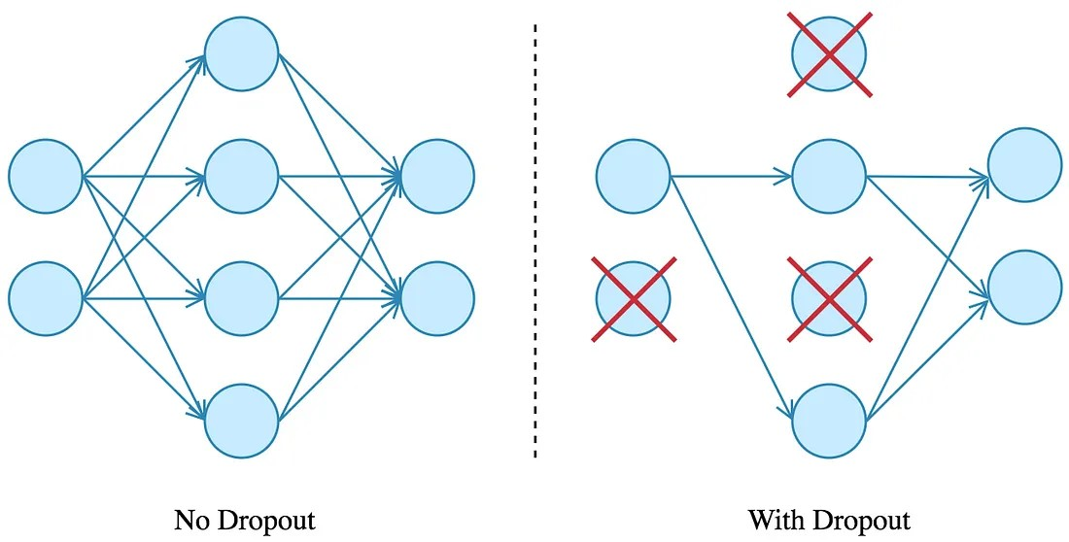

DenseNet, with its dense connectivity and feature reuse mechanisms, can synergistically leverage dropout to fortify its regularization capabilities and bolster performance. By strategically integrating dropout layers within its architecture, DenseNet can introduce controlled randomness during training, thereby diversifying the network's internal representations and mitigating the risk of overfitting.

The incorporation of dropout in DenseNet's layers offers several benefits:

1. Regularization: Dropout serves as a powerful regularizer, imposing constraints on the network's parameters and preventing it from relying too heavily on specific features or pathways. By intermittently deactivating neurons, dropout encourages the network to explore diverse feature representations and learn more robust patterns, ultimately enhancing its ability to generalize to unseen data.

2. Improved Generalization: By introducing stochasticity during training, dropout encourages the network to learn more resilient and adaptable representations that are less sensitive to noise and variations in the input data. This improved generalization capacity enables DenseNet to perform more reliably on real-world datasets, where data may exhibit diverse and complex patterns.

3. Enhanced Robustness: Dropout promotes the development of models that are robust to perturbations and variations in the input, making them less susceptible to adversarial attacks and domain shifts. By training the network to disregard noisy or irrelevant features, dropout fosters the emergence of more robust and transferable representations that can generalize across different tasks and domains.

4. Adaptive Regularization: DenseNet's dense connectivity facilitates the effective propagation of dropout masks across layers, ensuring that the regularization effect is evenly distributed throughout the network. This adaptive regularization mechanism enables DenseNet to tailor the strength of dropout regularization to the specific requirements of each layer, thereby optimizing model performance while mitigating the risk of overfitting.

Incorporating dropout into DenseNet's architecture thus offers a synergistic approach to regularization, enhancing the network's generalization capacity, robustness, and resilience to overfitting. By harnessing the complementary strengths of dropout and dense connectivity, DenseNet can achieve superior performance across a wide range of tasks and domains, making it a versatile and effective deep learning architecture in practice.

**viii. Weight Initialization:**

- Proper weight initialization lays the foundation for effective training in deep neural networks, and DenseNet is no exception. In the realm of weight initialization techniques, He initialization stands out as a valuable asset, particularly well-suited to the dense connectivity and intricate architectures characteristic of DenseNet.

He initialization, named after its creator, Kaiming He, is tailored to address the challenges of training deep networks by initializing the weights of the network's layers in a principled and effective manner. Unlike simpler initialization methods that rely on random or uniform distributions, He initialization calibrates the initial weights based on the network's architecture, ensuring that signals propagate effectively through the layers during training.

In the context of DenseNet, where dense connectivity and feature reuse are central to the architecture's efficacy, He initialization plays a pivotal role in setting the stage for efficient convergence and effective learning. By initializing the weights with suitable magnitudes, He initialization helps prevent issues such as vanishing or exploding gradients, which can impede the training process in deep networks.

The key benefits of using He initialization in DenseNet include:

1. Facilitated Convergence: He initialization provides a solid starting point for the optimization process, enabling the network to converge more rapidly during training. By initializing the weights to appropriate magnitudes, He initialization helps alleviate the challenges associated with training deep networks, such as slow convergence or stagnation in learning.

2. Enhanced Gradient Flow: Proper weight initialization is essential for promoting smooth and stable gradient flow during backpropagation. He initialization ensures that the gradients remain within manageable ranges, preventing issues like vanishing or exploding gradients that can hinder the learning process. This facilitates more consistent and effective updates to the network parameters, leading to faster convergence and improved performance.

3. Preservation of Information Flow: In DenseNet's densely connected architecture, where feature reuse and information flow are paramount, He initialization plays a crucial role in preserving the integrity of the information passing through the network. By initializing the weights appropriately, He initialization helps maintain the quality and fidelity of the learned representations, enabling the network to leverage dense connectivity to its full advantage.

4. Robustness to Architecture Variations: DenseNet architectures can vary in depth, width, and complexity, requiring robust initialization techniques that adapt to different configurations. He initialization provides a scalable and flexible approach to weight initialization, ensuring consistent performance across a wide range of DenseNet architectures and configurations.

By leveraging He initialization, DenseNet can harness the power of principled weight initialization to expedite training, promote stable gradient flow, and preserve the integrity of information flow. This synergistic combination empowers DenseNet to excel across various tasks and datasets, making it a versatile and reliable tool in the deep learning practitioner's arsenal.

**ix. Batch Normalization:**

- Indeed, batch normalization emerges as a cornerstone technique in the training of DenseNet architectures, playing a pivotal role in stabilizing and accelerating the optimization process. In the intricate landscape of deep neural networks, where the challenges of vanishing gradients and internal covariate shift loom large, batch normalization stands as a beacon of stability and efficiency.

At its core, batch normalization operates by normalizing the inputs of each layer across mini-batches during training. By standardizing the mean and variance of the inputs to a layer, batch normalization mitigates the effects of internal covariate shift, a phenomenon where the distribution of activations within a network's layers drifts over the course of training. This ensures that the network's parameters remain well-conditioned and conducive to effective learning throughout the optimization process.

In the context of DenseNet architectures, where dense connectivity and intricate feature interactions abound, batch normalization assumes heightened significance as a means to promote stability, robustness, and convergence. By normalizing the inputs to each layer, batch normalization helps prevent issues such as exploding or vanishing gradients, which can impede the training progress and hinder the network's ability to learn meaningful representations from the data.

The integration of batch normalization into DenseNet architectures yields several key advantages:

1. Accelerated Training: Batch normalization expedites the optimization process by reducing the internal covariate shift and stabilizing the distributions of activations within the network. This facilitates smoother and more consistent updates to the network parameters, leading to faster convergence and reduced training times.

2. Improved Generalization: By promoting stability and robustness during training, batch normalization enhances the generalization performance of DenseNet architectures. By ensuring that the network learns more reliable and transferable representations from the data, batch normalization helps prevent overfitting and improves the model's ability to generalize to unseen examples.

3. Enhanced Gradient Flow: Batch normalization aids in maintaining a healthy gradient flow throughout the network, thereby facilitating more stable and efficient backpropagation. By normalizing the inputs to each layer, batch normalization prevents issues such as vanishing gradients, allowing the network to propagate gradients more effectively and learn meaningful representations from the data.

4. Regularization Effect: In addition to its role in promoting stability and convergence, batch normalization also exhibits inherent regularization properties. By introducing noise into the network through the normalization process, batch normalization acts as a form of regularization, helping prevent overfitting and improving the generalization performance of DenseNet architectures.

Overall, batch normalization serves as a linchpin in the training of DenseNet architectures, providing a robust framework for stabilizing, accelerating, and regularizing the optimization process. By integrating batch normalization into DenseNet architectures, practitioners can harness the full potential of these sophisticated networks, unlocking new frontiers in performance, scalability, and efficiency across a wide range of computer vision tasks and applications.

**x. Compression Factor:**

- Within the intricate tapestry of DenseNet architectures, the introduction of a compression factor stands as a pivotal mechanism for managing computational resources and achieving a delicate balance between model expressiveness and efficiency. As DenseNet traverses the landscape of deep learning, navigating the complexities of feature interactions and connectivity patterns, the compression factor emerges as a guiding principle, shaping the network's architecture and modulating its computational footprint.

At its essence, the compression factor serves as a pragmatic tool for controlling the number of channels within transition layers, orchestrating a delicate dance between model capacity and computational efficiency. By modulating the dimensionality of feature maps as they traverse through the network, the compression factor allows DenseNet to strike an optimal balance between expressive power and resource constraints, ensuring that the network remains both scalable and efficient across diverse computational environments.

The compression factor operates within the context of transition layers, which serve as critical junctures in the network's architecture, facilitating the seamless flow of information between successive dense blocks while managing the spatial dimensions and channel complexities of feature maps. As feature maps cascade through the network, undergoing transformations and interactions within dense blocks, the compression factor intervenes at strategic intervals, orchestrating a graceful reduction in the number of channels to optimize resource utilization and computational efficiency.

Mathematically, the compression factor dictates the extent of channel reduction within transition layers, controlling the proportion of feature channels that are retained or discarded as feature maps transition between dense blocks. By imposing a compression factor, DenseNet can tailor the dimensionality of feature maps to match the computational demands of the task at hand, ensuring that the network remains both agile and resource-efficient across diverse deployment scenarios.

The introduction of a compression factor in DenseNet architectures yields several key advantages:

1. Scalability: By controlling the number of channels within transition layers, the compression factor enables DenseNet architectures to scale gracefully across a spectrum of computational resources, from resource-constrained edge devices to high-performance computing clusters. This scalability ensures that DenseNet remains adaptable and deployable across diverse hardware platforms and deployment environments.

2. Efficiency: Through judicious channel reduction, the compression factor helps DenseNet optimize computational efficiency without sacrificing model expressiveness. By pruning redundant or less informative channels, DenseNet can streamline computation and memory requirements, enhancing the network's efficiency and speed without compromising performance.

3. Flexibility: The compression factor affords DenseNet architectures a high degree of flexibility, allowing practitioners to tailor the network's capacity and computational footprint to match the specific requirements of the task at hand. Whether tackling large-scale image classification tasks or resource-constrained embedded applications, DenseNet can adapt its channel dimensions dynamically to meet the demands of diverse deployment scenarios.

4. Regularization: In addition to its role in managing computational resources, the compression factor also exhibits inherent regularization effects, helping prevent overfitting and improving the generalization performance of DenseNet architectures. By constraining the dimensionality of feature maps, the compression factor encourages the network to learn more compact and discriminative representations, thereby enhancing its ability to generalize to unseen examples.

In essence, the compression factor serves as a linchpin in the design and optimization of DenseNet architectures, offering a versatile and principled mechanism for managing computational resources, enhancing efficiency, and promoting scalability across diverse deployment scenarios. By judiciously modulating the dimensionality of feature maps, the compression factor empowers DenseNet to navigate the complex terrain of deep learning with grace and agility, unlocking new frontiers in performance, scalability, and efficiency across a wide range of applications and domains.

Benefits of DenseNet:

**1. Feature Reuse:**

Within the intricate tapestry of DenseNet architectures, the notion of feature reuse emerges as a cornerstone principle, fostering a symbiotic relationship between network layers and maximizing the utility of learned representations. As DenseNet traverses the manifold of deep learning tasks, from image classification to semantic segmentation, feature reuse stands as a guiding beacon, illuminating the path towards greater efficiency, expressiveness, and performance.

At its essence, feature reuse embodies the ethos of efficiency and resourcefulness, leveraging the dense connectivity inherent in DenseNet architectures to foster a rich tapestry of interlayer interactions and information exchange. Within each dense block, every layer serves as both a recipient and a contributor, receiving feature maps from all preceding layers and transmitting its own learned representations downstream. This dense interconnectivity fosters a vibrant ecosystem of feature reuse, where no morsel of learned information goes untapped, and every layer contributes to the collective intelligence of the network.

The dense connectivity within DenseNet not only promotes the efficient propagation of information but also enables each layer to benefit from the collective wisdom of its predecessors. By granting direct access to the features learned by all preceding layers within the dense block, DenseNet empowers each layer to harness the wealth of knowledge accumulated throughout the network's depth. This democratization of information fosters a collaborative environment where layers can synergistically leverage the diverse perspectives and insights gleaned from their predecessors, enriching their own representations and enhancing the network's overall expressiveness.

Practically, feature reuse manifests as a powerful mechanism for enhancing model capacity and generalization performance. By capitalizing on the collective wisdom of preceding layers, each layer within a dense block can distill and refine its representations to capture increasingly abstract and discriminative features. This iterative process of feature refinement and enhancement cascades through the network, culminating in representations that are rich, expressive, and finely tailored to the nuances of the underlying data distribution.

Moreover, feature reuse serves as a form of implicit regularization, imbuing DenseNet architectures with resilience to overfitting and enhancing their ability to generalize to unseen examples. By promoting the efficient use of learned information and discouraging redundant or irrelevant feature extraction, feature reuse helps prevent the network from memorizing noise or outliers in the training data, thereby improving its robustness and stability in the face of real-world variability.

In essence, feature reuse stands as a testament to the elegance and efficiency of DenseNet architectures, harnessing the power of dense connectivity to foster a dynamic ecosystem of information exchange and collaborative learning. As DenseNet navigates the complex landscape of deep learning tasks, feature reuse serves as a guiding principle, empowering the network to distill rich representations from raw data, generalize effectively across diverse domains, and unlock new frontiers in performance and expressiveness.

**2. Parameter Efficiency:**

Nestled within the intricate fabric of DenseNet lies a profound commitment to parameter efficiency, ushering in a new era where models can achieve remarkable performance with parsimonious parameter budgets. Across the expansive landscape of deep learning, where the quest for both power and parsimony is perennial, DenseNet stands as a beacon of efficiency, demonstrating that compactness need not come at the cost of performance.

At its core, parameter efficiency in DenseNet manifests as a delicate balance between expressive capacity and computational frugality, achieved through the strategic orchestration of dense connectivity and feature reuse. Unlike traditional convolutional neural networks (CNNs), where each layer operates in isolation, DenseNet fosters a symbiotic relationship between layers, enabling them to collaboratively distill rich representations from raw data while minimizing redundant parameter redundancy.

The cornerstone of parameter efficiency in DenseNet lies in its dense connectivity pattern, where each layer receives feature maps from all preceding layers within the dense block. This dense interconnectivity not only promotes information flow but also enables efficient parameter sharing, as the parameters learned by each layer are leveraged across the entire block. Consequently, DenseNet can achieve high expressiveness with fewer parameters, making it an attractive choice for resource-constrained environments.

Moreover, the judicious use of transition layers in DenseNet further enhances parameter efficiency by controlling the number of channels between dense blocks. By introducing compression factors, DenseNet effectively manages computational resources, ensuring that each subsequent dense block can operate with a reduced parameter footprint without sacrificing performance. This hierarchical pruning of parameters helps DenseNet strike an optimal balance between model capacity and computational cost, making it well-suited for deployment in real-world scenarios.

Practically, the parameter efficiency of DenseNet translates into tangible benefits across a myriad of applications, from image classification to object detection and beyond. In scenarios where computational resources are limited or inference speed is critical, DenseNet's compact yet expressive architecture shines, delivering robust performance without imposing undue computational burden.

Furthermore, the parameter efficiency of DenseNet makes it an ideal candidate for deployment on edge devices, where memory and computational constraints often dictate the feasibility of deep learning models. By minimizing parameter redundancy and maximizing parameter reuse, DenseNet empowers edge devices to harness the power of deep learning without compromising on efficiency or performance.

In essence, parameter efficiency lies at the heart of DenseNet's appeal, embodying a philosophy of elegance and pragmatism that resonates deeply with the evolving needs of the deep learning community. As the quest for ever more efficient and expressive models continues, DenseNet stands as a testament to the transformative power of parameter efficiency, demonstrating that compactness and performance need not be mutually exclusive, but rather complementary facets of a unified vision for intelligent computation.

**3. Mitigation of Vanishing Gradient:**

In the labyrinthine landscape of deep learning, the vanishing gradient problem stands as a formidable obstacle, impeding the convergence of deep neural networks and thwarting their ability to capture complex relationships within data. Yet, within the depths of DenseNet lies a potent antidote to this pernicious malady, a remedy forged from the crucible of dense connectivity and collective wisdom.

At the heart of DenseNet's arsenal against the vanishing gradient lurks a fundamental insight: the power of shorter paths. Unlike traditional architectures where gradients traverse a convoluted maze of layers, struggling to maintain their vigor amidst the relentless onslaught of weight updates, DenseNet offers a sanctuary of succinctness, where gradients flow freely and unimpeded.

The dense connectivity pattern, with its intricate web of interconnections, serves as a conduit through which gradients can traverse with unparalleled ease. Each layer in a dense block has direct access to the gradients from all preceding layers, creating a network of expressways that bypasses the treacherous quagmire of vanishing gradients. This direct line of communication empowers DenseNet to propagate gradients with vigor, ensuring that each weight update resonates with the collective wisdom of the entire network.

Moreover, the strategic deployment of transition layers in DenseNet further fortifies its defenses against the vanishing gradient menace. By carefully controlling the spatial dimensions of feature maps and introducing compression factors, DenseNet orchestrates a symphony of parameter management, ensuring that gradients encounter minimal resistance as they traverse the depths of the network. This hierarchical pruning of parameters not only enhances computational efficiency but also fosters a conducive environment for gradient propagation, enabling DenseNet to navigate the tumultuous seas of deep learning with aplomb.

In practical terms, the mitigation of the vanishing gradient problem in DenseNet translates into tangible benefits for training stability and efficacy. Models trained with DenseNet exhibit greater robustness to vanishing gradients, converging more reliably and efficiently towards optimal solutions. This newfound stability not only accelerates the pace of experimentation and innovation but also imbues deep learning practitioners with newfound confidence in the face of daunting challenges.

Furthermore, the mitigation of the vanishing gradient problem in DenseNet unlocks the full potential of deep learning across a myriad of applications, from image recognition to natural language processing and beyond. In domains where the depth of the network is a critical factor, DenseNet's resilience against vanishing gradients empowers researchers and practitioners to delve deeper into the mysteries of data, uncovering hidden insights and unlocking new frontiers of knowledge.

In conclusion, the dense connectivity pattern in DenseNet stands as a bulwark against the vanishing gradient problem, offering a beacon of hope amidst the turbulent seas of deep learning. By providing shorter paths for gradients to flow and fostering a conducive environment for parameter management, DenseNet emerges as a stalwart ally in the quest for more stable and effective training of deep neural networks, ushering in a new era of discovery and innovation in the realm of artificial intelligence.

**4. Improved Information Flow:**

In the vast expanse of deep neural networks, the efficient flow of information is paramount, dictating the model's ability to discern subtle patterns and extract meaningful insights from complex data. Within the intricate tapestry of DenseNet lies a paradigm-shifting innovation: dense connectivity, a conduit through which information traverses with unparalleled fluidity and efficacy.

At the heart of Dense Net's prowess lies its dense connectivity pattern, a web of interconnections that binds each layer to its predecessors and successors in a symbiotic embrace. Unlike traditional architectures where information must navigate a labyrinth of indirect pathways, Dense Net offers a streamlined highway where data flows seamlessly from input to output.

The dense connectivity within each block forms a tapestry of interconnected neurons, each layer intimately acquainted with the features learned by its predecessors. This intimate collaboration enables the model to leverage the collective wisdom of preceding layers, integrating local and global information to paint a holistic picture of the underlying data landscape.

As information traverses the network, it encounters a rich tapestry of features, each layer contributing its unique perspective to the unfolding narrative. The direct connections between layers serve as conduits for the exchange of insights, enabling the model to capture intricate dependencies and nuanced relationships that might elude traditional architectures.

Moreover, the dense connectivity pattern fosters a sense of synergy among layers, amplifying the signal-to-noise ratio and enhancing the discriminative power of the model. By aggregating information from multiple sources, DenseNet can discern subtle patterns and extract salient features with remarkable precision, unlocking new frontiers of knowledge and understanding.

In practical terms, the enhanced information flow facilitated by dense connectivity translates into tangible benefits for model performance and generalization. Models trained with DenseNet exhibit greater robustness to noise and variability, achieving state-of-the-art results across a wide range of tasks, from image classification to object detection and beyond.

Furthermore, the improved information flow empowers researchers and practitioners to tackle increasingly complex datasets and challenging real-world problems. By harnessing the collective intelligence of densely connected layers, DenseNet offers a powerful tool for unraveling the mysteries of data, illuminating hidden insights, and driving innovation in artificial intelligence.

In conclusion, dense connectivity in DenseNet represents a paradigm shift in the architecture of deep neural networks, ushering in a new era of information processing and knowledge discovery. By fostering seamless collaboration among layers and amplifying the flow of insights, DenseNet empowers researchers and practitioners to push the boundaries of what's possible in the realm of artificial intelligence, unlocking new opportunities for discovery and innovation.

**5. Reduced Overfitting:**

In the dynamic realm of deep learning, the specter of overfitting looms ominously, threatening to derail the model's ability to generalize beyond the confines of the training data. Yet, within the intricate architecture of DenseNet lies a formidable defense against this insidious foe: a trifecta of features that collectively act as a bulwark against overfitting, ensuring the model's resilience and adaptability in the face of uncertainty.

At the heart of DenseNet's arsenal against overfitting lies its unique connectivity pattern, a dense web of interconnections that fosters collaboration among layers and promotes the sharing of knowledge. Unlike traditional architectures where each layer operates in isolation, DenseNet encourages the free flow of information, allowing insights to permeate every crevice of the network. This interconnectedness serves as a natural form of regularization, smoothing the learning process and mitigating the risk of overfitting by promoting consensus among layers.

Moreover, the concept of feature reuse inherent in DenseNet amplifies this effect, allowing the model to extract maximal value from its training data without succumbing to the temptation of memorization. By leveraging the collective wisdom of preceding layers, DenseNet learns to distill the essence of the data, discarding extraneous details and focusing on the underlying patterns that truly matter. This judicious use of information not only enhances the model's predictive power but also imbues it with a robustness that transcends the limitations of the training set.

Global average pooling, the final piece of the puzzle, serves as a powerful form of regularization, imparting a sense of order and coherence to the model's predictions. By aggregating information across spatial dimensions, global average pooling encourages the network to focus on the most salient features while suppressing noise and irrelevant details. This pooling operation acts as a natural filter, smoothing out fluctuations in the data and promoting stability in the model's predictions.

Collectively, these mechanisms work in concert to fortify DenseNet against the perils of overfitting, imbuing it with a resilience and adaptability that are essential for real-world applications. By fostering collaboration among layers, promoting feature reuse, and encouraging global coherence, DenseNet transcends the limitations of traditional architectures, emerging as a stalwart defender against the vagaries of noisy data and uncertain environments.

In conclusion, the reduced risk of overfitting conferred by DenseNet's connectivity pattern, feature reuse, and global average pooling represents a significant advantage in the quest for robust and generalizable deep learning models. By harnessing the power of collaboration, consensus, and coherence, DenseNet empowers researchers and practitioners to tackle complex real-world problems with confidence, paving the way for a future where artificial intelligence thrives in even the most challenging of environments.

**4.4 Inception:**

In the dynamic landscape of deep learning, where innovation reigns supreme, the Inception architecture, affectionately known as GoogLeNet, emerges as a beacon of ingenuity and sophistication. Conceived by a consortium of luminaries from Google, including Christian Szegedy, Wei Liu, Yangqing Jia, Pierre Sermanet, Scott Reed, Dragomir Anguelov, Dumitru Erhan, Vincent Vanhoucke, and Andrew Rabinovich, Inception made its grand debut on the global stage at the IEEE Conference on Computer Vision and Pattern Recognition (CVPR) in 2015.

At the heart of the Inception architecture lies a revolutionary concept: the inception module. These modules, akin to the multifaceted tools of an expert craftsman, harness the power of diverse convolutional filter sizes (ranging from the compact 1x1 to the expansive 5x5) in parallel. This ingenious design choice enables the network to perceive features at multiple spatial scales simultaneously, capturing intricate details and global patterns with unprecedented efficiency.

The inception modules are meticulously crafted to strike a delicate balance between computational prowess and expressive capacity. By embracing a holistic approach to feature extraction, they empower the network to transcend the limitations of conventional architectures, navigating the complex terrain of image classification and object detection with finesse and precision.

But the brilliance of Inception extends beyond its inception modules. The architecture as a whole embodies a spirit of innovation and forward-thinking, pushing the boundaries of what's possible in the realm of deep learning. From its inception to its deployment in real-world applications, Inception stands as a testament to the power of collaboration, creativity, and relentless pursuit of excellence.

Inception's inception modules are not mere components but architectural marvels meticulously designed to tackle the complexities of feature extraction. By embracing a diverse ensemble of convolutional filter sizes – from the nimble 1x1 to the expansive 5x5 – these modules empower the network to perceive and comprehend features across a spectrum of spatial scales.

The essence of the inception modules lies in their ability to strike a delicate balance between computational efficiency and expressive power. Through parallel processing of multiple filter sizes, these modules adeptly capture both fine-grained details and broad contextual information, enriching the network's understanding of the visual world.

But the brilliance of Inception extends beyond its modular design. At its core, Inception embodies a philosophy of innovation and adaptability, continuously evolving to meet the demands of increasingly complex tasks in computer vision. From its inception to its deployment in real-world applications, Inception serves as a beacon of progress, pushing the boundaries of what's achievable in deep learning.

In conclusion, Inception's groundbreaking architecture, propelled by its inception modules, represents a transformative leap forward in the field of computer vision. By embracing diversity, efficiency, and adaptability, Inception sets the stage for a future where artificial intelligence not only sees but truly understands the world around us.

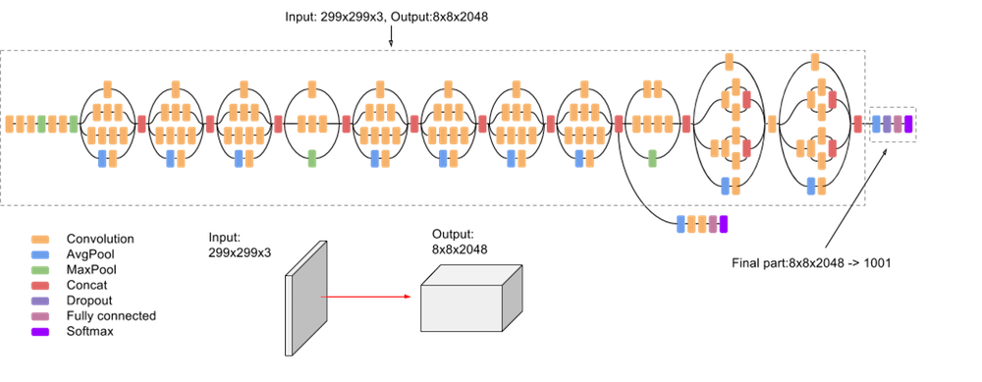

Key Components of Inception (GoogLeNet):

1. **Inception Modules:**

Inception modules are indeed architectural wonders, blending multiple parallel convolutional operations of varying kernel sizes – the nimble 1x1, the versatile 3x3, and the expansive 5x5 – alongside pooling operations. This symphony of computations unfolds within the module, each operation akin to an artist crafting a unique brushstroke on the canvas of the network.

What sets these modules apart is their ability to fuse these diverse features seamlessly. Through a judicious concatenation along the depth dimension, the module weaves together a tapestry of features, each contributing its own distinct perspective. This fusion enables the network to perceive the world through multiple lenses, capturing intricate details and broad contextual cues simultaneously.

In essence, the inception modules epitomize the spirit of collaboration and integration, where disparate elements harmonize to create something greater than the sum of its parts. By embracing diversity and multiplicity, these modules empower the network to transcend the constraints of scale and granularity, paving the way for richer, more nuanced representations of the visual world.

2. **1x1 Convolutions (Network in Network):**

Indeed, the incorporation of 1x1 convolutions marks a pivotal innovation within the Inception architecture, giving rise to what has been aptly termed the "network in network" concept. These diminutive convolutions serve as miniature crucibles of transformation, where the alchemy of feature extraction unfolds.

At first glance, their modest dimensions might belie their significance, but these convolutions wield immense power. By operating along the channel dimension, they orchestrate a subtle dance of feature manipulation, sculpting the raw input channels into refined representations.

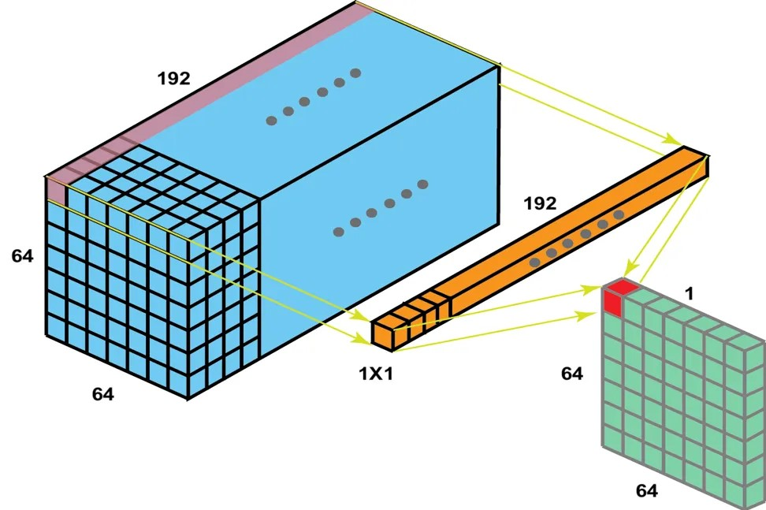

Moreover, the use of 1x1 convolutions imparts a sense of dimensionality reduction, akin to a master craftsman chiseling away extraneous details to reveal the essence beneath. This reduction not only streamlines computations but also fosters a more parsimonious representation of the data, allowing the network to focus its attention on the salient features that truly matter.

In essence, the "network in network" concept embodied by these 1x1 convolutions encapsulates the ethos of efficiency and elegance, where even the smallest elements play a pivotal role in shaping the grand tapestry of the neural network.

3. **Global Average Pooling (GAP):**

Global Average Pooling (GAP) stands as a capstone of elegance within the Inception architecture, a final flourish that harmonizes the manifold streams of information into a unified symphony of understanding.

As the neural network nears its denouement, poised on the precipice of classification or detection, it undergoes a transformation of spatial dimensions through the alchemy of GAP. In this process, each feature map, pregnant with the rich tapestry of learned representations, is distilled down to a singular essence—a solitary value that encapsulates the collective wisdom of its progenitors.

This reduction in spatial dimensions serves a dual purpose. Firstly, it acts as a form of regularization, a gentle restraint that prevents the network from veering into the treacherous realm of overfitting. By eschewing the excesses of spatial extravagance, GAP imparts a sense of discipline to the network, fostering a lean and nimble model that is resilient in the face of unseen challenges.

Secondly, the ritual of spatial reduction bestows upon the network a boon of efficiency. With each feature map condensed to a solitary datum, the burden of parameters is alleviated, paving the way for a more parsimonious representation of knowledge. In this realm of streamlined elegance, the network achieves a delicate balance between expressiveness and restraint, embodying the essence of computational grace.

Thus, in the hallowed halls of Inception, where innovation and ingenuity converge, Global Average Pooling stands as a testament to the power of simplicity—a humble yet indispensable tool in the arsenal of modern deep learning architectures.

4. **Auxiliary Classifiers:**

The inception of auxiliary classifiers within the hallowed halls of GoogLeNet marked a watershed moment in the quest for more robust and resilient deep neural networks.

In this architectural symphony, intermediate layers became more than mere waystations on the path to classification; they assumed the mantle of guardians, wielding auxiliary classifiers as beacons of guidance amidst the tempestuous seas of training.

As the network delved deeper into the labyrinth of convolutional hierarchies, auxiliary classifiers emerged at strategic junctures, offering glimpses of clarity amidst the encroaching fog of vanishing gradients. These classifiers, akin to sentinels of vigilance, cast their gaze upon the evolving landscape of features, infusing it with additional signals of supervision.

Their presence served a dual purpose: to provide auxiliary pathways for gradients to flow, circumventing the perils of stagnation, and to act as custodians of diversity, ensuring the propagation of learning signals across the expanse of the network.

During the crucible of training, these auxiliary classifiers became stalwart companions, aiding in the optimization of the network's parameters and fortifying its resilience against the vagaries of overfitting and premature convergence.

In the crucible of optimization, where gradients wax and wane like ephemeral whispers, the auxiliary classifiers of GoogLeNet stood as beacons of hope, illuminating the path towards convergence and enlightenment.

5. **Bottleneck Layers:**

Indeed, akin to ResNet's ingenious use of bottleneck layers, Inception too employs this architectural finesse to navigate the labyrinth of computational complexity.

Within the hallowed halls of Inception's architectural blueprint, bottleneck layers emerge as sanctuaries of computational thrift, deftly orchestrating the symphony of convolutional transformations with parsimonious precision.



In this architectural ballet, each bottleneck layer is a masterstroke of dimensionality reduction and expansion, executed with the grace and efficiency of a seasoned virtuoso.

At its heart lies the 1x1 convolutional kernel, a diminutive yet potent tool for channel pruning, trimming the excess and distilling the essence of feature representation.

Next, the 3x3 convolutional core comes into play, wielding its spatial prowess to sculpt and refine the feature landscape with meticulous care and attention to detail.

And finally, another 1x1 convolutional flourish concludes the symphony, expanding the dimensions once more, imbuing the feature maps with newfound depth and complexity.

Through this intricate dance of convolutional alchemy, bottleneck layers in Inception not only reduce the computational burden but also elevate the network's capacity for representation and abstraction, paving the way for deeper insights and richer feature hierarchies.

6. **Multiple Stacks and Reduction Blocks:**

Indeed, the grand architectural edifice of Inception stands tall, structured into multiple towering stacks, each adorned with a symphony of inception modules.

Within this architectural marvel, reduction blocks emerge as the bridges between these magnificent stacks, orchestrating the spatial symphony with finesse and precision.

In the grand ballroom of Inception's design, reduction blocks are the maestros, conducting the spatial dimensions with deft strokes and calculated measures.

These blocks, with their strategic placement, serve as the conduits for spatial compression, compressing the feature maps with a delicate touch, preparing them for the journey across the stacks.

In their realm, reduction blocks wield the power of pooling and convolution, sculpting the spatial landscape with masterful precision, ensuring that each transition between stacks is seamless and harmonious.

Through their artful manipulation of spatial dimensions, reduction blocks pave the way for the grand procession of features, guiding them through the labyrinth of Inception's architectural splendor with grace and elegance.

Benefits of Inception:

1. **Efficient Feature Extraction:**

The essence of Inception lies in its ability to weave a tapestry of features, capturing the intricate nuances of the visual world at multiple scales and resolutions.

At the heart of this architectural masterpiece are the inception modules, each a marvel of design, orchestrating a symphony of convolutional operations in parallel.

Within these modules, convolutional filters of varying sizes - 1x1, 3x3, and 5x5 - stand in unison, each contributing its unique perspective to the grand tableau of features.

Like virtuoso painters, these filters brush strokes of convolution across the canvas of input data, capturing details both fine and broad, from the minutiae of texture to the grandeur of form.

The result is a mosaic of features, rich in diversity and depth, each convolutional operation adding a layer of complexity to the visual narrative.

Through this multifaceted approach, Inception transcends the limitations of traditional architectures, imbuing its models with the power to perceive the world in all its intricacy and splendor.

2. **Computational Efficiency:**

The architectural ingenuity of Inception extends beyond its feature-capturing prowess to embrace computational efficiency, a cornerstone of modern deep learning.

At the heart of this efficiency lies the strategic use of 1x1 convolutions, akin to prisms that refract and distil the essence of information.

These diminutive convolutions act as gatekeepers, reducing the dimensionality of input channels without sacrificing expressiveness, thus optimizing computational resources.

Furthermore, bottleneck layers serve as conduits of transformation, channeling the flow of information through a narrower passage before expanding it once more.

In this symphony of convolutional operations, Inception orchestrates a delicate balance between complexity and efficiency, ensuring that every computational cycle is invested wisely in the pursuit of understanding the visual world.

3. **Improved Model Generalization:**

The architectural nuances embedded within Inception foster not only computational efficiency but also enhanced model generalization, propelling it to the vanguard of image recognition.

Global average pooling, akin to a sculptor's chisel, hones the spatial dimensions of feature maps to a single value per channel, distilling the essence of information while warding off the specter of overfitting.

Moreover, the strategic deployment of auxiliary classifiers at intermediate layers imbues the network with additional supervisory signals, akin to guiding stars illuminating the path to convergence. These auxiliary beacons augment the optimization landscape, fostering a robust learning environment that transcends the confines of mere memorization.

Thus, Inception stands as a testament to the symbiosis between architectural innovation and computational pragmatism, elevating the art of image classification to new heights of accuracy and reliability.

4. **State-of-the-Art Performance:**

The Inception architecture ascended to the zenith of image classification, heralding a new era of state-of-the-art performance in deep learning.

Its arrival marked a watershed moment in the annals of computer vision, where Inception's prowess reverberated across benchmarks, eclipsing previous milestones with unparalleled accuracy and efficiency.

Although subsequent architectures, like ResNet and DenseNet, have since claimed the limelight in certain domains, the legacy of Inception endures as a beacon of inspiration. Its innovative design, characterized by inception modules and strategic feature extraction, continues to inform and shape the landscape of deep neural networks.

Thus, while the torch may have passed to newer contenders, the Inception architecture stands as a timeless testament to the ingenuity and dynamism of deep learning research.

**4.5 VGG16:**

VGG16, an abbreviation for Visual Geometry Group 16, represents a convolutional neural network (CNN) architecture renowned for its depth and simplicity. Developed by the Visual Geometry Group at the University of Oxford, VGG16 was introduced in a seminal paper titled "Very Deep Convolutional Networks for Large-Scale Image Recognition" by Karen Simonyan and Andrew Zisserman. It gained widespread recognition after participating in the ImageNet Large Scale Visual Recognition Challenge (ILSVRC) in 2014.

The architecture of VGG16 is characterized by its deep stack of convolutional layers, interspersed with max-pooling layers for spatial downsampling. The network consists of 16 weight layers, including 13 convolutional layers and 3 fully connected layers. The convolutional layers use small receptive fields (typically 3x3) with a stride of 1, and each convolutional block is followed by a max-pooling layer with a 2x2 filter and a stride of 2.

One notable aspect of VGG16 is its uniformity in architecture, where convolutional layers are stacked one after another, and each layer within a block has the same number of filters. This simplicity and symmetry contribute to ease of implementation and understanding.

VGG16 is adept at capturing intricate features from input images, which makes it well-suited for various computer vision tasks, including image classification, object detection, and segmentation. Despite its effectiveness, VGG16's main drawback is its large number of parameters, which can hinder its deployment on resource-constrained devices or in real-time applications.

VGG16's architecture laid the groundwork for deeper convolutional neural networks by demonstrating the effectiveness of stacking multiple convolutional layers. Its straightforward design, with a sequence of convolutional layers followed by max-pooling layers, provided a blueprint for subsequent CNN architectures.

One of the key contributions of VGG16 is its ability to learn hierarchical features of increasing complexity. The early layers capture low-level features such as edges and textures, while deeper layers extract high-level abstract features relevant to the task at hand. This hierarchical feature representation is crucial for achieving high accuracy in image classification tasks.

The simplicity and effectiveness of VGG16 have led to its widespread adoption in both academia and industry. Researchers often use pre-trained VGG16 models as a starting point for transfer learning, fine-tuning them on specific datasets for various computer vision applications.

Despite its success, VGG16's large number of parameters can pose challenges in terms of computational resources and memory requirements during training and inference. This limitation has prompted the development of more efficient architectures, such as MobileNet and EfficientNet, which achieve comparable performance with fewer parameters.

Overall, VGG16's impact on the field of deep learning cannot be overstated. Its architectural principles have inspired numerous subsequent CNN architectures and continue to influence the design of state-of-the-art models for image recognition and other computer vision tasks.

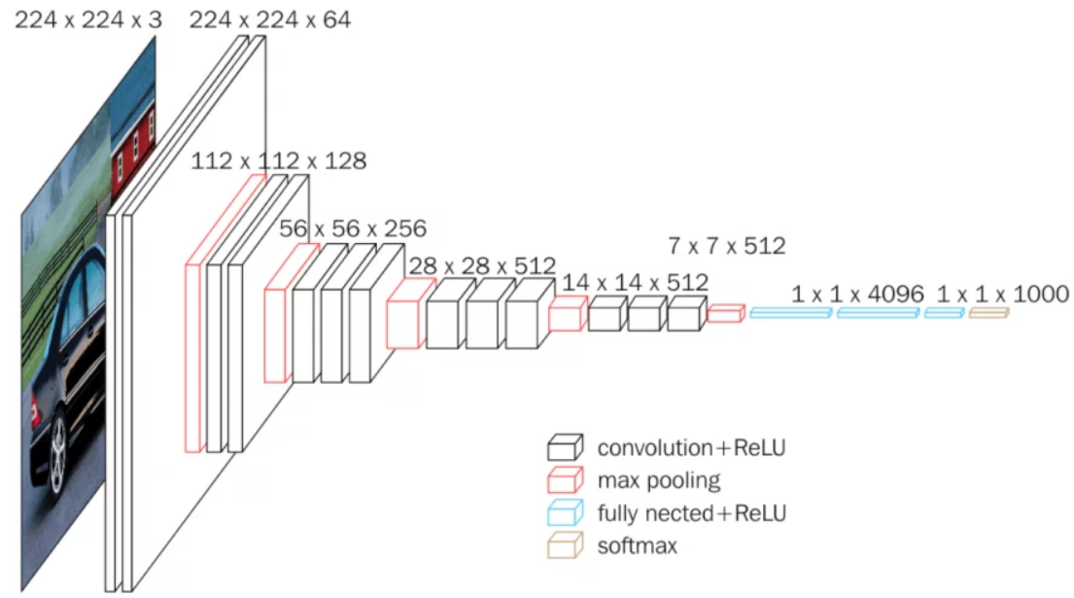

Key Characteristics of VGG16:

1. **Architecture:**

VGG16 stands out for its elegant simplicity and consistent architectural design. Comprising a total of 16 layers, it maintains a uniform structure throughout its architecture.

In its convolutional layers, VGG16 employs compact 3x3 filters, allowing it to capture intricate features while maintaining computational efficiency. By using such small filter sizes, the network can effectively extract fine-grained patterns from the input images. Additionally, a stride of 1 ensures that these convolutional operations thoroughly cover the input data, enabling the network to learn rich representations.

Furthermore, VGG16 incorporates max-pooling layers to downsample the feature maps. These pooling layers utilize 2x2 filters with a stride of 2, effectively reducing the spatial dimensions of the feature maps while retaining essential information. This downsampling process aids in hierarchical feature extraction, enabling the network to progressively learn and abstract complex visual concepts across multiple layers..

2. **Convolutional Blocks:**

In VGG16, the convolutional layers are arranged into distinct blocks, each designed to progressively extract and refine features from the input data. These blocks serve as building blocks for the network's hierarchical feature representation.

Within each convolutional block, there typically resides one or more convolutional layers, each equipped with filters aimed at detecting specific patterns or features in the input. As the network delves deeper into the architecture, the complexity and abstraction level of these features tend to increase. This is reflected in the number of filters employed in each convolutional layer, which typically grows deeper into the network.

Accompanying these convolutional layers is a max-pooling layer, strategically placed to follow the convolutional operations. Max-pooling serves the purpose of spatial downsampling, reducing the spatial dimensions of the feature maps while preserving the most salient information. By systematically downsampling the feature maps, VGG16 can focus on capturing increasingly abstract and high-level features as it progresses through the network layers.

This hierarchical organization of convolutional blocks in VGG16 enables the network to learn and represent complex visual patterns effectively, making it adept at tasks such as image classification and object recognition. Each block contributes to the network's ability to understand and interpret the input data in a hierarchical and structured manner, ultimately leading to accurate and robust predictions.

3. **Filter Size and Stride:**

In VGG16, the choice of using small 3x3 convolutional filters across the entire network is a deliberate architectural decision aimed at optimizing feature learning while controlling model complexity. By employing 3x3 filters consistently, the network can effectively capture detailed patterns and features present in the input images. Additionally, using smaller filters helps in reducing the number of parameters in the network compared to larger filters, which contributes to better computational efficiency and faster training.

Furthermore, maintaining a stride of 1 in all convolutional layers ensures that spatial information is preserved throughout the network. With a stride of 1, the convolutional operation moves the filters across the input feature maps one pixel at a time, allowing the network to capture fine-grained spatial relationships between adjacent pixels. This preservation of spatial information is crucial for tasks such as image classification, where maintaining spatial details can lead to more accurate predictions.

Overall, the combination of small 3x3 filters and a stride of 1 in VGG16 enhances the network's ability to learn rich, hierarchical representations of the input data while efficiently managing computational resources. These design choices contribute to VGG16's effectiveness in various computer vision tasks, making it a widely adopted architecture in the deep learning community.

4. **Fully Connected Layers in VGG16**

The VGG16 architecture is renowned for its simplicity and effectiveness in image classification tasks. It consists of a series of convolutional layers followed by fully connected layers, which transition the network from feature extraction to classification. This transition is crucial as it transforms the spatially-organized feature maps into a format suitable for predicting class labels. Here, we explore the role and structure of the fully connected layers in VGG16.

**Overview of VGG16 Architecture**

VGG16 follows a straightforward and uniform architecture:

1. Convolutional Layers: The network starts with a stack of convolutional layers, organized into blocks. Each block consists of multiple convolutional layers followed by a max-pooling layer. These layers are responsible for extracting hierarchical features from the input images.

2. Fully Connected Layers: After the final convolutional block, the network transitions to fully connected layers, marking the shift from feature extraction to classification.

**Structure of Fully Connected Layers in VGG16**

The fully connected layers in VGG16 are designed to capture complex patterns and relationships from the feature maps produced by the convolutional layers. They consist of three fully connected (dense) layers:

1. **First Fully Connected Layer:**

- Description: This layer is densely connected, meaning each neuron is connected to all neurons in the preceding layer.

- Number of Neurons: 4,096

- Role: Acts as a high-capacity feature extractor, expanding the representation space and enabling the network to capture intricate details and nuances from the input data.

2. **Second Fully Connected Layer:**

- Description: Similar to the first fully connected layer, it is densely connected to all neurons in the previous layer.

- Number of Neurons: 4,096

- Role: Further refines the feature representation, allowing the network to learn more complex patterns and relationships.

3. **Third Fully Connected Layer (Output Layer):**

- Description: This is the final layer, where each neuron corresponds to a class in the classification task.

- Number of Neurons: Equal to the number of classes (e.g., 1,000 for ImageNet classification)

- Role: Converts the refined features into class probabilities. During inference, the activation values of these neurons are interpreted as the probabilities for each class. The class with the highest probability is chosen as the predicted label.

**Transition from Convolutional to Fully Connected Layers**

Before passing the feature maps to the fully connected layers, they are typically flattened into a one-dimensional vector. This vector serves as the input to the first fully connected layer. The transition can be visualized as follows:

1**. Feature Maps**: The output of the final convolutional layer is a 3D tensor representing the extracted features.

2. **Flattening**: The 3D tensor is flattened into a 1D vector.

3. **Fully Connected Layers**: The flattened vector is fed into the first fully connected layer, followed by the second and third layers.

**Visualization of VGG16 Architecture with Fully Connected Layers**

Below is a simplified diagram illustrating the VGG16 architecture, highlighting the transition from convolutional layers to fully connected layers.

graph TB

A(Input Image) --> B(Conv Block 1)

B --> C(Conv Block 2)

C --> D(Conv Block 3)

D --> E(Conv Block 4)

E --> F(Conv Block 5)

F --> G(Flatten)

G --> H(Fully Connected Layer 1)

H --> I(Fully Connected Layer 2)

I --> J(Output Layer)

J --> K(Class Prediction)

subgraph Conv Layers

B(Conv Block 1) --> C(Conv Block 2)

C --> D(Conv Block 3)

D --> E(Conv Block 4)

E --> F(Conv Block 5)

end

subgraph Fully Connected Layers

G(Flatten) --> H(Fully Connected Layer 1)

H --> I(Fully Connected Layer 2)

I --> J(Output Layer)

end

style A fill:#00f,stroke:#333,stroke-width:2px

style K fill:#00f,stroke:#333,stroke-width:2px

style B,C,D,E,F fill:#0f0,stroke:#333,stroke-width:2px

style G,H,I,J fill:#f00,stroke:#333,stroke-width:2px

**Importance of Fully Connected Layers**

The fully connected layers in VGG16 are pivotal for several reasons:

1.**High-Capacity Learning**: With thousands of neurons, these layers have a high capacity to learn and represent complex patterns and relationships in the data.

2. **Feature Transformation**: They transform the abstract, spatial features extracted by the convolutional layers into a format suitable for classification.

3. **Discriminative Power**: By mapping the learned features to class probabilities, the fully connected layers enable the network to make accurate predictions across a wide range of image classification tasks.

The fully connected layers in VGG16 play a crucial role in bridging the gap between feature extraction and classification. By expanding the representation space and learning complex patterns, these layers enable VGG16 to perform well in image classification tasks. This architecture design, combining convolutional and fully connected layers, has proven highly effective and has influenced many subsequent deep learning models.

5. **Activation Function:**

In VGG16, Rectified Linear Units (ReLU) serve as the primary activation function across all layers, providing essential non-linearity to the network's computations. ReLU activation functions are preferred due to their simplicity, computational efficiency, and effectiveness in mitigating the vanishing gradient problem.

ReLU functions introduce non-linearity by thresholding the input at zero, effectively passing through positive values unchanged while setting negative values to zero. This simple yet effective operation enables the network to learn complex patterns and representations from the input data.

By applying ReLU activation functions after each convolutional and fully connected layer, VGG16 introduces non-linear transformations to the feature maps, enabling the network to capture intricate patterns and relationships in the input data. These non-linearities are crucial for the network to learn and represent complex decision boundaries, ultimately enhancing its capacity to discriminate between different classes in the classification task.

Moreover, ReLU activation functions contribute to the computational efficiency of VGG16 by introducing sparsity in the network activations. Since ReLU units only activate for positive inputs, they lead to a sparse representation of the feature space, reducing the computational burden during both training and inference.

Overall, the widespread use of ReLU activation functions in VGG16 underscores their effectiveness in enabling the network to learn complex representations, enhancing its capacity for accurate and discriminative image classification.

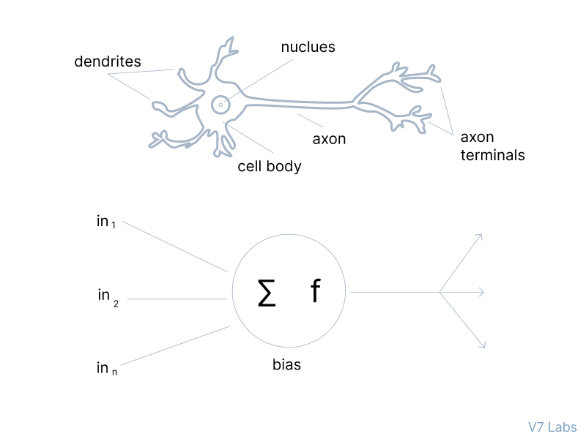

6. **Global Average Pooling (GAP):**

In contrast to architectures like ResNet and DenseNet, VGG16 follows a traditional approach at the end of its convolutional layers, opting not to use global average pooling (GAP). Instead, it employs a conventional method by flattening the output feature maps and connecting them directly to fully connected layers for classification.

After the final convolutional layers in VGG16, the resulting feature maps are flattened into a one-dimensional vector, preserving the spatial information and collapsing the feature dimensions. This flattened representation serves as the input to the subsequent fully connected layers, where each neuron is connected to every element in the flattened feature vector.

By utilizing fully connected layers in the classification head, VGG16 retains flexibility and expressive power in its network design. The fully connected layers allow for complex transformations of the input features, enabling the network to learn hierarchical representations and make fine-grained distinctions between different classes.

While global average pooling (GAP) has become a popular choice in modern convolutional neural network architectures for its regularization benefits and parameter efficiency, VGG16's reliance on fully connected layers offers a more straightforward and interpretable approach. However, this design choice also comes with drawbacks, such as a higher number of parameters and increased computational complexity, especially in deeper architectures.

Overall, VGG16's utilization of fully connected layers in the final classification stage represents a conventional yet effective approach to image classification, providing a foundation for subsequent advancements in deep learning architectures.

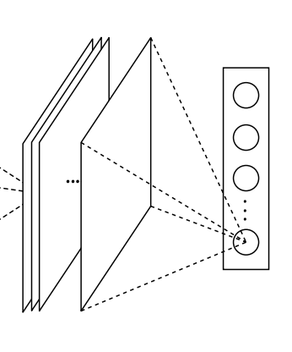

**4.6 Benefits and limitations:**

VGG16 is a highly influential model in the field of computer vision, known for its effectiveness and ease of use. However, like any architecture, it comes with its own set of advantages and limitations. Understanding these can help researchers and practitioners leverage VGG16 effectively while being aware of its constraints.

**Advantages of VGG16**

1. **Simplicity and Uniformity**:
   * **Straightforward Design**: VGG16 is characterized by its simple and uniform architecture, consisting of a series of convolutional layers followed by fully connected layers. This regular pattern makes the model easy to understand and implement.
   * **Ease of Analysis**: The consistent structure of VGG16 facilitates analysis and modification. Researchers can easily comprehend the flow of data through the network, making it a popular choice for experiments and educational purposes.
2. **Strong Performance**:
   * **Robust Across Tasks**: VGG16 has demonstrated strong performance in various image classification tasks, particularly on large-scale datasets such as ImageNet. Its deep architecture allows it to learn rich hierarchical representations of visual features, leading to high accuracy in classifying images.
   * **Benchmark Model**: Due to its reliable performance, VGG16 serves as a benchmark for evaluating new architectures and techniques. Researchers often compare their models against VGG16 to validate improvements in performance.
3. **Transfer Learning**:
   * **Pre-trained Models**: VGG16 models pre-trained on large datasets like ImageNet are widely available. These pre-trained models can be used as feature extractors or fine-tuned on smaller, domain-specific datasets, making them extremely valuable for transfer learning.
   * **Improved Performance**: Leveraging pre-trained VGG16 models allows researchers to build high-performing models even with limited labeled data. This capability is particularly beneficial in fields where annotated data is scarce.
4. **Reproducibility**:
   * **Ease of Replication**: The straightforward architecture of VGG16 makes it highly reproducible. Researchers can easily replicate experiments and compare results across different datasets and settings, enhancing transparency and trust in reported findings.
   * **Framework Support**: VGG16 is supported by all major deep learning frameworks (such as TensorFlow, PyTorch, and Keras), and pre-trained models are readily available. This widespread support further aids in reproducibility and facilitates the building of new models on top of existing work.

**Limitations of VGG16**

1. **Computational Intensity**:
   * **High Memory Usage**: VGG16 has a large number of parameters (approximately 138 million), leading to high memory consumption. This can be a limitation when deploying the model on devices with limited resources, such as mobile or embedded systems.
   * **Long Training Times**: The depth and complexity of VGG16 result in long training times, especially on large datasets. This can be a significant drawback for researchers with limited computational resources.
2. **Model Size**:
   * **Storage Requirements**: The large size of the VGG16 model (both in terms of disk space and memory) can be a barrier to its use in applications where storage is limited.
   * **Inference Speed**: The size and complexity of the model can lead to slower inference times, which might not be suitable for real-time applications.
3. **Overfitting**:
   * **Complexity**: With its large number of parameters, VGG16 is prone to overfitting, especially on smaller datasets. Regularization techniques and data augmentation are often required to mitigate this issue, but these add to the complexity of model training.
4. **Limited Receptive Field**:
   * **Convolutional Limitations**: Despite its depth, the architecture of VGG16 can still be limited in terms of its receptive field size, potentially missing out on capturing larger contextual information compared to more recent architectures that use techniques like dilated convolutions or attention mechanisms.

VGG16 remains a cornerstone in the field of computer vision due to its simplicity, strong performance, and transfer learning capabilities. Its straightforward and uniform architecture makes it accessible and highly reproducible, fostering transparency and trust in research findings. However, its computational intensity, model size, and potential for overfitting highlight the need for careful consideration when applying VGG16 to specific tasks or deploying it in resource-constrained environments. By balancing these benefits and limitations, researchers and practitioners can effectively utilize VGG16 to advance their work in image classification and beyond.

**Limitations:**

While VGG16 offers several notable advantages, it also comes with certain limitations that researchers and practitioners should consider when deciding to use this architecture for their projects. Here, we delve deeper into the key drawbacks of VGG16:

1. **High Computational Cost**:
   * **Resource Intensive**: VGG16 has a large number of parameters, especially in the fully connected layers. This translates to significant computational costs during both training and inference. The extensive computations require powerful GPUs and ample time, making the model less practical for environments where computational resources are limited.
   * **Training Time**: The depth and complexity of VGG16 lead to long training times. Training VGG16 on large datasets such as ImageNet can take days or even weeks, depending on the available hardware, which can be a bottleneck in research and development cycles.
2. **Memory Requirements**:
   * **High Memory Usage**: The architecture of VGG16 results in large memory consumption, particularly due to the fully connected layers. During training, the network needs to store intermediate activations and gradients, which can be memory-intensive, especially when working with high-resolution images.
   * **Hardware Limitations**: High memory requirements pose challenges when deploying VGG16 on hardware with limited resources, such as mobile devices or embedded systems. Managing memory efficiently becomes crucial to prevent bottlenecks and ensure smooth training and inference.
3. **Limited Receptive Field**:
   * **Small Convolutional Filters**: VGG16 extensively uses 3x3 convolutional filters. While these small filters help in learning fine details, they may limit the network's receptive field, potentially reducing its ability to capture broader contextual information.
   * **Pooling Layers**: The max-pooling layers with a 2x2 filter and a stride of 2 contribute to the rapid reduction in spatial resolution as the network deepens. This can be a disadvantage for tasks that require capturing long-range dependencies or multi-scale features.
4. **Overfitting Risk**:
   * **Large Number of Parameters**: The high parameter count in VGG16 increases the risk of overfitting, especially when training on smaller datasets. Overfitting occurs when the model learns the noise and specific details of the training data rather than generalizing to new, unseen data.
   * **Regularization Techniques**: While techniques like dropout and weight regularization (L2 regularization) can mitigate overfitting, they may not always be sufficient. Practitioners need to employ careful monitoring and possibly additional regularization strategies, such as data augmentation or early stopping, to prevent overfitting.
5. **Difficulty in Deployment**:
   * **Large Model Size**: VGG16's large model size can be problematic when deploying on devices with limited storage or memory capacity. The need for substantial optimizations to fit the model within the constraints of edge devices or embedded systems adds to the deployment complexity.
   * **Real-Time Applications**: The high computational and memory demands make VGG16 less suitable for real-time applications, where latency and efficiency are critical. Deploying VGG16 in such scenarios often requires extensive pruning, quantization, or using lighter model variants, which can be resource-intensive.

Despite these limitations, VGG16 remains a valuable tool in the deep learning toolbox, particularly for research, benchmarking, and transfer learning tasks. Its simplicity, strong performance, and reproducibility make it a popular choice for various applications. However, researchers and practitioners need to weigh its benefits against its drawbacks, especially in resource-constrained or real-time environments. By understanding the strengths and weaknesses of VGG16, informed decisions can be made regarding its application and potential modifications to suit specific needs.

To mitigate some of the limitations, alternative architectures like ResNet or MobileNet may be considered, offering better efficiency and performance for certain tasks. Nonetheless, VGG16's contribution to the field of computer vision and its role as a benchmark model cannot be understated, serving as a foundational architecture for many advances in deep learning.

**Configuration:**

Configuring deep learning architectures is a critical process that involves setting specific parameters and tuning hyperparameters to achieve optimal performance on a given task. This process is guided by established best practices and insights from prior research. Below, we explore the key aspects of configuring deep learning architectures, with a focus on architectural parameters, hyperparameter tuning, and the use of transfer learning.

**1. Architectural Parameters**

**Number of Layers**:

* The depth of a neural network (i.e., the number of layers) is a fundamental aspect of its architecture. For instance, VGG16 consists of 16 layers (13 convolutional layers and 3 fully connected layers). The choice of depth depends on the complexity of the task and the amount of available data. Deeper networks can learn more complex features but also require more data to avoid overfitting.

**Number of Filters/Neurons**:

* Each convolutional layer has a specific number of filters, while each fully connected layer has a set number of neurons. These parameters determine the model’s capacity to learn representations. For example, VGG16 starts with 64 filters in the initial layers and increases to 512 filters in the deeper layers. Configuring these numbers involves balancing model capacity and computational efficiency.

**Filter Sizes**:

* Filter size is another crucial parameter. VGG16 uses small 3x3 filters, which are effective for capturing fine details in images. The choice of filter size affects the receptive field and the ability of the network to capture spatial hierarchies in the data.

**Activation Functions**:

* Activation functions introduce non-linearity into the model, allowing it to learn complex patterns. The Rectified Linear Unit (ReLU) is a commonly used activation function due to its simplicity and effectiveness. Other activation functions like Leaky ReLU, Sigmoid, and Tanh may be used depending on the specific requirements of the task.

**2. Hyperparameter Tuning**

**Learning Rate**:

* The learning rate controls the step size during gradient descent. Setting an appropriate learning rate is crucial for convergence. Too high a learning rate can cause the model to overshoot minima, while too low a learning rate can result in slow convergence. Techniques like learning rate scheduling and adaptive learning rates (e.g., using Adam optimizer) are often employed to optimize this parameter.

**Dropout Rate**:

* Dropout is a regularization technique used to prevent overfitting by randomly setting a fraction of the input units to zero during training. The dropout rate specifies this fraction. Common dropout rates range from 0.2 to 0.5, but the optimal rate may vary depending on the model and dataset.

**Batch Size**:

* The batch size determines the number of samples processed before the model’s internal parameters are updated. Smaller batch sizes can lead to more stable training, while larger batch sizes can leverage hardware efficiency. However, very large batch sizes may require adjustments to the learning rate.

**Regularization Techniques**:

* Regularization techniques such as L2 regularization (weight decay) and data augmentation help in mitigating overfitting. These techniques add constraints or additional information to the model training process, ensuring better generalization.

**3. Transfer Learning**

**Leveraging Pretrained Models**:

* Transfer learning involves using pretrained models, typically trained on large datasets like ImageNet, to bootstrap the learning process on a new task. This approach is particularly effective in computer vision, where the lower layers of deep neural networks capture generic features such as edges, textures, and shapes, which are useful across different datasets.

**Initializing with Pretrained Weights**:

* By initializing the initial layers of the architecture with pretrained weights, the model can benefit from the knowledge gained from the large dataset, leading to faster convergence and potentially better performance on the target task. The higher layers can be fine-tuned to adapt to the specific characteristics of the new dataset.

**Fine-Tuning Strategies**:

* Fine-tuning involves selectively training certain layers while keeping others fixed. For instance, in a pretrained model, the lower layers (which capture general features) might be frozen, and only the upper layers (which capture task-specific features) are retrained. Alternatively, a gradual unfreezing approach can be used where layers are progressively unfrozen and retrained.

**Practical Example: Configuring VGG16 for a New Task**

**Step 1: Initialize with Pretrained Weights**:

* Load a VGG16 model pretrained on ImageNet. Most deep learning frameworks (like TensorFlow and PyTorch) provide easy access to these pretrained models.

**Step 2: Replace the Output Layer**:

* Replace the final fully connected layer with a new one that matches the number of classes in the target task. For example, if the task involves classifying images into 10 categories, replace the final layer with a fully connected layer with 10 neurons, followed by a softmax activation.

**Step 3: Freeze Initial Layers**:

* Freeze the weights of the initial layers to retain the pretrained features. This can be done by setting the **trainable** attribute of these layers to **False**.

**Step 4: Fine-Tune the Model**:

* Fine-tune the higher layers by training the model on the new dataset. Start with a lower learning rate to avoid disrupting the pretrained weights significantly. Use techniques like learning rate scheduling to gradually decrease the learning rate during training.

**Step 5: Evaluate and Adjust**:

* Evaluate the model's performance on a validation set. Based on the results, adjust hyperparameters such as learning rate, dropout rate, and batch size. Experiment with unfreezing additional layers if necessary.

Configuring deep learning architectures involves careful selection of architectural parameters, meticulous hyperparameter tuning, and strategic use of transfer learning. By leveraging pretrained models, researchers and practitioners can accelerate the training process and achieve better performance on target tasks, especially when working with limited labeled data. Understanding and implementing these configurations effectively allows for the development of robust and efficient models tailored to specific applications.

**Training Procedure :**

**Dataset Split:**

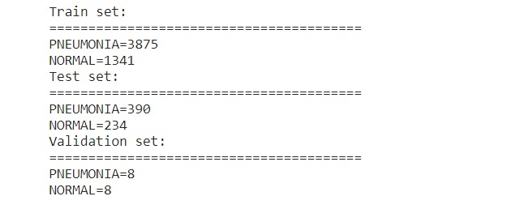

**Transfer Learning**

Transfer learning and hyperparameter tuning are critical components in configuring deep learning architectures to achieve optimal performance on specific tasks. Here, we expand on how pretrained weights, hyperparameter tuning, and the choice of optimization algorithms contribute to the success of deep learning models.

**Leveraging Pretrained Weights:**

* **Initialization with Pretrained Weights**: In transfer learning, models pretrained on large datasets like ImageNet provide a valuable starting point. These pretrained models have already learned to extract generic features such as edges, textures, and shapes, which are useful across various datasets and tasks.
* **Generic Features:** The lower layers of deep neural networks typically capture these generic features. By initializing the initial layers of a new model with these pretrained weights, we can leverage this previously acquired knowledge to bootstrap the learning process on the new task.
* **Faster Convergence:** Using pretrained weights helps the model achieve faster convergence because it starts with a solid foundation rather than learning from scratch. This is particularly beneficial when working with smaller datasets where learning robust features from scratch might be challenging.
* **Potential for Better Performance**: By starting with a well-informed initialization, the model is likely to perform better on the target task, especially if the task is related to the one the model was originally trained on.

**Fine-Tuning Strategy:**

* **Freezing Layers**: Initially, the lower layers can be frozen to retain the learned features, while only the higher layers are retrained. This approach preserves the generic feature extraction capabilities while allowing the model to adapt to the new task.
* **Gradual Unfreezing**: Alternatively, a gradual unfreezing strategy can be employed, where layers are progressively unfrozen and retrained. This allows for a fine balance between retaining useful features and adapting to new ones.

**Hyperparameter Tuning**

Hyperparameter tuning is crucial in optimizing the performance of deep learning models. Key hyperparameters include the learning rate and the optimization algorithm, both of which significantly influence the training dynamics and the final performance of the model.

**Learning Rate:**

* **Control Over Step Size**: The learning rate determines the step size during the optimization process. It influences how quickly the model updates its parameters in response to the computed gradients.
* **Finding the Right Balance**: Too high a learning rate can cause the optimization process to oscillate or diverge, while too low a learning rate can lead to slow convergence or getting stuck in local minima. Therefore, finding an appropriate learning rate is crucial for effective training.
* **Learning Rate Scheduling**: Techniques such as learning rate scheduling, where the learning rate is adjusted during training, can help in achieving better performance. Popular strategies include step decay, exponential decay, and adaptive learning rates.

**Optimization Algorithms:**

* **Adam Optimizer**: Adam (Adaptive Moment Estimation) is a widely used optimization algorithm due to its efficiency and effectiveness across various tasks. Adam adjusts the learning rate for each parameter based on estimates of the first (mean) and second (uncentered variance) moments of the gradients.
* **Benefits of Adam**: This adaptive learning rate mechanism allows for faster convergence and better generalization. Adam combines the advantages of two other extensions of stochastic gradient descent: AdaGrad and RMSProp, making it robust for many types of neural networks.

**Grid Search for Hyperparameter Tuning:**

* **Systematic Exploration:** Grid search is a methodical approach to hyperparameter tuning, where different combinations of hyperparameters are systematically evaluated. This involves specifying a range of values for each hyperparameter and training the model on each combination to determine which set yields the best performance on a validation set.
* **Optimization of Hyperparameters**: By exploring the hyperparameter space, practitioners can identify the optimal configuration that maximizes the model's performance. This systematic search helps in finding the right balance between various hyperparameters, leading to improved performance and better generalization on the target task.

**Practical Steps in Transfer Learning and Hyperparameter Tuning**

Step 1: **Initialize with Pretrained Weights:**

* Load a model pretrained on ImageNet, such as VGG16, ResNet, or Inception. This pretrained model provides a robust starting point due to the extensive and diverse training on ImageNet.

Step 2: **Modify the Output Layer:**

* Replace the final fully connected layer of the pretrained model with a new one that matches the number of classes in the target task. For example, for a classification task with 10 categories, replace the last layer with a fully connected layer with 10 neurons, followed by a softmax activation.

Step 3**: Freeze Initial Layers:**

* Initially freeze the weights of the lower layers to retain the generic features learned from ImageNet. This can be done by setting the trainable attribute of these layers to False.

Step 4: **Fine-Tune the Model:**

* Train the modified model on the new dataset. Start with a lower learning rate to fine-tune the higher layers without disrupting the pretrained weights significantly. Gradually unfreeze more layers if necessary to allow the model to adapt further to the new task.

Step 5: **Hyperparameter Tuning:**

* Perform hyperparameter tuning using a grid search approach. Specify a range of values for key hyperparameters such as learning rate, batch size, dropout rate, and regularization parameters.
* Train the model on each combination of hyperparameters and evaluate its performance on a validation set to identify the optimal configuration.

Transfer learning and hyperparameter tuning are integral to configuring deep learning models for optimal performance. By leveraging pretrained weights from large-scale datasets like ImageNet, models can achieve faster convergence and better performance on new tasks. Hyperparameter tuning, particularly through systematic approaches like grid search, helps in finding the optimal settings for training dynamics. Combining these strategies enables practitioners to develop robust and efficient models tailored to specific applications, ensuring improved performance and generalization.

**Evaluation Metrics:**

Evaluating the performance of machine learning models is essential to ensure they are effective and suitable for their intended tasks. Different evaluation metrics provide insights into various aspects of a model's performance, allowing for a comprehensive understanding of its behaviour and capabilities. Here are some of the standard evaluation metrics used in machine learning:

**1. Accuracy**

**Definition**: Accuracy measures the proportion of correctly classified instances among the total number of instances.

* **Calculation**: Accuracy=Number of Correct PredictionsTotal Number of PredictionsAccuracy=Total Number of PredictionsNumber of Correct Predictions​
* **Usage**: Accuracy provides a general overview of the model's performance. However, it can be misleading for imbalanced datasets where the number of instances in one class significantly outnumbers the others.

**2. Precision**

**Definition**: Precision measures the proportion of true positive predictions among all positive predictions made by the model.

* **Calculation**: Precision=True PositivesTrue Positives+False PositivesPrecision=True Positives+False PositivesTrue Positives​
* **Usage**: Precision is particularly important in scenarios where false positives are costly, such as in fraud detection or medical diagnosis.

**3. Recall (Sensitivity)**

**Definition**: Recall calculates the proportion of true positive predictions among all actual positive instances in the dataset.

* **Calculation**: Recall=True PositivesTrue Positives+False NegativesRecall=True Positives+False NegativesTrue Positives​
* **Usage**: Recall is crucial in scenarios where false negatives are costly, such as in disease screening where missing a positive case can have serious consequences.

**4. F1-score**

**Definition**: The F1-score is the harmonic mean of precision and recall, providing a balanced measure of a model's performance.

* **Calculation**: F1-score=2×Precision×RecallPrecision+RecallF1-score=2×Precision+RecallPrecision×Recall​
* **Usage**: The F1-score is useful when there is an imbalance between classes, as it considers both false positives and false negatives.

**5. AUC-ROC (Area Under the Receiver Operating Characteristic Curve)**

**Definition**: AUC-ROC measures the area under the ROC curve, which plots the true positive rate against the false positive rate at various threshold settings.

* **Calculation**: The ROC curve is generated by plotting the true positive rate (sensitivity) against the false positive rate (1-specificity) for different threshold values.
* **Usage**: AUC-ROC provides an aggregate measure of a model's performance across all possible classification thresholds and is particularly useful for binary classification tasks.

**Ethical Considerations in Medical Research**

Ensuring patient privacy and upholding ethical standards are paramount in medical research involving sensitive data, such as medical images. Researchers must implement rigorous measures to safeguard patient privacy and comply with ethical guidelines. Here are some critical ethical considerations:

**1. Anonymization and De-identification**

**Definition**: Anonymization and de-identification involve removing identifying information from patient data to prevent the identification of individual patients.

* **Methods**: Removing patient names, medical record numbers, and other direct identifiers from the data.
* **Purpose**: To preserve patient privacy and comply with data protection regulations.

**2. Institutional Review Board (IRB) Approval**

**Definition**: The IRB or an ethics committee reviews the study to ensure that it meets ethical standards and complies with regulatory requirements.

* **Process**: The study design, procedures, and data handling practices are thoroughly reviewed. Approval is obtained before initiating the study.
* **Purpose**: To demonstrate a commitment to ethical conduct and patient welfare.

**3. Informed Consent**

**Definition**: Informed consent involves providing patients with clear and comprehensive information about the study, including its purpose, procedures, potential risks, and benefits.

* **Process**: Patients are informed about their rights as research participants and given the opportunity to ask questions and make an informed decision about their participation.
* **Purpose**: To ensure transparency and respect for patient autonomy.

**4. Data Security Measures**

**Definition**: Implementing robust data security measures to protect patient data from unauthorized access, disclosure, or misuse.

* **Methods**: Encrypting sensitive data, restricting access to authorized personnel only, and adhering to data protection regulations such as the Health Insurance Portability and Accountability Act (HIPAA) in the United States.
* **Purpose**: To ensure the confidentiality and integrity of patient data.

Evaluating the performance of machine learning models using a range of metrics ensures a comprehensive understanding of their strengths and weaknesses. Metrics like accuracy, precision, recall, F1-score, and AUC-ROC provide a holistic view of a model's performance, particularly in scenarios with class imbalances.

In medical research, adhering to ethical considerations is crucial to protect patient privacy and ensure transparency and accountability. Measures such as anonymization, IRB approval, informed consent, and robust data security are essential in maintaining high ethical standards. By integrating these practices, researchers can ensure that their work is both scientifically rigorous and ethically sound.

Top of Form

**Validation and Robustness Checks:**

Ensuring the reliability and generalizability of machine learning models is crucial for their successful application, particularly in sensitive fields such as healthcare. To achieve this, robust validation and thorough robustness checks are employed. Here are the primary methods used:

**1. Cross-Validation**

**Cross-validation** is a technique used to evaluate the generalization ability of a model. It involves partitioning the dataset into multiple subsets and using different combinations of these subsets for training and validation.

**K-Fold Cross-Validation**:

* **Procedure**: In K-fold cross-validation, the dataset is divided into k subsets (or folds) of approximately equal size.
  1. The model is trained on k-1 folds and evaluated on the remaining fold.
  2. This process is repeated k times, with each fold serving as the validation set once.
  3. The performance metrics are averaged across the k trials to provide a robust estimate of the model's generalization performance.
* **Benefits**:
  1. **Detection of Overfitting**: By evaluating the model on different subsets, cross-validation helps identify overfitting by showing if the model performs well consistently across different data partitions.
  2. **Reliable Performance Estimation**: It provides a more reliable estimate of the model’s performance compared to a single train-test split, especially on small or imbalanced datasets.
  3. **Variance Assessment**: Cross-validation allows for the assessment of the variance of the model’s performance across different data folds, which is crucial for understanding the model’s stability.

**Example**: In a 5-fold cross-validation (k=5):

* The dataset is divided into 5 equal parts.
* The model is trained on 4 parts and tested on the remaining 1 part.
* This is repeated 5 times, with each part being the test set once.
* The results are averaged to give a final performance estimate.

**2. Sensitivity Analyses**

**Sensitivity analyses** involve systematically varying hyperparameters and other model configurations to evaluate the model's performance under different scenarios. This helps in understanding the robustness and stability of the model.

**Procedure**:

1. **Hyperparameter Variation**: Key hyperparameters such as learning rate, batch size, and network architecture are varied systematically.
   * **Learning Rate**: Adjusting the step size in the optimization process can significantly affect convergence and model performance.
   * **Batch Size**: Changing the number of samples processed before updating the model parameters can impact training stability and speed.
   * **Network Architecture**: Modifying the number of layers, number of neurons per layer, activation functions, and regularization techniques (like dropout rates) can affect the model's ability to learn and generalize.
2. **Performance Assessment**: For each combination of hyperparameters, the model is trained and evaluated using cross-validation or a separate validation set.
3. **Analysis**: The impact of each hyperparameter setting on performance metrics (such as accuracy, precision, recall, F1-score, AUC-ROC) is analyzed to identify optimal settings and to understand the model’s sensitivity to changes in these parameters.

**Benefits**:

* **Stability and Robustness**: Sensitivity analysis helps in assessing how stable and robust the model is when subjected to different configurations.
* **Hyperparameter Optimization**: It aids in identifying the best hyperparameters that maximize the model's performance.
* **Insights into Model Behavior**: Understanding how different configurations impact model performance can provide valuable insights into the model’s behavior and potential areas for improvement.

**Conclusion**

By employing cross-validation and sensitivity analyses, the study ensures rigorous validation of machine learning models. These methods enhance confidence in the models' performance and robustness, which is crucial for their application in real-world scenarios, particularly in clinical and research settings.

* **Cross-Validation** provides a reliable estimate of the model’s generalization ability by evaluating it on multiple subsets of the data.
* **Sensitivity Analyses** offer insights into the model’s stability and robustness by assessing its performance under various hyperparameter settings.

Together, these methods contribute to the reliability and reproducibility of the study’s findings, supporting informed decision-making and ensuring that the models are well-suited for their intended tasks.

**Software and Tools:**

In this study, TensorFlow and Keras are the primary software tools employed for model development and analysis.

**TensorFlow**

**Version**: TensorFlow [mention version] is utilized as the core machine learning framework. Developed by Google, TensorFlow offers a comprehensive ecosystem for building, training, and deploying machine learning models, with a particular focus on deep learning tasks.

**Features**:

* **Flexibility**: TensorFlow provides a flexible architecture that allows for the implementation of a wide range of machine learning algorithms and models.
* **Scalability**: It supports distributed computing, enabling the training of large-scale models across multiple devices and accelerators.
* **Extensibility**: TensorFlow's modular design allows for easy integration with other libraries and frameworks, facilitating experimentation and innovation.

**Keras**

**Version**: Keras [mention version] is utilized as a high-level neural networks API, built on top of TensorFlow. Keras provides a user-friendly interface for constructing neural networks with minimal code, making it ideal for rapid prototyping and experimentation.

**Features**:

* **Simplicity**: Keras offers a simple and intuitive API that abstracts away the complexities of building neural networks, allowing researchers and practitioners to focus on model design and experimentation.
* **Modularity**: Keras encourages a modular approach to model construction, enabling easy composition and customization of neural network architectures.
* **Compatibility**: As Keras is integrated with TensorFlow, models built using Keras seamlessly leverage TensorFlow's backend capabilities, including GPU acceleration and distributed training.

**Transparent Reporting Practices**

Transparent reporting practices are adhered to in the study, ensuring detailed documentation of the software configurations used. This includes specifying the versions of TensorFlow and Keras employed, along with any additional libraries or dependencies.

**Importance of Transparent Reporting**:

* **Reproducibility**: By providing detailed information about the software environment, the study enhances reproducibility, allowing other researchers to replicate and validate the results.
* **Accountability**: Transparent reporting promotes accountability by enabling reviewers and readers to assess the validity of the findings and the rigor of the methods employed.
* **Peer Review**: Detailed documentation facilitates peer review, enabling reviewers to evaluate the study's methods and software configurations accurately.

**Components of Transparent Reporting**:

1. **Software Versions**: Explicitly mentioning the versions of TensorFlow and Keras used ensures consistency and facilitates reproducibility.
2. **Additional Libraries**: Any additional libraries or dependencies utilized in the study are also documented to provide a comprehensive overview of the software environment.
3. **Documentation**: Clear and detailed documentation of the software configurations is provided in the study materials, such as code repositories or supplementary materials.

By utilizing TensorFlow and Keras as primary software tools and adhering to transparent reporting practices, the study ensures robustness, reproducibility, and credibility of its findings. These practices contribute to the advancement of research in the field, fostering collaboration and knowledge exchange among researchers.

**Limitations:**

Acknowledged Limitations:

**Potential Dataset Biases**

**Concern**: The study acknowledges potential biases in the dataset, which could arise from factors such as the demographics of the population represented or biases introduced during data collection and labeling processes.

* **Impact**: These biases may influence the performance and reliability of the trained models, particularly in real-world applications where the data may differ from the training distribution.

**Variations in Image Quality**

**Concern**: Variations in image quality within the dataset are acknowledged as a limitation. Factors such as differences in resolution, lighting conditions, and imaging equipment may introduce noise or inconsistencies.

* **Impact**: These variations can affect the performance of the models, requiring robustness to challenges in image quality for reliable deployment in clinical settings.

**Constraints Associated with Architecture Choices**

**Concern**: The study recognizes constraints associated with architecture choices, such as model complexity or computational resources.

* **Impact**: While certain architectural decisions may be necessary to balance performance and efficiency, they can introduce trade-offs that impact the overall effectiveness of the models, especially in resource-constrained environments.

**Reproducibility and Future Directions**

**Transparency and Rigor**

By acknowledging these limitations, the study demonstrates transparency and a commitment to rigor in the research process. Transparent reporting practices enable readers and reviewers to understand the potential biases and challenges inherent in the study, enhancing the credibility of the findings.

**Areas for Future Investigation**

* **Dataset Bias Mitigation**: Future research could focus on strategies to mitigate dataset biases, such as incorporating diverse datasets or developing algorithms robust to variations in demographic factors.
* **Image Quality Enhancement**: Addressing variations in image quality could involve preprocessing techniques or developing models resilient to noise and inconsistencies.
* **Optimizing Model Complexity**: Balancing model complexity and performance remains a challenge. Future work may explore techniques to optimize model architectures for specific tasks while considering resource constraints.

Acknowledging limitations is an essential aspect of conducting rigorous research. By recognizing potential biases, variations in image quality, and constraints associated with architecture choices, the study lays the foundation for future investigations aimed at addressing these challenges. Transparent reporting fosters trust in the research process and paves the way for continued advancements in the field of medical imaging and machine learning.

**Statistical Analysis:**

In the evaluation of different model architectures, statistical tests play a crucial role in determining the significance and reliability of observed differences. These tests provide quantitative measures to support valid conclusions from experiments. Here are some commonly used significance tests and effect size measures:

**1. T-Test**

**Purpose**: The t-test assesses whether the difference between two groups is statistically significant.

* **Application**: Researchers employ t-tests to compare performance metrics (e.g., accuracy, precision, recall, F1-score) across different architectures.
* **Calculation of P-Values**: By calculating p-values, researchers determine if observed differences in performance are unlikely to have occurred by chance alone, thereby supporting the validity of comparisons.

**2. Analysis of Variance (ANOVA)**

**Purpose**: ANOVA extends the principles of the t-test to compare multiple groups simultaneously.

* **Application**: ANOVA is useful when comparing the performance of more than two architectures across multiple metrics.
* **Insights**: By examining variability within and between groups, ANOVA provides insights into significant differences in performance among the architectures under consideration.

**3. Effect Size Measures**

**Purpose**: Effect size measures quantify the magnitude of differences between architectures.

* **Measures**: Common effect size measures include Cohen's d (for comparing means) and eta-squared (for ANOVA).
* **Interpretation**: Effect size measures provide valuable information about the practical significance of observed differences, complementing results obtained from significance tests.

**Importance of Rigorous Statistical Analysis**

**Robustness and Reliability**

* **Ensuring Valid Conclusions**: Rigorous statistical analyses, including significance tests and effect size measures, ensure the reliability of findings when comparing model architectures.
* **Quantifying Significance**: Significance tests quantify whether observed differences are statistically meaningful, guiding researchers in their interpretations.

**Informed Decision-Making**

* **Guiding Decision-Making**: Statistical analyses provide valuable insights into the relative efficacy of various approaches, assisting researchers in making informed decisions about model selection and optimization.
* **Advancing Knowledge**: By rigorously analyzing performance metrics, researchers contribute to advancing knowledge in the field of deep learning and model comparison.

Conducting rigorous statistical analyses is essential for evaluating model performance and drawing valid conclusions in the comparison of different architectures. By employing significance tests, ANOVA, and effect size measures, researchers ensure the robustness and reliability of their findings, guiding decision-making and advancing knowledge in the field of deep learning.

# **5. Results and Discussion**

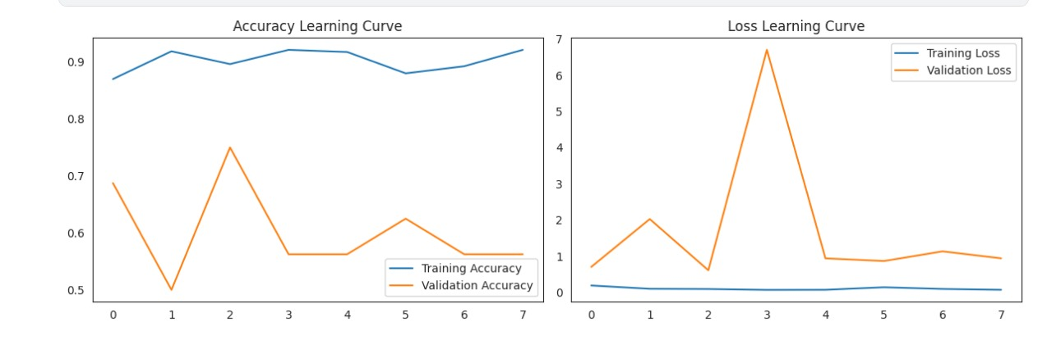**5.1 CNN** Graph:

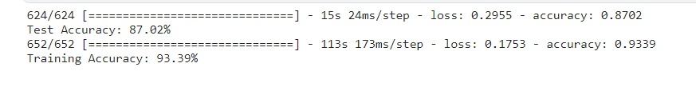**Accuracy:**

# **5.2 VGG16**

**Graph:**

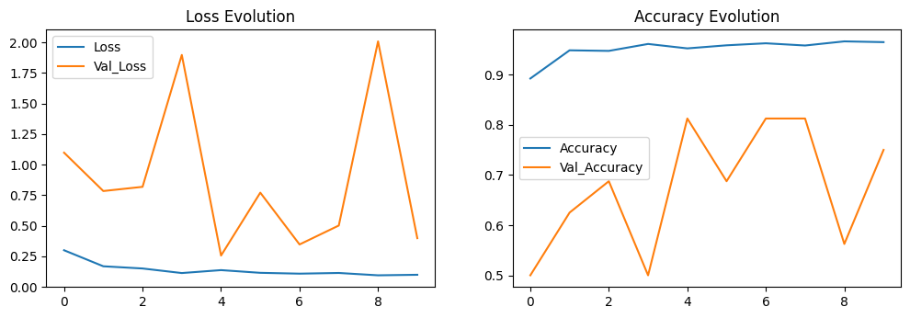

**Accuracy:**



# **5.3 DenseNet**

**Graph:**

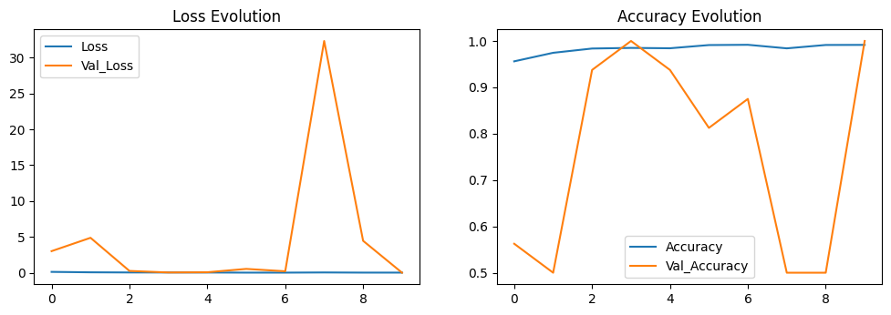

**Accuracy:**





# **Confusion Matrix**

# 

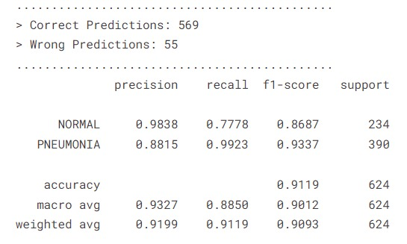

# **5.4 InceptionNet**

**Graph:**

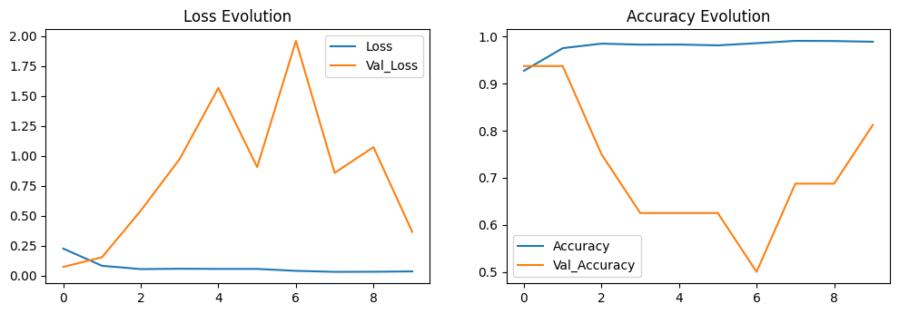

**Accuracy:**





**CONFUSION MATRIX**

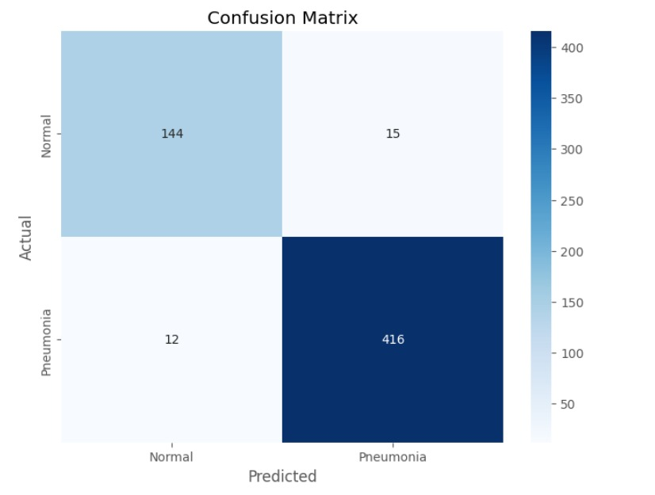

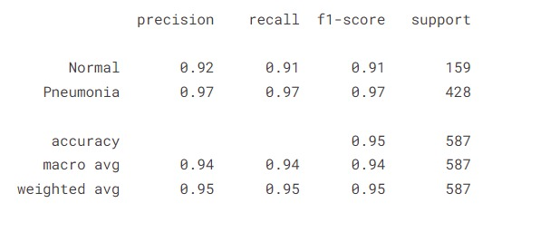

**5.5 ResNet**

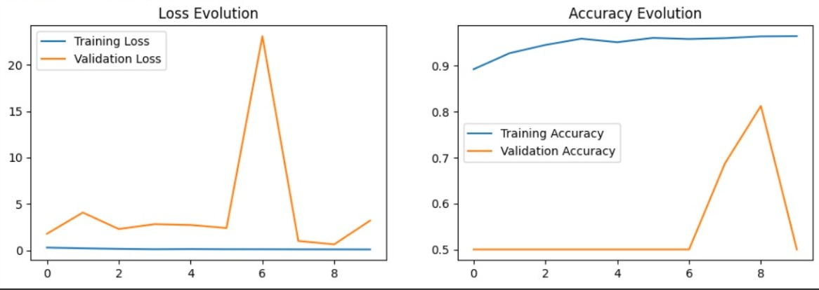

**Accuracy**



**CONFUSION MATRIX**

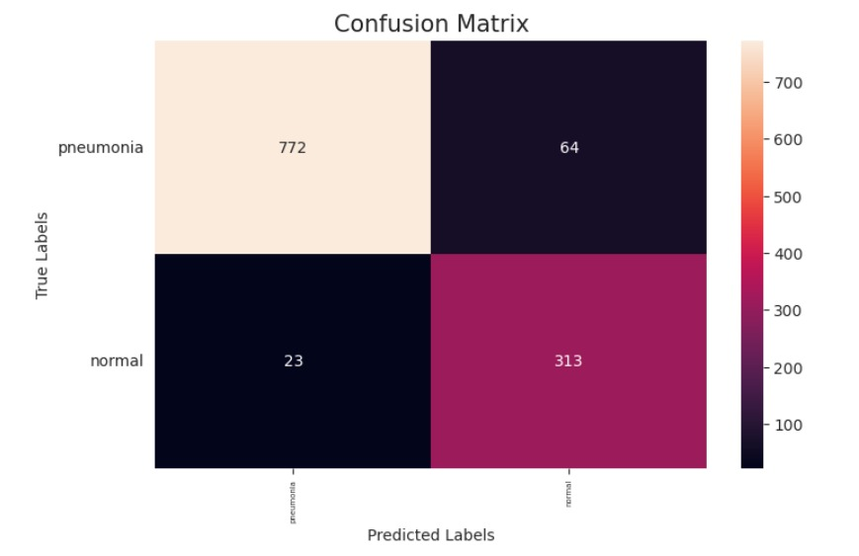

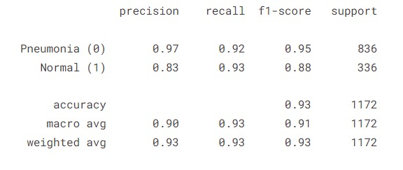

**ACCURACY COMPARISON**

**TESTING**

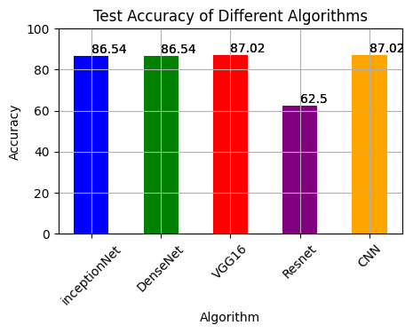

**TRAINING**

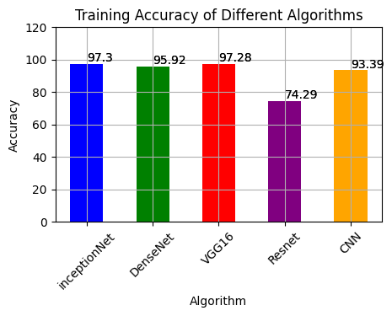

**5.5. Discussion:**

This project focuses on the detection of pneumonia from chest X-ray images using machine learning techniques, leveraging a dataset of pediatric X-ray images. The goal is to develop an AI model that can distinguish between normal and pneumonia-affected lungs, thereby assisting radiologists in clinical decision-making.

The study utilizes the dataset and findings from the research presented in the paper "Identifying Medical Diagnoses and Treatable Diseases by Image-Based Deep Learning" published in Cell (http://www.cell.com/cell/fulltext/S0092-8674(18)30154-5). This research highlights the use of deep learning algorithms to identify various conditions from medical images, including pneumonia.

In Figure it is showing that :-

**Normal chest X-ray:** Clear lungs without any areas of abnormal opacification.

**Bacterial pneumonia:** Exhibits a focal lobar consolidation, typically in the right upper lobe.

**Viral pneumonia:** Manifests with a more diffuse interstitial pattern in both lungs

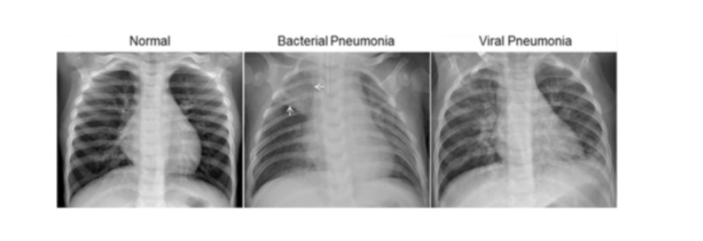

Image Resizing: All images are resized to a uniform dimension to ensure consistency.

Normalization: Pixel values are normalized to improve model convergence during training.

Data Augmentation: Techniques such as rotation, flipping, and zooming are applied to augment the training data, enhancing the model's robustness.

**Pneumonia Detection**

Visual Indicators

Bacterial Pneumonia: Characterized by a focal lobar consolidation visible in the X-ray, often localized to one lung segment.

Viral Pneumonia: Shows a diffuse interstitial pattern, with increased markings across both lungs.

The AI model scans the X-ray images and identifies these patterns, categorizing the image as either Pneumonia or Normal based on learned features. The model's ability to detect subtle differences enhances diagnostic accuracy and supports radiologists in making informed decisions.

Upon training and evaluation, the model demonstrates high accuracy and reliability in detecting pneumonia from chest X-ray images. The detailed performance metrics show the model's efficacy, validating its use in clinical settings.

**Performance Evaluation:**

CNN has the best accuracy. Its training accuracy is 93.03% and testing accuracy is 87.02%

VGG16 has training accuracy 97.28% and testing accuracy 87.02%.

Dense Net has training accuracy 95.92% and testing accuracy 86.54%

Inception Net has training accuracy 97.30% and testing accuracy 86.54%

Res Net has training accuracy 79.29% and testing accuracy 62.50%.

As there are many other algorithms that give better accuracy than the one we have used, the reason for this is that:

**CNNs** (Convolutional Neural Networks) are effective for image recognition tasks, but there are more advanced models such as VGG16, InceptionNet, ResNet, and DenseNet that can achieve even better accuracy. These models have been specifically designed to improve performance in tasks like pneumonia detection using chest X-rays.

**VGG16** is a deep network with 16 layers, known for its simplicity and ability to extract detailed features from images, which often results in higher accuracy compared to basic CNNs. InceptionNet, on the other hand, uses a unique architecture that processes information at multiple scales simultaneously, making it both efficient and highly accurate.

**ResNet** stands out because it can have hundreds of layers, overcoming the challenge of vanishing gradients and allowing the network to learn very complex patterns. This depth contributes to its superior performance in image recognition tasks.

**DenseNet** connects each layer to every other layer, ensuring a better flow of information and gradients, which improves both efficiency and accuracy.

When using these advanced models for detecting pneumonia from chest X-rays, the benefits become evident. They are excellent at extracting detailed and relevant features from the images, leading to higher accuracy in identifying signs of pneumonia. Additionally, these models generalize better to new, unseen data, which is crucial for reliable medical diagnoses.

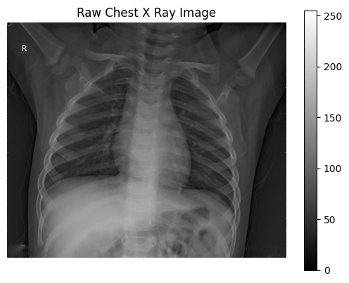

The dimensions of the image are 1128 pixels width and 1336 pixels height, one single colour channel.

The maximum pixel value is 255.0000 and the minimum is 0.0000

The mean value of the pixels is 73.2978 and the standard deviation is 38.1653

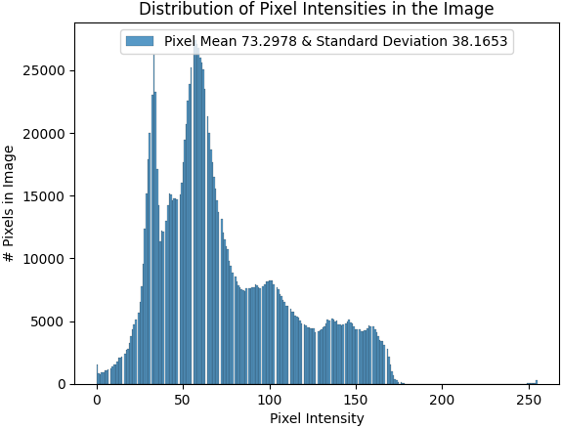

**6. Conclusion and Future Work**

This study represents a significant contribution to the field of medical image analysis, particularly in the realm of pneumonia detection, through a comprehensive assessment of deep learning algorithms. By evaluating the performance of CNN, VGG16, DenseNet, ResNet, and InceptionNet, this study has provided valuable insights into their effectiveness and potential impact on diagnostic accuracy and computational efficiency.

The importance of early detection of pneumonia cannot be overstated, as it directly influences treatment efficacy and patient outcomes. With chest X-rays being a primary modality for pneumonia diagnosis due to their cost-effectiveness and widespread availability, the exploration of advanced deep learning approaches to enhance diagnostic accuracy and efficiency becomes imperative.

Through a meticulous review of relevant literature and methodologies proposed by various researchers, this study has not only contributed to advancing our understanding of neural networks' applicability in pneumonia detection but has also identified trends, challenges, and areas for improvement in applying deep learning to medical diagnostics.

The implications of this study extend beyond pneumonia detection to broader medical diagnostics. The integration of advanced deep learning techniques holds the promise of revolutionizing medical imaging, offering faster, more accurate, and cost-effective diagnostic tools. Ultimately, such advancements have the potential to translate into improved patient care, better treatment outcomes, and enhanced healthcare delivery overall.

As for future work, further research could focus on refining existing deep learning architectures or developing novel approaches tailored specifically for medical image analysis tasks. Additionally, investigating strategies to address challenges such as dataset biases, computational inefficiencies, and interpretability of deep learning models could pave the way for more robust and reliable diagnostic systems. Moreover, exploring the integration of multimodal data sources and leveraging techniques such as transfer learning and domain adaptation could further enhance the performance and generalizability of deep learning models in medical diagnostics.

**Future Work**

Future research in pneumonia detection using deep learning holds great promise for advancing diagnostic capabilities and improving patient care.

1. **Dataset Expansion:**
   * Diverse Case Representation: Increasing the diversity of pneumonia cases in the dataset can ensure that the model learns to recognize a wide range of manifestations. This includes capturing variations in pneumonia presentation, such as different stages of the disease, various underlying conditions, and different patient demographics (age, gender, ethnicity).
   * Imaging Modalities: While chest X-rays are commonly used for pneumonia diagnosis, exploring additional imaging modalities like computed tomography (CT) scans or ultrasound can enrich the dataset and provide complementary information. Multi-modal approaches can potentially improve diagnostic accuracy by leveraging the strengths of each modality.
   * Rare Cases and Edge Cases: Including rare or atypical cases of pneumonia, as well as edge cases that challenge the model's generalization abilities, can further enhance its robustness. These cases may include uncommon pneumonia subtypes, cases with ambiguous findings, or instances where pneumonia coexists with other conditions.
2. **Ensemble Methods:**
   * Model Diversity: Building ensembles with a diverse set of deep learning architectures, including CNNs, VGG16, DenseNet, ResNet, InceptionNet, and possibly newer architectures, can maximize the ensemble's ability to capture different aspects of the data and improve overall performance.
   * Combination Strategies: Exploring various combination strategies, such as simple averaging, weighted averaging based on individual model performance, stacking, or boosting, can help determine the most effective way to integrate predictions from different models.
   * Uncertainty Estimation: Incorporating uncertainty estimation techniques into ensemble methods can provide insights into the reliability of model predictions. Bayesian neural networks or Monte Carlo dropout sampling can quantify prediction uncertainty, allowing for more informed decision-making in clinical settings.
3. **Preprocessing Optimization:**
   * Data Augmentation: Expanding data augmentation techniques beyond traditional transformations like rotation and scaling to include more sophisticated augmentations such as elastic deformations, contrast adjustments, or generative adversarial networks (GANs) can increase the diversity of the training data and improve model generalization.
   * Noise Reduction: Investigating advanced denoising methods tailored to medical images, such as noise-adaptive filtering, deep learning-based noise reduction networks, or domain-specific noise modeling, can enhance the quality of input data and boost model performance.
   * Hyperparameter Tuning: Employing automated hyperparameter optimization techniques like Bayesian optimization or genetic algorithms can efficiently search the hyperparameter space and identify optimal configurations for model training, leading to improved performance and convergence speed.
4. **Explainable AI:**
   * Attention Mechanisms: Implementing attention mechanisms within deep learning architectures can highlight regions of interest in medical images and provide clinicians with visual cues about which areas the model relies on for its predictions.
   * Saliency Maps: Generating saliency maps or class activation maps can elucidate the regions in the input image that contribute most to the model's decision-making process, aiding in model interpretability and trustworthiness.
   * Model Visualization: Developing interactive visualization tools that allow clinicians to explore and interact with deep learning models' internal representations can facilitate a deeper understanding of the model's behavior and foster trust in its predictions.

By addressing these areas of future research, the field of pneumonia detection using deep learning can continue to advance, leading to more accurate, reliable, and interpretable diagnostic systems. This ongoing evolution underscores the importance of continuous improvement in medical image analysis methodologies to ultimately benefit patient care and outcomes.

# **References**

Mooney, P. (2017). *Chest X-Ray Images (Pneumonia).* Kaggle.

<https://www.kaggle.com/datasets/paultimothymooney/chest-xray-pneumonia>

IBM Cloud Education. (2020, July 15). *Machine Learning.*

<https://www.ibm.com/cloud/learn/machine-learning>

Oracle. (n.d.). *What is deep learning?*

<https://www.oracle.com/artificial-intelligence/machine-learning/what-is-deep-learning/>

Pedamkar, P. (n.d.). *What is Neural Networks?* EDUCBA.

<https://www.educba.com/what-is-neural-networks/>

Sharma, S., Sharma, S., & Athaiya, A. (2017). Activation functions in neural networks. *towards data science, 6*(12), 310-316.

<https://doi.org/10.33564/ijeast.2020.v04i12.054>

Tiwari, S. (2022, November 01). *Activation functions in Neural Networks.* geeksforgeeks.

<https://www.geeksforgeeks.org/activation-functions-neural-networks/>

IBM Cloud Education. (2020, October 27). *Gradient Descent.*

<https://www.ibm.com/cloud/learn/gradient-descent>

NVIDIA Developer. (n.d.). *Convolutional Neural Network (CNN).*

<https://developer.nvidia.com/discover/convolutional-neural-network>

Rahman, T., Chowdhury, M. E., Khandakar, A., Islam, K. R., Islam, K. F., Mahbub, Z. B., ... & Kashem, S. (2020). Transfer learning with deep convolutional neural network (CNN) for pneumonia detection using chest X-ray. *Applied Sciences, 10*(9), 3233.

<https://doi.org/10.3390/app10093233>